  - IBM Administrator Tools for BrassRing
User Guide

Release Date: May 2020

Edition Notice

Note: Before using this information and the product it supports, read the information in Notices.

This edition applies to IBM® Kenexa® Administrator Tools for BrassRing on Cloud User Guide and to all subsequent releases and modifications until otherwise indication in new editions.

Licensed Materials - Property of IBM

© Copyright IBM® Corporation, 2020.

US Government Users Restricted Rights – Use, duplication or disclosure restricted by GSA ADP Schedule Contract with IBM Corp.

Table of Contents

Contents
Edition Notice 2
Table of Contents 3
Introduction 6
About BrassRing Training 6
Chapter 1: Administering Users 7
Chapter Overview 7
Chapter Objectives 7
Overview of User Types 8
User Types 8
Persona Groups 9
User Groups 10
Managing User 10
Adding Users 10
Editing Users 12
Transfer Folder Ownership 12
Deactivating Users 12
Reactivating Users 13
Exporting User Lists 14
Exporting a User List to Excel 14
Organizational Groups 14
Adding an Organizational Group 14
Editing an Organizational Group 16
Deleting an Organizational Group 17
Data Insight Tool (DIT) Roles 17
Add a DIT Role 17
Manage the User Roster 18
Edit a DIT Role 20
Copy a DIT Role 20
Delete a DIT Role 20
Chapter 2: Administering Codes 23
Chapter Overview 23
Chapter Objectives 23
Overview of Code Types 24
Code Types 24
Adding Code Types 24
Adding Codes 25
Adding Job Codes 25
Editing Job Codes 27
Adding Source Codes 27
Adding Req Codes 28
Deactivating Codes 28
Reactivating Codes 29
Exporting Code Lists 29
Chapter 3: Managing Lists 32
Chapter Overview 32
Chapter Objectives 32
Overview of Lists 33
Elements of Lists 33
BrassRing Field Types 33
Managing Lists 34
Adding an Option 34
Editing Options 35
Inactivating Options 36
Reactivating Options 36
Export Option List to Microsoft Excel 37
Chapter 4: Using Miscellaneous Administrative Features 39
Chapter Overview 39
Chapter Objectives 39
Mass Emails 40
Sending Mass Emails 40
Stacking Duplicate Resumes or CVs 41
Notes Audit 42
Attachments Audit 43
Login Failure Audit 43
Chapter 5: Setting up Communication Templates 46
Chapter Overview 46
Chapter Objectives 46
Working with Communication Templates 47
Elements of Communication Templates 47
Adding a Communication Template 47
Editing a Communication Template 49
Working with Letter Templates 50
Elements of Letter Templates 50
Adding a Letter Template 50
Deactivating Communications 52
Document Templates 52
Adding Document Templates 53
Deactivate a document template 56
Delete a document template 57
Administering Blurbs 57
Adding a Blurb 57
Document Packet Templates 61
Adding Document Template Packets 61
System Email Templates 62
Adding System Email templates 63
Check Your Skills Answers 67
Chapter 1 67
Chapter 2 67
Chapter 3 67
Chapter 4 67
Chapter 5 67
Notices 68
Trademarks 70

Introduction

This user guide provides BrassRing administrators (commonly referred to as Super Users) with an introduction to all of the administrative features that BrassRing offers. This course helps you to become proficient with all aspects of BrassRing

BrassRing is a highly customizable Talent Management solution. Therefore, some of the features that are discussed in this workbook might not apply to your company or might look different than you are used to seeing. We hope you take advantage of “Apply Your Knowledge” questions that are incorporated in this workbook. These questions give you the opportunity to note your company’s business practices and specialized processes.

About BrassRing Training
This course is the first step in becoming proficient using BrassRing’s Talent Management solution. We encourage you to take advantage of online “Help” available within BrassRing and as pursue additional training opportunities. IBM offers a number of tools including instructor-led and self-study courses that help support your company’s specific learning needs.

Administering Users

Chapter Overview
Not everyone who uses BrassRing needs the same level of access to the information within it. You might want to limit access to certain function for one type of user while allowing others less restricted use. Within BrassRing, you classify users by user types, user groups, and organization groups to specify the roles and privileges available to them.

In this chapter, we examine administering your users of BrassRing.

Chapter Objectives

At the end of this chapter you will be able to:
- Identify User types and User groups.
- Describe user role assignments.
- Define Organizational groups.
- Add users.
- My Req Relationship by using User Profile.
- Transfer Working Folder Ownership.
- Manage Data Insight Tool (DIT) Roles.

Overview of User Types
User types or user access levels define the function within BrassRing that specific staff members within your organization are permitted to use. User types are assigned according to the roles and responsibilities of the user.

While BrassRing initially provides the five standard User types listed, each with its own default BrassRing access privileges, your organization might have changed the default settings to better suit the needs of the user population and your specific hiring processes.

User Types
The five standard user types in BrassRing are:

Hiring Manager | User type has access to View my reqs and the candidates that are filed to those reqs. Even if your Hiring Managers will not access the BrassRing application directly, you enter them as users to include their names in the single-select list for the Manager field on the Requisition, and to easily send information from the system.
HR Coordinator | User type has general access to non-administrative functions, such as View my reqs, Search candidates and Working folders.
Recruiter | User type has access to all BrassRing function except for Admin+ and View all reqs. Also has access to selected Standard reports.
System Administrator | User type has access to all BrassRing function including administrative functions, such as job and source code maintenance and all reporting capabilities. System Administrator is also known as Super User.
QuickStart User | User type is assigned to eLink recipients who are not listed in the BrassRing system (that is, non-users of BrassRing). For this reason, it is recommended this User Type is not assigned to any BrassRing users. Candidates are also considered QuickStart Users when interacting with them by using eLinks.

Apply your knowledge
What are the names of your organization’s User Types?

-----------------------------------------------------------------------------------------------------------------

Persona Groups
The home page is designed to displays cards, grids, visualizations, and welcome messages specific to five different personas:
- Recruiter
- Hiring Manager
- Administrator
- HR User
- Reporting / Analytics

The BrassRing user home page experience is based on persona designation. Each persona provides the users with the view of the data that works best for them. Users can personalize the view of the home page depending on their day-to-day tasks and needs.

Additional Elements to Consider:
- The HR Status Categories must be mapped in order for visualizations to work on the home page.
- Based on configuration and appropriate privileges, the home page for users with recruiter persona displays information specific to their requisitions in individual containers, also known as cards. The cards come with multiple view options and as the permissions to refresh and update data in them.
- Users can switch to grid view or to the visualize view (Figure 1-4). The visualize view provides a pictorial representation of the req data. Currently, users can review time to fill and req aging visualizations.
- You might add up to 20 fields for display in the My Open Reqs grid views.

New users logging in to BrassRing, or existing users accessing the New UI for the first time will be defaulted as follows:
- Recruiter – My Open Reqs tab, Card View
- Hiring Manager – My Tasks tab. When the user clicks their My Open Reqs tab for the first time they will be defaulted to the Visualize View.

When users access the My Open Reqs and the Card View the default view by personas are as follows:
- Recruiter – Req #, Job Title, Location or Division, Department, Posting icon, New, and Total Candidates.
- Hiring Manager – Req #, Job Title, Location or Division, Department, Recruiter, New, and Total Candidates.
Note: Currently, your Workbench administrator can configure different default fields for the My Open Reqs card and grid views, and the My Candidates grid view that will only apply to any new users to BrassRing. The Recruiter persona is used for the remainder personas that will be updated with persona-specific configuration in future Releases.

User Groups
Some companies must limit access to resumes or CVs by division or by business unit. This might be accomplished by using User groups. If your organization opted to enable User groups, you see them when adding a new user within BrassRing.

While an individual’s User group is assigned when they are added as a BrassRing user, it is facilitated through the designation of a code which is assigned to incoming resumes or CVs. It is typically a division code or source code that allows or restricts access to these resumes or CVs by a particular User group.

It should be noted that User groups are created and managed by your Workbench Administrator.

Managing User
IBM entered your initial list of users during implementation. Moving forward as a Super User, you can add, update, deactivate, and reactivate users of BrassRing.

Adding Users
To add a user:

- From the Hiring Navigation icon , click Admin Admin+ Users.
- Click Add new user by using the Actions menu. Refer to Figure 1-1.
- Complete any required fields (*) and optional fields as necessary.
- For User type, select the User type for the user. Users can only have one User type selected.
- For User group, select the appropriate User group for the user. Users can have multiple User groups selected. Hold the Ctrl key down to select multiple user groups.
- For Org group, select the Organizational groups. Users can have multiple Org groups selected. Hold the Ctrl key down to select multiple org groups.
- For Approval authorizations and role definitions, click the box for the roles that are applicable for this user. See Table 1-1 for additional information about this field.
- Click Save.
- Click OK to close the confirmation message.

- Required fields are indicated with an asterisk.
- If you do not see more than one User group listed, then select the only group listed.

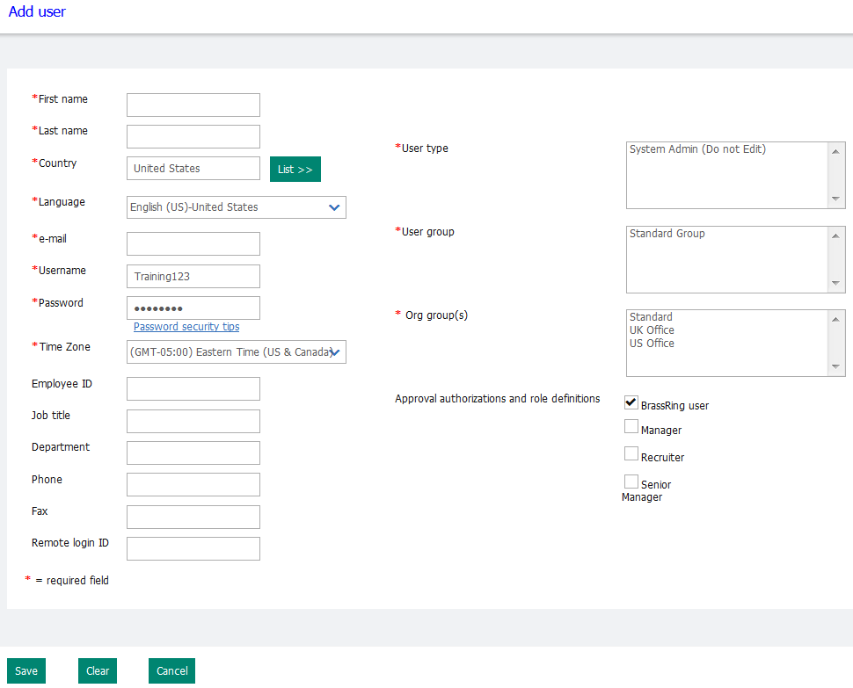
Figure 1- 1: Adding a user

Approval authorizations and role definition option | Description
BrassRing user | If the user is going to log on to BrassRing, then this option must be selected. If the user is never going to log on to BrassRing, then do not select this option.
Manager | If this user is a hiring manager and should appear in the Manager drop-down list on the req forms, then select this option.
Recruiter | If this user is a recruiter and should appear in the Recruiter drop-down list on the req forms, then select this option.
Approval routing titles (specific to your company’s BrassRing configuration) | If your company uses req approval routing, the approver levels are listed. When appropriate, select the appropriate Approver level for the user. The user’s name will now appear in the dropdown list of options for that particular approval level.
Table 1- 1: Approver and role options

Editing Users
To edit a user:

- From the Hiring Navigation icon , click Admin Admin+ Users.
- Click the Edit icon for the user.
- Change the appropriate fields.
- Click Save.
- Click OK to close the confirmation message.

Transfer Folder Ownership
As a Super User, you are able to transfer the folder ownership of a user’s Working Folder.
Best Practice is to use this feature when inactivating a user. Transferring Folder Ownership moves the ownership of that Working Folders to another user. As a result the “original” owner of the Working Folder no longer has the ability to edit, delete, or inactivate the Working Folder.

- From the Hiring Navigation icon , select Admin Admin+ Users.
- Select the user whose working folder ownership that you would like to transfer.
- Click Transfer working folder ownership in the Actions toolbar.
- In the Folders select box, select the folders to be transferred.
Note: The active and inactive working folders of which the user is the owner will appear.
- In the User select box, highlight the user to whom that ownership will be transferred.
- Click Save.

Deactivating Users
There will be occasions when you need to deactivate users, typically when they leave your company or transition into a new role that does not require the use of BrassRing.

To deactivate a user:
From the list of Active users, click the Deactivate icon for that user.

When users are being deactivated, they sometimes have active reqs that are attached to them that need to be reassigned to other users. A window will automatically open with a list of these reqs when you attempt to inactivate. Refer to Figure 1-2.

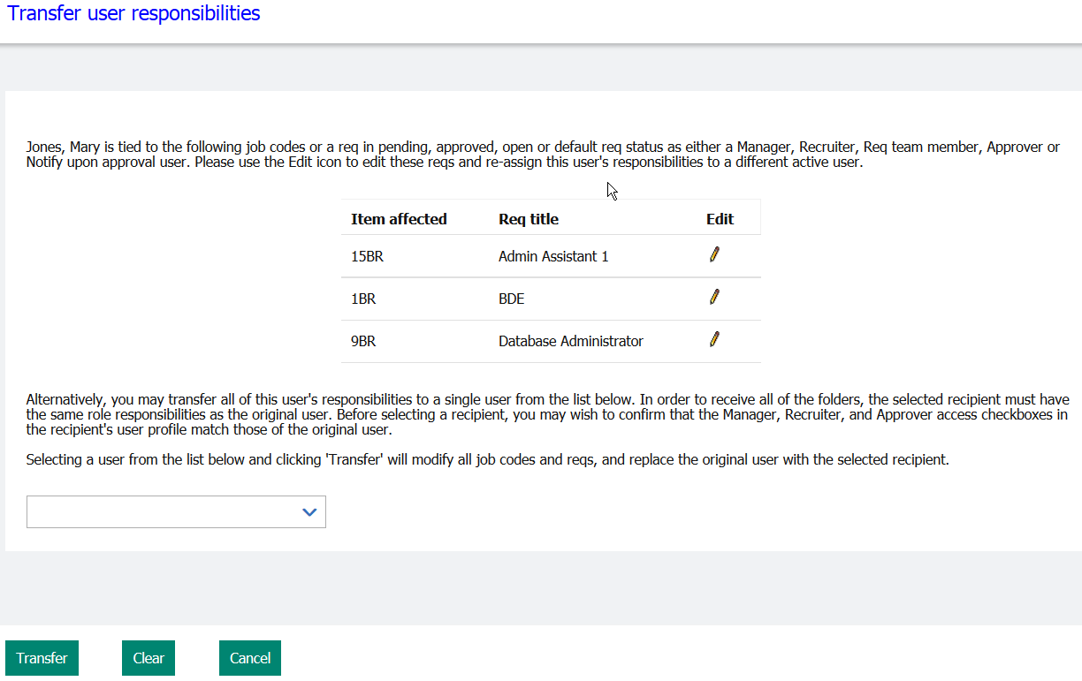
Figure 1- 2: Deactivating a user

Reactivating Users
To reactivate a user:

- From the list of Active users, click the Inactive users link located in the upper left corner of the screen.
- You will see a list of your inactive users. Refer to Figure 1-3.
- Click the Activate icon for the user.
- The user’s name returns to the list of your Active users.

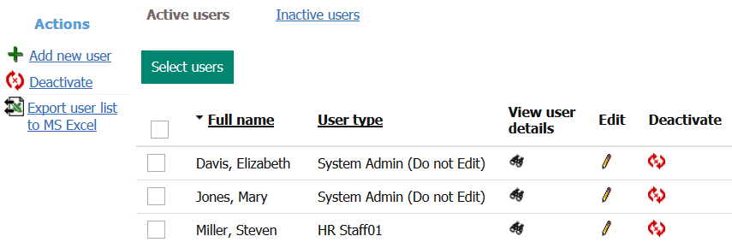
Figure 1- 3: Deactivating a user

Exporting User Lists
BrassRing enables you to export a comma-separated list (CSV) of users that you can then open in Microsoft Excel. You can use this function to compare BrassRing data to a list of data from another source.

Exporting a User List to Excel

To export a user list to Excel:

- From the Hiring Navigation icon , click Admin Admin+ Users.
- Click Export user list to MS Excel in the Actions list.
- In the File download screen, click Open.
- From the Microsoft Office Excel screen, select Yes. See Figure 1-4.

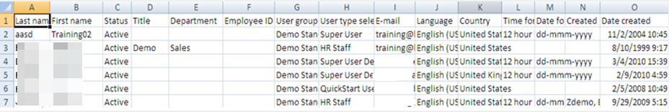
Figure 1- 4: Exported user list

- Click the appropriate hyperlink, either Active Users or Inactive Users to export the group of your choice.

My Req Relationship by using User Profile

This feature provides an automated way to create a My Req relationship in situations with high mobility rates or turnover among hiring managers, where the usual manual maintenance can be difficult. The setting enables a user to update all of a user’s My Req relationships by updating their User Profile field and easily update requisition privileges that are related to employee transfers and company reorganizations.

When enabling this feature a Req field is selected. In addition, one of more of its options are selected on the user’s profile. When a requisition’s option value for the selected field matches an option value that is selected on the profile, the user has a My Req relationship with the requisition, with all the functions a Req Team member would have. If either the Req value or the user profile option value changes, the My Req relationship dynamically changes.
This feature is enabled by selecting Configure for the Req privilege based on User Profile client setting. To enable the feature, contact your IBM representative. A req field must be selected to map to the user profile field. After a field is selected for the client setting, the field type cannot be changed or inactivated. The field’s options can be inactivated as these are used to link the BrassRing user to the reqs that have the options that are selected.

Elements of the My Req Relationship using User Profile:
- When there is a match between any of the options that are selected for the requisition and an option that is selected on the user’s Requisition privileges profile field, the user has a My Req relationship to the requisition. However, the user is not listed in the Requisition Team field as a result of the relationship.
- Org Groups are respected. If the req field option matches the user’s, but the Org Groups with which the user is associated don’t have privileges to the requisitions req form, the user is not granted a My Req relationship.
- When the options selected for the user on their profile are updated by using any means, for example an XML user import, Excel user import, or manually by using Workbench or BrassRing, then the My Req relationship is automatically updated. This includes both establishing new My Req relationships and severs those that are no longer valid.
- When the Req option is updated or created by using any means, for example adding or editing a Req, a Req import, a RAM-update custom field, or a Req Mass Update, the My Req relationship is automatically updated. This includes both establishing new My Req relationships and severs those that are no longer valid.
- All My Req privileges for the user’s user type are respected. For example, whether the user can Edit or View the req is determined based on the My Req privileges. If the user does not have the applicable My Req – view, they do not see the requisitions even though the user profile criteria matches the req criteria.
- User Profile imports support a Replace All action only.
- The Requisition Team field is respected if the user appears in the Req Team field. If the user profile field doesn’t match the req field, the user still has a My Req relationship to the req.
Editing the User’s Profile:
- From the Hiring Navigation icon , click Admin Admin+ Users.
- Click Edit icon for the select user.
- Click List >> and select the options from the Req field that is selected in the client setting.
- Save. When any of the user’s selected options match any of the options that are selected on a requisition, then a My Req relationship is established. The system will not attempt to match ALL.
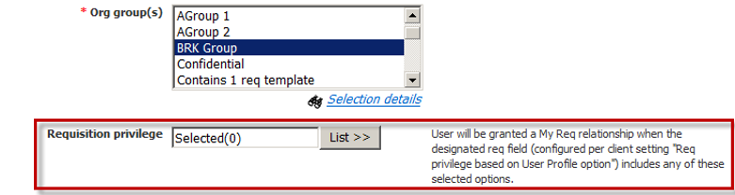
Figure 1- 5: Create My Req relationship on User Profile

Adding an Organizational Group
To add an Org group:

- From the Hiring Navigation icon , click Admin Admin+ Org. groups. See Figure 1-6.
- Click Add new group.
- Enter the Group name for the Org group. Refer to Figure 1-7.
- For Users, click List to search for the users to assign to this group.
- For Affiliated letter templates, hold down the [Ctrl] key to select the templates that should be available to this particular group.
- For Affiliated communication templates to send, hold down the [Ctrl] key and select the templates that should be available to this particular group.
- For Affiliated communication templates to administer, hold down the [Ctrl] key and select the templates that should be available to this particular group.
- For Affiliated document template to send, hold down the [Ctrl] key and select the templates that should be available to this particular group.
- For Affiliated document template to administer, hold down the [Ctrl] key and select the templates that should be available to this particular group.
- For Affiliated blurbs, hold down the [Ctrl] key and select the blurbs that should be available to this particular group when sending a communication.
- For Affiliated req templates, hold down the [Ctrl] key and select the req forms that should be available to this particular group.
- For Affiliated Gateway Questionnaire, hold down the [Ctrl] key to select the templates that should be available to this group.
- Click Save.
- Click OK to close the confirmation message.

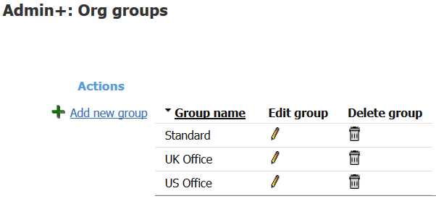
Figure 1-6: Organizational groups

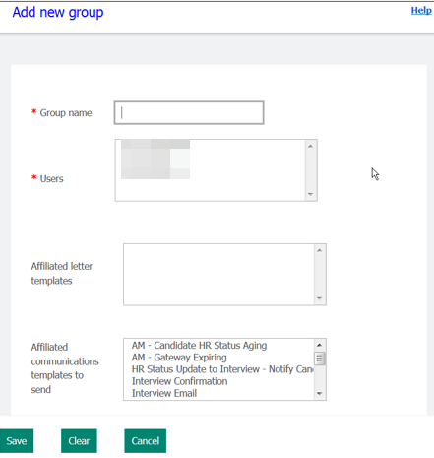
Figure 1- 7: Adding new Org group

- Users can be assigned to more than one Organizational Group.
- A blurb is pre-defined text that can be selected by the sender of a communication to a candidate. Examples would be a disclaimer, equal employment opportunity statement, etc. Blurbs are discussed later in the manual.
- Once an Org Group is created, all of your users must be assigned to at least one org group.
- Org Group cannot be inactivated but can be deleted.

Editing an Organizational Group
Org groups need updating as new templates, blurbs, and Talent Gateways are added.

To edit an Org group:

- From the Hiring Navigation icon , click Admin Admin+ Org groups.
- Click the Edit icon for the group.
- Modify the appropriate information.
- Click Save.
- Click OK to close the confirmation message.

Deleting an Organizational Group

To delete an Org group:

- From the Hiring Navigation icon , click Admin Admin+ Org groups.
- Click the Delete icon for the group you would like to delete.
- The org group details display.
- Click the Delete button.
- Click OK to close the confirmation message.

Apply your knowledge

List any Organizational Groups you need to create for your company:
-----------------------------------------------------------------------------------------------------------------
-----------------------------------------------------------------------------------------------------------------

Data Insight Tool (DIT) Roles
Users who require access to the DIT, must first be assigned to a User Role. The User Role is specific to DIT and is different than a User Type. You create roles to secure and restrict data from users when running DIT reports.

Creating User Roles is a two-step process:
- Create the role in BrassRing
- Assign the user type to the role in Workbench (managed by your Workbench Administrator)

Add a DIT Role
To add a DIT role:

- From the Hiring Navigation icon , click Reports Data Insight Tool Manage users and roles.
- From the User Role Library tab, select Create New Role. See Figure 1-8
- Role Name – Add a unique name for the role (up to 50 characters).
- Click the checkbox for Hide inactive items in User Role Workshop if you only want active items in the User Role Workshop to appear.
- Description – Optional – Add a description for the role (up to 150 characters).
- Click the checkbox for Restrict users assigned to this role from creating or editing ALL templates if you do not want the user to be able create, run, or schedule their own DIT reports. This means that the user would only have access to run public reports. Once selected, the following statement appears:
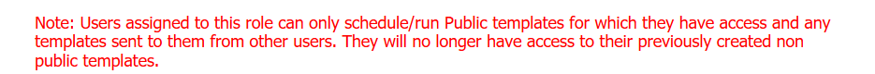
- Click Next. The User Role Workshop screen displays.
- The fields you want to restrict access for the user role are organized by categories. Click the plus sign (+) next to the category and sub-category to select the appropriate field, and click the Add to Worksheet button.
Note: You can select up to 10 items to restrict access per user role.
- The fields you added to the Worksheet will appear as filters. You can include an additional restriction by adding criteria. Click the criteria icon , and select the appropriate criteria.
- Click Next. The User Role Summary screen displays. You can click Print to print the summary. Should you not agree with the summary, you can click the Back button to return to the User Role Workshop to edit the role.
- Click Save.

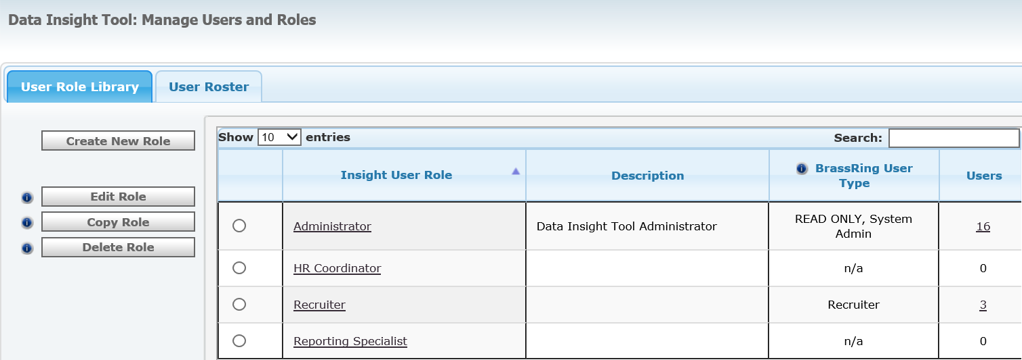
Figure 1- 8: User Role Library

Manage the User Roster
The user roster tab provides you with the names of users (active and inactive), their respective BrassRing user type and assigned User Role. See Figure 1-9. The User Roster tab allows you to:
- Add Users
- Change Role
- Inactivate Users
- Reactivate Users

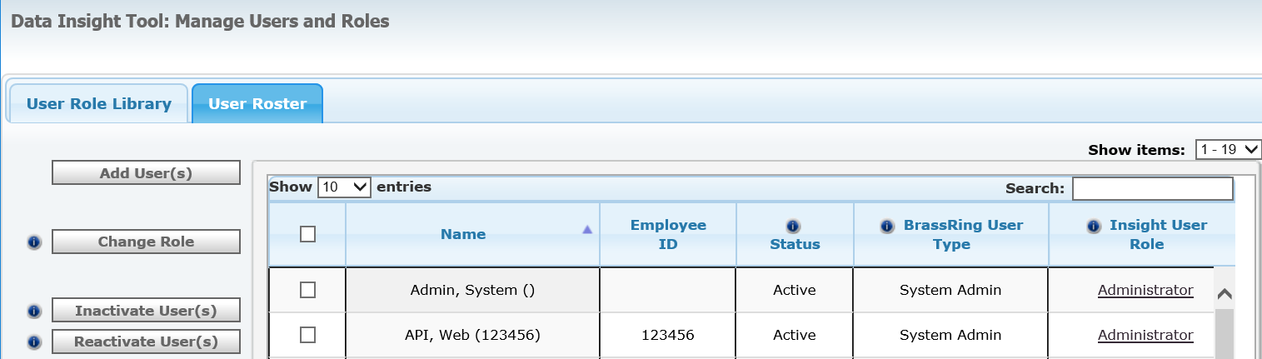
Figure 1- 9: User Role Library

To Add a User:
- From the Hiring Navigation icon , click Reports Data Insight Tool
Manage users and roles.
- Click the User Roster tab.
- Click Add Users.
- Select the user from the list of BrassRing Users, and add them to the Selected Users section by clicking .
Note: You can select up to 25 users to be added to DIT.
- Click Next. The Assign Role window appears.
- Select the appropriate user role form, and click Save.

To Change the Role of a User:
- From the Hiring Navigation icon , click Reports Data Insight Tool
Manage users and roles.
- Click the User Roster tab.
- Select the user whose role needs to be changed.
- Click Change Role.
- Select the Role to assign to the user, and click Save.

To Inactivate or Reactivate a User:
- From the Hiring Navigation icon , click Reports Data Insight Tool
Manage users and roles.
- Click the User Roster tab.
- Select the user to inactivate or reactivate.
- Click Inactivate or Reactivate.
- Confirm Inactivation or Reactivation by clicking the Inactivate or Reactivate button.
- The Status of the user has now changed to either Inactivate or Active, based on the action you took.

Edit a DIT Role
To edit a DIT role:

- From the Hiring Navigation icon , click Reports Data Insight Tool Manage users and roles.
- Select the DIT role that you want to edit from the list of roles on the User Role Library.
- Click Edit Role.
- You can edit fields on the User Role Identity window and in the User Role Workshop.
- Once you completed the edits, click Next and Save.

Copy a DIT Role
To copy a DIT role:

- From the Hiring Navigation icon , click Reports Data Insight Tool
Manage users and roles.
- Select the DIT role that you want to copy from the list of roles on the User Role Library.
- Add a unique Role Name.
- Add a Description (optional).
- Click Save.
- The user role was added to the User Role Library and can now be edited by selecting the role and clicking Edit.

Delete a DIT Role
To delete a DIT role:

- From the Hiring Navigation icon , click Reports Data Insight Tool
Manage users and roles.
- Select the DIT role that you want to delete from the list of roles on the User Role Library.
Note: You cannot delete a role that includes active users.
- Click Delete Role. The Delete the following User Role? Window appears.
- Click Delete. The role was removed from the User Role Library.

Chapter Summary
- BrassRing provides five standard levels of user access called User types.
- Users are assigned to a User type that delineates their access privileges.
- Persona Groups provide the users with the view of the data that works best for them on the home page.
- BrassRing uses Organizational (Org) groups to determine which Req templates, and as which letter and email communication templates a user can access. Org groups can also be used to limit access to your company’s Talent Gateways and Gateway Questionnaires.
- As a Super User, you are able to transfer the folder ownership of a user’s Working Folder.
- You can export lists of Active or Inactive users to MS Excel.

Check Your Skills

Answer these True or False questions:

- BrassRing groups users into sections called teams.
- The Hiring Manager user type has access to folders but not the entire system.
- Once a user is inactivated, he/she is deleted permanently from BrassRing.

Answer the following short answer questions:

- The user types that are listed are part of the five standard BrassRing User types except?
- HR Coordinator
- Quick Start User
- Hiring Manager
- HR Staff
- Recruiter
- System Administrator
- _________ allows you to define the Communication Templates, Req Templates and document templates you can see and use in BrassRing?
- User Groups
- User Types
- Org Groups
- None of the Above
Perform these hands-on exercises in BrassRing:

- Add a user. Begin the username with the word “training.”
- Add an Organizational group.
- Edit the user that you created and change the Organizational group to the one you created.
- Deactivate the user that you created in #6.
- Delete the Org group that you created in #7.

Chapter 2: Administering Codes

Chapter Overview
You organization has set-up standards for working with codes. They are assigned to candidates during their resume or CV submission. Examples of codes are: source code, job req ID (job req code), and job code.

Careful administration of codes can help sustain a higher level of data integrity and enable you to better interpret results generated from Standard reports.

In this chapter, we focus on the administration of codes.

Chapter Objectives

At the end of this chapter you will be able to:

- Define the difference between code types and specific codes.
- Add codes.
- Inactivate codes.

Overview of Code Types
Once a code is assigned to a candidate, it becomes a unique identifier that allows BrassRing users to recognize and identify specific information pertaining to that candidate’s resume or CV submission.

All codes belong to one of several overall categories, also known as code types.

Code Types
BrassRing has three default code types in the system: Job code, Job Req ID (job code), and Source code. Your organization might have additional code types by which codes are grouped, such as Division code, Business Unit code, or Agency code (Figure 2-1).

For example, a candidate’s job apply URL was tagged with a source code. When the candidate is added to BrassRing the user will be able to see the source code, job req ID (job req code), and job code associated with that candidate’s submission.

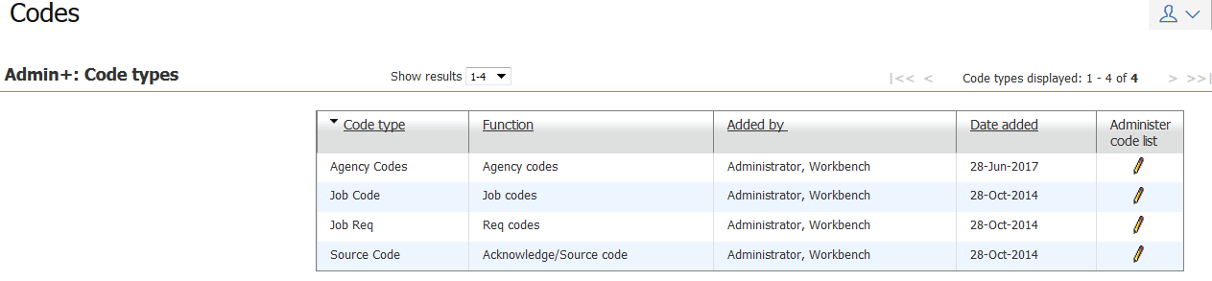
Figure 2- 1: A list of Code Types

Adding Code Types
During the implementation of BrassRing, your company decided on the code types that best meet the needs of its users and management. Your certified Workbench Administrator will be responsible for adding and changing code types after implementation is complete and your company is live on BrassRing.

Apply Your Knowledge
Does your organization use any code types in addition to the three default code types of Job code, Req code, and Source code? If so, make note of them here.

------------------------------------------------------------------------------------------------------------------------------

Adding Codes
Adding specific codes to a code type list is performed within BrassRing. Keep in mind that each code type has its own set of function. For example, job codes supply default job data for requisitions, such as the job description. Source codes identify the source that generated the resume or CV for your company, such as a job board or a newspaper.

Adding Job Codes
Job codes offer additional function beyond identifying which types of jobs candidates applied for. You can associate default job req information with your job codes so that when they are selected in the req creation process, the default job information auto-populates on the req form. This can be useful in two ways:

First, by having information automatically populate on the req form. It serves as a time saver for the creator of the req. Second, by having Super Users enter the significant pieces of data such as cost center, department number, or pertinent HR data, the need for regular users to guess this information or inaccurately enter it, is eliminated.

To add a job code:

- From the Hiring Navigation icon , select Admin Admin+ Codes.
The list of existing code types appears.
- Click the Administer code list icon for Job Code.
- Click Add new code.
- Name the code in the Code field. See Figure 2-2.
- Add a Description in the Description field. This should be the job title corresponding to the job code. It will always accompany the job code in BrassRing.
- Click Save.
- If your organization is going to associate default req data with job codes, select a req form to associate with the job code. See Figure 2-3.
- Click Continue.
- Complete those fields on the req form that should populate when the job code is selected by individuals creating reqs.
Note: None of the fields on the Req form have a red asterisk. You are not adding a real req; you are determining which fields should pre-populate on the req form whenever a job code is selected during the req creation process. If your organization uses additional languages, you can click the language toggle at the top of the screen to add defaults for that language.
- Click Save and continue.
- If you selected more than one req form in Step 7, you will be prompted to go through the next req form after completing one.
- The Posting Screen will appear with the Talent Gateway(s) your company is using. Set the default settings for the Talent Gateway(s), select default questions and score those questions (if available/appropriate).
- Click Continue.
- Type a default message to the first approver and Req team.
- Click Finish.

- It is best practice to use the same naming convention when adding job codes. This will help retain data integrity.

- If your company is not using req default data with job codes, you will only need to enter the Job code, job title, and the appropriate job description. The job description that you enter will still auto-populate on the req form.

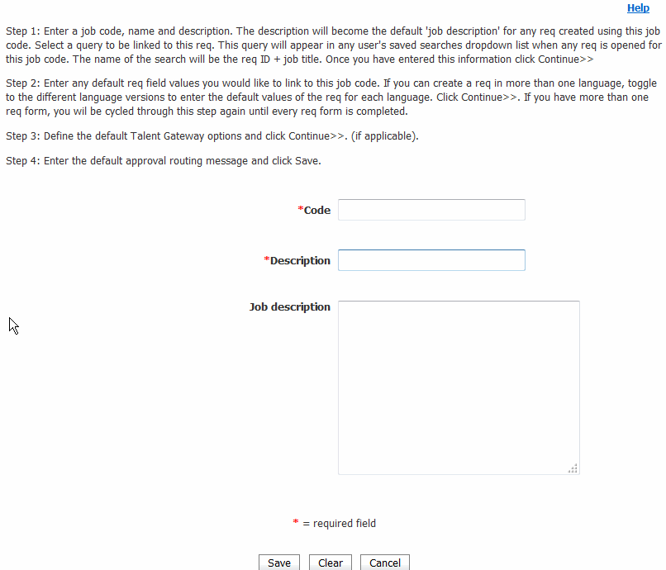
Figure 2- 2: Adding a job code

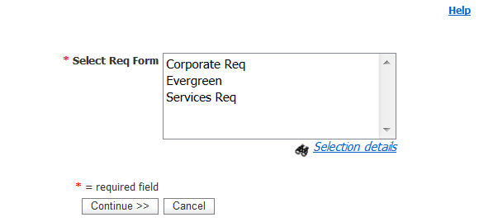
Figure 2- 3: Selecting req forms

Editing Job Codes

To edit a job code:

- From the Hiring Navigation icon , select Admin Admin+ Codes.
- In the Administer code list, find the code type to edit and click the edit icon.
- You might notice a checkbox appearing in step 2 (Replace the req template default job description with the above job code job description), if your company uses default job code data. If left unchecked, the contents of the job description field while editing job codes will not replace the contents of the req template default job description field. If checked, the contents of the req template default job description field are replaced with the job description from the Edit code page. This checkbox is visible only when editing job codes, not when adding them.
- On the Edit code page, make your changes.
- Click Save.
- Click OK.

Adding Source Codes

Source codes identify the source that generated the resume or CV for your company, such as a job board or newspaper.

To add a source code:

- From the Hiring Navigation icon , click Admin Admin+ Codes.
- Click the Administer code list icon for Source code.
- Click Add new code.
- Name the code in the Code field. See Figure 2-4.
- Add a Description. This should be the actual name of the source. It will always accompany the source code that you entered in Step 4 within BrassRing.
- Click Save.
Note: The setting for acknowledgement is no longer being used.

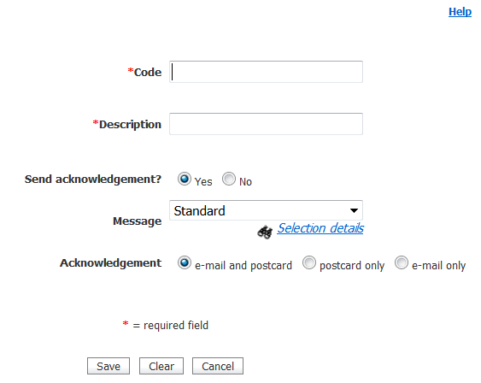
Figure 2- 4: Adding a source code

- It is best practice to consistently use your company’s naming conventions for codes when adding new ones.

Adding Req Codes

Req codes are automatically created in BrassRing whenever a req is added. BrassRing will automatically populate the req code table with either your company’s specific Req ID (such as the req code from your HRIS system) or the BrassRing -generated req code (ex. 1234BR).

Best practice is to NOT add, edit, or deactivate Req Codes.

Deactivating Codes

You can deactivate a code at any time. But before doing so, confirm that the code is no longer going to be used by any of your users. Also, when a code is deactivated, data integrity might be compromised. For example, there might be reqs currently open that have an association with the job code you have chosen to deactivate.

To deactivate a code:

- From the Hiring Navigation icon , click Admin Admin+ Codes.
- Click the Administer code list icon for the appropriate code type.
- Click the Deactivate icon for the code.
- Click OK.

Reactivating Codes

To reactivate a code:

- From the Hiring Navigation icon , click Admin Admin+ Codes.
- Click the Administer code list icon for the appropriate code type.
- Click the Inactive link.
- Click the Activate icon for the code. The code returns to the list of active codes.
- Click OK.

Exporting Code Lists
BrassRing enables you to create a comma-separated list (CSV) of codes that you can then open in Microsoft Excel. Use this function to compare BrassRing data to a list of data from another source.

To export a code list to Excel

- From the Hiring Navigation icon , select Admin Admin+ Codes.
- Click Export user list to MS Excel in the Actions list
- In the File download screen, click Open
- From the Microsoft Office Excel screen, select Yes.

Apply Your Knowledge

When might it be helpful to export a list of codes?
------------------------------------------------------------------------------------------------------------------------------------------------------------------------------------------------------------------------

Chapter Summary

- BrassRing contains three default code types: job code, source code, and req code.
- You can add specific codes to an existing list of code types.
- Codes can be deactivated and also reactivated.
- You can export a list of codes into MS Excel.

Check Your Skills

Answer these True or False questions:

- Code types are the same as codes.
- IBM can only establish code types at implementation.

Answer the following short answer questions:

- Name the three default code types. Which code type is your company using?

Perform these hands-on exercises in BrassRing:

- Add one code to the Req code type. Use the word “test” in the description.

- Inactivate the code you added in #4.

Chapter 3: Managing Lists

Chapter Overview
In addition to users and codes, System Administrators can also manage certain options that display for form fields and Talent Gateway questions.

An example of options is: Boston or New York or London for a question of, “What is your preferred work location?”

In this chapter we concentrate on managing lists by editing, adding, and inactivating form field options.

Chapter Objectives

At the end of this chapter you will be able to:

- Describe the different types of form fields used in BrassRing.
- Add, edit, and inactivate list options.

Overview of Lists

During implementation, your company provided IBM with the specifications for all the forms in your BrassRing site. This included the req form, candidate forms, candidate/req subsidiary forms and as Talent Gateway questions. IBM then created and configured the forms and the questions appearing on them to meet these specifications.

On an ongoing basis, you and other System Administrators at your company have the ability to manage the options that display for certain form field types on these forms. You can edit, add, and inactivate these form field options in Lists.

Keep in mind that the form fields continue to be managed by your certified Workbench Administrator; as a BrassRing System Administrator, you have control over the options for those form fields.

Example: A field on the req form asks, “Does this position require travel?” The possible answers are “Yes,” “No,” and “N/A.” Your certified Workbench Admininstrator would make any changes to the question itself; you would make any changes to the options available for that question.

Elements of Lists
Here are some important facts to keep in mind when managing lists:

- You can edit, add, and inactivate form field options for single-select, multi-select, radio button, checkbox, and search-select form fields.
- A new value entered in the description field for a list option automatically populates the code field (in the background). The value that appears in the drop-down menu is the description field.
- Only the description field for an option might be updated, not the code value.
- When changing the description field, be aware that this will change all instances of the previous description to the new description. This can lead to data integrity issues.
- Only single-select and multi-select option lists can be administered within BrassRing. See Table 3-1.

BrassRing Field Types
Table 3-1 lists the field types that you can manage in Lists with descriptions of the fields and an example for each one.

Field Type | Description | Example
Single-select list | A field associated with a drop-down list. Only one option from the list might be selected at a time.
Multi-select list | A field that allows the user to select multiple options simultaneously. The Ctrl key is used to select multiple options. | 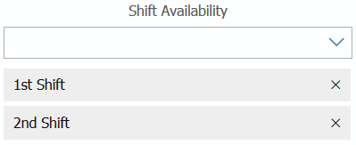
Autocomplete | Appears automatically when more than 200 options are available for a user to choose from in a list. Users can type in a portion of the word or phrase they are looking for and the field displays the value that is similar or exactly as the portion of the word or phrase. The drop-down error displays the first 100 values.
Radio button | A field in which a relatively small number of options is displayed, allowing the user to choose only one of the options.  Examples: yes/no, male/female, etc. | 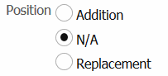
Checkbox | Similar to a radio button, except the user can select more than one option. | 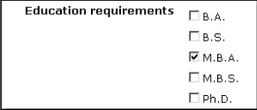

Managing Lists
We discuss how to add, edit, and inactivate list options.

Adding an Option
Form fields are established during your company’s implementation of BrassRing, but moving forward, you can add individual list options to an existing form field or list.

To add an option to a list:

- From the Hiring Navigation icon , select Admin Admin+ Lists.
The list of form fields appears, See Figure 3-1.
- Click the Administer this list icon to update the list. A list of the options that are associated with the field appears.
- Click Add new option.
- Name a unique option in the Code field. Special characters (for example: ;”*!@~#+?\,’%[{}]) are not accepted.
- Add a Description. 255 characters are accepted. Special characters (such as “&” in place of “and”) are accepted. (Note the caution message on this page).
- If available, indicate the Sort order. By default, options are sorted in numerical order, then alphabetical order. If you are entering a numeric value, the order in which options are to appear is designated. Numbers less than ten should begin with a 0, for example, 03, 04, etc.
- Click Save.

- Best practice is to number options in a list with intervals, such as 05, 10, 15 to allow for easy changes later. For example, you might want to insert new options between existing options. By numbering options with intervals, it frees up space to enter future options between the existing ones.

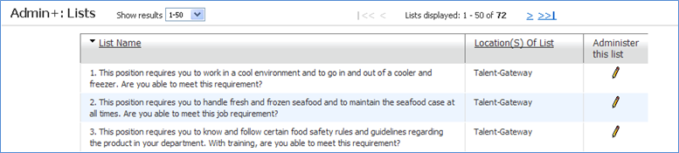
Figure 3- 1: List of all editable form fields

Editing Options

To edit an option:

- From the Hiring Navigation icon , select Admin Admin+ Lists.
The list of form fields appears.
- Click the Administer this list icon to update the list.
- Click the Edit description icon for the option to edit.
- Make the edit, as necessary.
- Click Save.

- When changing the description field, be aware that this will change all instances of the previous description to the new description. This can lead to data integrity issues.

Inactivating Options

To inactivate an option:

- From the Hiring Navigation icon , select Admin Admin+ Lists.
- Click the Administer this list icon to update the list.
- Click the deactivate icon for the option to inactivate.
- Click OK to inactivate the option. See Figure 3-2.

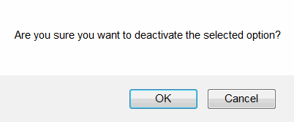
Figure 3- 2: Deactivating an option

Reactivating Options

To reactivate an option:

- From the Hiring Navigation icon , select Admin Admin+ Lists.
- Click the Administer this list icon for the list.
- To the right of the Actions List click the Inactive hyperlink.
- Click the reactivate icon for the option to reactivate.
- Click OK.

Export Option List to Microsoft Excel
BrassRing enables you to create a list by using comma-separated values (CSV) format for options that you can then open and manipulate in Microsoft Excel. Use this function to compare BrassRing data to a list of data from another source.

To export an option list to MS Excel

- From the Hiring Navigation icon , select Admin Admin+ Lists.
- Click Export user list to MS Excel in the Actions list.
- In the File download screen, click Open.
- From the Microsoft Office Excel screen select Yes.

Chapter Summary

- You can edit, add, and inactivate form field options for single-select, multi-select, radio button, checkboxes, and search-select form fields.
- Option values are automatically sorted numerically then alphabetically.
- BrassRing allows you to create a comma-separated list by exporting to Microsoft Excel.

Check Your Skills

Answer these True or False questions:

- You can add options for all form fields on candidate forms.
- You can only add options to lists during implementation of BrassRing.
- Individual options cannot be added to existing lists.

Perform these hands-on exercises in BrassRing:

- Deactivate an option. Write down the name of the option.

- Reactivate the option that you inactivated above.

Chapter 4: Using Miscellaneous Administrative Features

Chapter Overview
BrassRing makes it easy to communicate with your active system users when you have information to announce, such as scheduled downtime or changes to your process. BrassRing also allows you to monitor file attachment space and perform periodic audits on notes.

This chapter reviews these administrative features of BrassRing.

Chapter Objectives

At the end of this chapter you will be able to:

- Use the Mass email feature.
- Stack duplicate resumes or CVs.
- Define and run a Notes audit.
- Define and run an Attachment audit.
- Define and run a Log in Failure audit.

Mass emails

You can use Mass email to communicate en masse with all of your active BrassRing users electronically.

Mass email is convenient to use when you need to make a general announcement to your users, such as notification regarding planned system downtime, introducing new team members, or announcing upcoming system or process changes.

Sending Mass emails

To send an email to all active BrassRing users:

- From the Hiring Navigation icon , select Admin Admin+ Mass email to users. See Figure 4-3.
- In the Subject line field, type a subject.
- In the Message body field, type the text of the message.
- Click Send.
- Click OK to close the confirmation message.

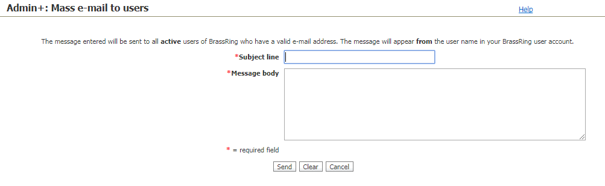
Figure 4- 1: Sending Mass email to users

Stacking Duplicate Resumes or CVs
As you learned in New User Fundamentals, each resume or CV loaded into BrassRing goes through an automatic check to determine whether the candidate already has a record in the system. By default, BrassRing always compares the incoming candidate’s first name with candidates of the same first name currently in your database. It then also compares the phone numbers and the email addresses of those resumes or CVs currently residing in BrassRing. If there is a match of this information, the older files becomes the duplicates and the new file is stacked on top.

This automatic duplicate check is highly accurate. However, there might be an occasion when you come across two resumes or CVs for the same candidate that were not stacked. System Administrators typically have the ability within BrassRing to manually stack these resumes.

To stack a duplicate resume or CV:

- From a list of candidates, select the two candidate talent records that are duplicates.
- Click Stack duplicates from the Actions list. A new window opens with the two overviews for the selected candidates. Refer to Figure 4-2.
- Decide which record should be the current active record. (You might need to view both Talent Records in which case you will need to start over.)
- Click Record 1 : 2 or Record 2 : 2 to review the two records you are considering to stack.
- Click Keep this candidate to indicate the overview screen that you want to retain. This merges all of the other two Talent Record’s information, except for the Overview screen you opted not to keep.
- Click OK to confirm that you want to proceed with this action.

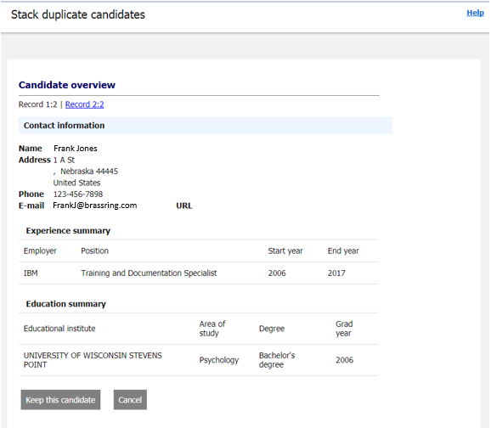
Figure 4- 2: Stacking duplicate resumes or CVs

Notes Audit
The Notes audit allows you to review all notes that have been added to candidates. This includes both public and personal notes (referred to as My notes).

To run a notes audit:

- From the Hiring Navigation icon , click Admin Admin+ Notes audit.
- Choose filter criteria for your audit. See Figure 4-3.
- Click Run.

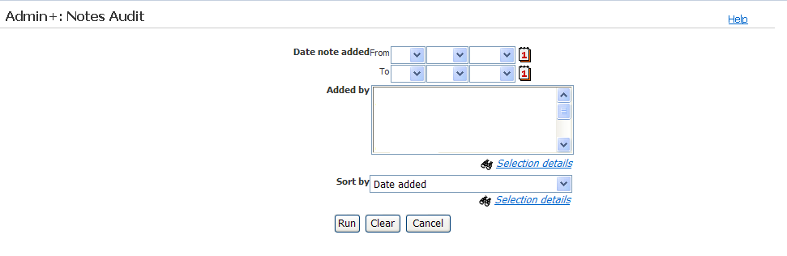
Figure 4- 3: Notes audit

Attachments Audit
You can use Attachments audit to monitor the attachments that your users or candidates (by using your Talent Gateways) have uploaded to BrassRing.

To run an attachments audit:

- From the Hiring Navigation icon , select Admin Admin+ Attachments audit.
- Choose the filter criteria for your audit.
- Click Run. The list of attachments appears.

Login Failure Audit

The Login failure audit allows a user with proper privileges to identify all failed BrassRing -login attempts by username attempted, whether that name was valid, date or time of the attempt, and IP address. This audit does not apply to single-sign-on or Talent Suite clients.

To run a Login Failure audit:

- From the Hiring Navigation icon , select Admin Admin+ Login failure audit.
- Choose the filter criteria for your audit.
- Click Run. The list of login failures appears.

Chapter Summary

- Mass emails provide another means to communicate with all active BrassRing users.
- A Notes audit allows you to examine notes that have been attached to candidates.
- An Attachments audit allows you to review and manage attachments.
- A Login failure audit identifies failed attempts at BrassRing access.

Check Your Skills

Answer these True or False questions:

- Mass emails offer a way to communicate with specific BrassRing users.
- Notes audit allows the System Administrator in BrassRing to review only public notes.
- Any user of BrassRing can run the Attachment audit.

Answer the following short answer questions:

- List three things that display in a Notes audit.

Chapter 5: Setting up Communication Templates

Chapter Overview
The BrassRing Communication module streamlines your organization’s talent relationship management efforts by allowing your users to send communications to candidates from within BrassRing.

By incorporating standardized letters, emails, and read-only documents within BrassRing, your users can consistently and efficiently keep in touch with candidates by using templates created and maintained by System Administrators.

In this chapter, we explore your options for using BrassRing to communicate with your candidates.

Chapter Objectives

At the end of this chapter you will be able to:

- Create a standard Communication (email) template.
- Create a standard Letter template.
- Create a standard Document template.
- Create a standard Document template packet.
- Create a Blurb
- Understand conditional Blurbs
- Create a system email template.

Working with Communication Templates
Communication templates are created by System Administrators and used by your recruiters to contact one or more candidates electronically from within BrassRing. The templates are typically created for messages that will be sent repeatedly to candidates, advancing your company’s relationships with them. For example, Communication (email) templates can be used to thank candidates for interviewing to gather application and EEO data, and to inform candidates of an upcoming recruiting event.

Elements of Communication Templates

The following are points to keep in mind when working with Communication templates:

- Links to a BrassRing form and the job details posted on a Talent Gateway can be included in email templates, as can candidate and req fields.
- “Blurbs” are strings of text that is commonly used by users to insert to a communication template before sending the email. Communication history pertaining to messages that are sent to candidates is tracked in the Talent Record from the Action Log tab.
- BrassRing includes a text editor with HTML and plain text tabs, an expandable message area, standard options for formatting text (for example, bold, italic, underline, colors, justify, and number text) and spell check.

Adding a Communication Template

To add a Communication template:

- From the Hiring Navigation icon , click Admin Communications Add communication template. See Figure 5-1.
- For Template name, enter the name of the template you are adding.
- For Email subject line, type the standard subject line for the email template. Hovering over the field displays standard tokens that can be used in the subject line of your communication template.
  - To add a merge field to the subject, select the Merge Field in the Merge fields option, select Email Subject, and select Add.
- Enter what the default Return email address should be. If you opt to leave this field blank, it is later populated automatically with the sender's email address.
- If needed, enter your organization domain name in the From alias address field. This replaces the email address of the senders and ensures that the communication is sent with a configured domain address.
- Insert the Message body for your template. The text editor allows for customization. Use spell check to correct any possible errors in the message text.
- Select the appropriate Top/Bottom and Left/Right margin widths from the options.
- Use Insert blurb to select and Add any of your choices.
- Upload any attachments which should be included with your email template. File size cannot be larger than 4 MB.
To upload more than one attachment:
    - Go to the Upload attachments section of the page and select Multiple Attachments.
    - On the Select Files to Upload window, select Browse and go to the directory that contains the files you want to attach.
    - Right-click to open the Select menu, select Send to > Compressed (zipped) folder. The compressed file is saved in the same directory, where you can rename it.
    - Select Open. The file path name is added to the browse field in the Select Files to Upload window.
    - Select Upload. The compressed file is added to the attachments grid.
- From Merge fields, Select variable group is used to select from general categories-specific suboptions. Add those you need for your email. This allows data that is captured in BrassRing to pre-populate the text of your message.
- Add numeric field with formatting must we configured first before you can select a format. It provides multi-level list capability (similar to that provided in word) for paragraphs. Multi-level list examples: 1, 1.1, 1.1.1, and 1.1.1.1; 1, 1.a, 1.a.i, and 1.a.i.1
- You might opt to Add a Link to jobs on Gateway to provide a link to the posted job details for the candidates.
- If you want and if applicable, you might select a form by using Include forms to complete. This is similar to attaching a form to your message for the candidate to complete. Once you have made a selection, click the Add link to add the form as an attachment to the communication template. The Add URL allows you to add a link to the form to be completed and automatically stored in BrassRing.
- If you require a form to be included in the communication to view only, you might select Include forms to view. This allows the recipient to view a form, but not edit the form. Click the Add link to add the form as an attachment. The Add URL allows you to add a link to the form in the communication.
- The Add Talent Record eLinks option allows you to include a link to the Talent Record. The [#elink:Talent Record#] token is added to the message body. You can specify whether you want to include notes, HR status, attachments, and Doc sub forms.
When sending communication with [#elink:Talent Record#] token:
    - Send to: Other recipients is selected by default; Send to: Candidates option is disabled.
    - Each ‘To: recipient’ receives only one email not one per candidate.
- Select the Org groups authorized to send this email template.
- Select the Org groups authorized to administer this email template.
- Confirm that your email template is Active, and whether it will be used with the Agency Manager.
- Select the Sending method.
    - Manual Send – The template is available in the list of email templates when you click Send communication.
    - Auto Send - The template is available only for use with Automation Manager and Rules Automation Manager and does not appear in the list of email templates in the Send communication workflow.
    - Auto and Manual Send - The template can be used from the Send Communication workflow and by Automation and Rule Automation Manager.
- Save copy of correspondence: Select Yes to save a read-only copy of correspondence created from this email template on each candidate’s Talent Record. This option is only available if the user has the permission to save a copy.
- Click Save.
- Click OK to finish.

- The address that is entered in the Return email address field defines a generic email reply-to address that displays in the “From” line of the message at the time of sending. If the field is left blank, it populates with the BrassRing user’s email address at the time of sending the communication.

- You can compose the email message in a word-processing application, then copy and paste the text into an email template. However, if you want hard line breaks, you must put them in after you paste the text. Copying and pasting from Word can often carry over hidden HTML. If you choose this method to create your communication template, it is necessary to perform a test before starting to use the template for your active candidates.

- Email templates to be able for selection in the Interview Manager must include at least one Interview Manager standard fields token (i.e. [#InterviewStandard:InterviewDatetime#]).

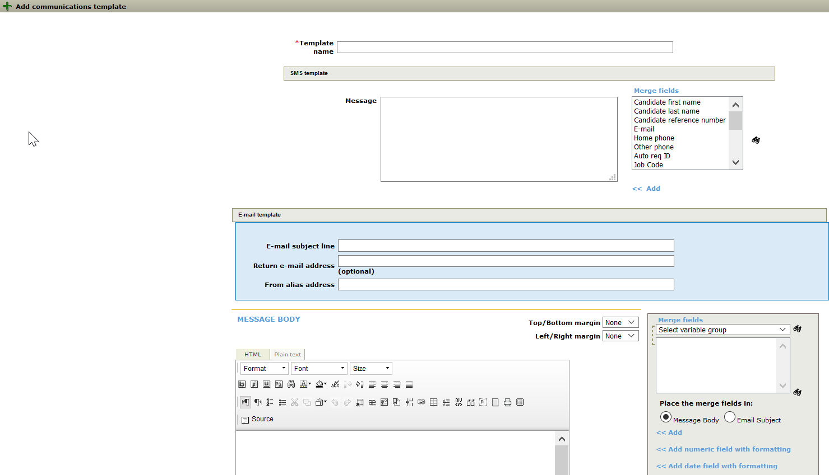
Figure 5- 1: Adding an email template

Editing a Communication Template

To edit an email template:

- From the Hiring Navigation icon , click Admin Communications Communication templates. See Figure 5-2.
- Click the Edit icon for the email template you want to edit. Make the edits.
- Click Save.

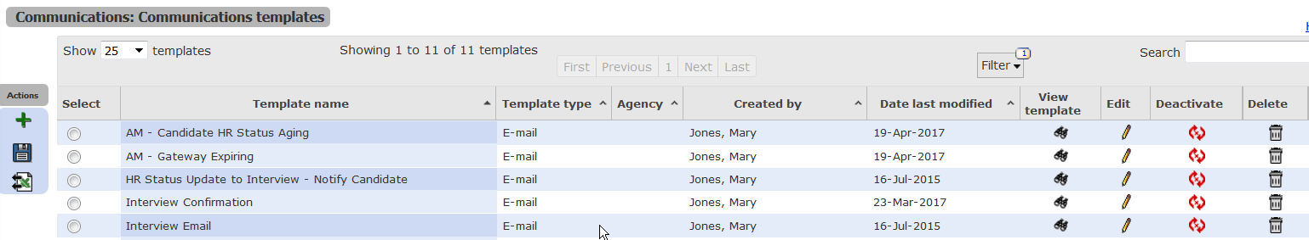
Figure 5- 2: Editing Communication templates

Working with Letter Templates
Letter templates are standardized letters that are initially created in BrassRing by System Administrators. They are easily accessed by recruiters, who are able to print the letters while incorporating the mail merge functions of Microsoft Word™ with data entered and stored in your BrassRing site. For example, the candidate’s name and contact information from their resume or CV.

Other examples of data that might be merged onto a letter are job req data (such as the job title the candidate has applied to, or the salary being offered) which is typically captured on an Offer form.

Elements of Letter Templates
- A Letter template merges a saved document in Microsoft Word™ with data fields on Reqs and candidate forms and as candidate data itself.
- Users who generate letters in BrassRing must have Microsoft Word 97™ or a more recent version.
- Letters can be generated on demand by users and by a Communications manager who processes letters on a regularly scheduled, batch process basis.

Adding a Letter Template

To add a Letter template:

- From the Hiring Navigation icon , click Admin Communications Add Letter template.
- Letter name: type the name of the Letter template.
- From Merge fields, click List to select the fields you want included in the Letter template. See Figure 6-3.
- Select either Data required for all merge fields (the letter will not be able to be generated if the data on the selected is missing) or Data optional for merge fields (the letter can be generated regardless of missing merge field data because the recruiter will be permitted to add any missing information).
- Click Launch MS Word, and then minimize the window.
- Click Preview merge format. Copy and paste the entire string of characters from Document reference to the Word document window, including the # signs (for example #Contact-Info: First Name#). See Figures 5-3 and 5-4.
- Save your Word document, then Use Upload letter template and Browse to add it to BrassRing.
- If applicable, select Org groups authorized to send this letter from the groups listed. Hold the CTRL key to select more than one group.
- Select Users authorized to administer this letter from the users listed. This gives those you opt to select privileges to process “batch letters”.
- Select Yes or No for Activate batch letter.
- Require letter creation from within req folder: Yes means that the user must be in the req folder to create the letter for the candidates.
- For the Save copy of correspondence, select whether you would like to save a copy of the correspondence on the candidate’s Talent Record.
- Click Save.
- Click OK to finish.

- Fields with an asterisk (*) are required.

- Be sure that the font within the document is consistent for all text, namely the fields copied and pasted into your Word document.

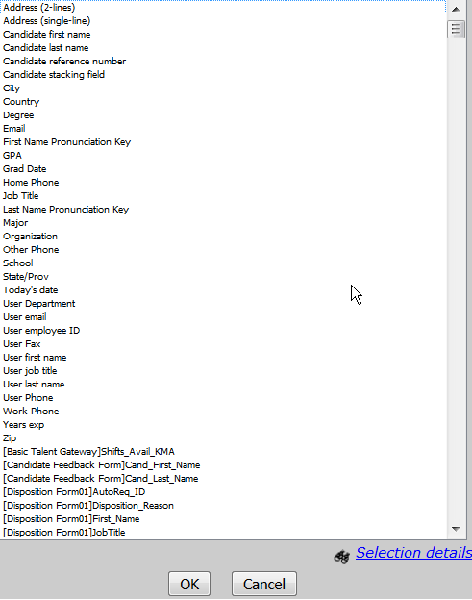
Figure 5- 3: Selecting Merge fields

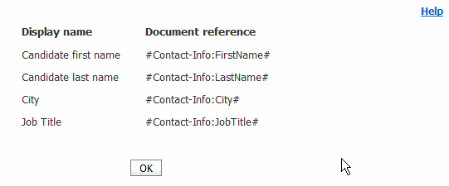
Figure 5- 4: Copying the Document references that are pasted into MS Word. Note that the “#” signs are being copied and by the System Administrator creating the template.

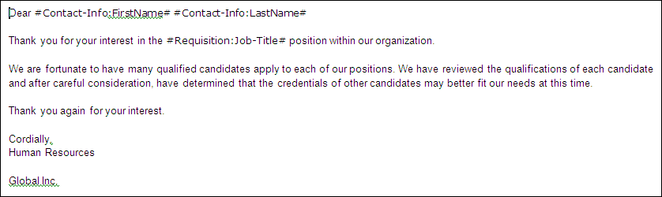
Figure 5- 5: Creating Word document with the pasted-in merge fields/document references

Deactivating Communications
To deactivate a Letter or email template:

Click the Deactivate icon for the template you want to deactivate. See Figure 5-6 for the Deactivate icon.

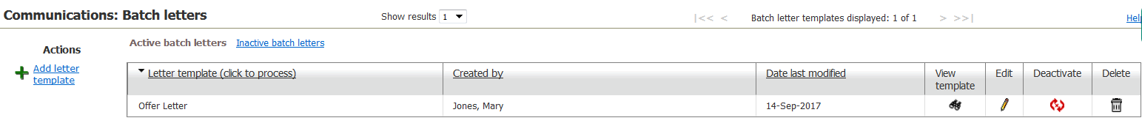
Figure 5- 6: Deactivating a Letter Template

Document Templates
Document Templates allow users to create a ‘read only’ pdf version of a document. After the document is created, it is stored in the candidate’s Talent Record. The document can then be attached to an email communication and sent to the candidate or posted to the candidate Zone.

Adding Document Templates
When adding a document template, you can select to either use the HTML editor or to use a Word or other word processor that must create .doc or .docx file types.

To add a document template by using the HTML editor:

- From the Hiring Navigation icon , click Admin Communications Add document template.
- Select HTML editor and click Go.

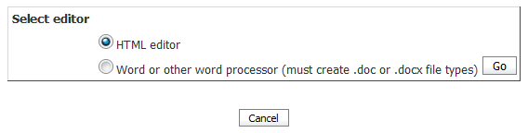
Figure 5- 7: Select HTML Editor

- In the Template name field, enter an informative name (50 characters maximum) for this document template.
- Optionally enter a name in the Pre-configured document name field to populate the Document name field for BrassRing users creating documents from the template. This field can help standardize document names, and as save users a step. In this field, you can use up to 255 characters and manually enter the following merge tokens, along with any free-form text, in any order or combination:
- [#SystemInfo:CurrentTime#] – System Info token represents the server time (Eastern Time) when the document is generated. It is presented in the format hh:mm:ss (24-hour clock). The token is not included in the merge field list.
- [#Document:TemplateName#] – represents the contents of the document template’s Template name field. The token is not included in the merge field list.
- [#Contact-info:FirstName#] – Candidate field token for candidate’s first name
- [#Contact-info:LastName#] – Candidate field token for candidate’s last name
- [#RequisitionStd:AutoReqId#] - Req ID standard field token
- [#SystemInfo:TodaysDate#] – System Information token for today’s date. The date is calculated based on the date picked up from the server (Eastern Time). (When the two tokens [#SystemInfo:TodaysDate#] and [#SystemInfo:CurrentTime#] are included in the “Pre-configured document name” field, the date or time stamp in the generated document name in the File column is the same as the date or time stamp in the Date added column of the grid on the Attachments tab of the Talent Record.)
Note: You can use special characters, but IBM recommends not using characters such as angle brackets (< and >) that might be interpreted as html by the html parser. An example of a name you might enter follows:
[#Contact-info:LastName#][#Contact-info:FirstName#]_ [#RequisitionStd:AutoReqID#]_[#SystemInfo:TodaysDate#]_ [#SystemInfo:CurrentTime#]_[#Document:TemplateName#]
which might resolve to:
JonesGenevieve_10567BR_19-Jul-2015_13:47:42_ProfessionalServicesOfferLetter
- Create the document content.
- Select the appropriate Top/Bottom and Left/Right margin widths from the options.
- Use spell check to correct any possible errors in the text content.
- Select Merge fields from the list and click Add to insert them into the body of the document. Once they are inserted, they are referred to as merge tokens.
If enabled, you can also add "additional user" user profile merge tokens. Click the Add additional user information link to add the first and last names of an "additional user" - a system user who is not necessarily the current, logged-in user taking action in the Communications module.
Insert "hard" page breaks where needed by using the Page break token from the Document formatting merge category. The inserted [#Document formatting: Page break#] token takes precedence over the automatic page breaks applied by the Document Generator when processing documents.
Click View text to see how the merge tokens look when rendered as text in the document.
- Insert one or more blurbs in the body of the document template.
- Add numeric field with formatting must be configured first before you can select a format. It provides multi-level list capability (similar to that provided in word) for paragraphs. Multi-level list examples: 1, 1.1, 1.1.1, and 1.1.1.1; 1, 1.a, 1.a.i, and 1.a.i.1
- Optionally, select paper size from the drop-down Paper size for printed document list: Letter or A4.
- Select the option Data optional for merge fields to determine whether the document can be generated with or without the merge field data. When this checkbox is selected and the document generates, a red flag does not display should data be missing from a merge field.
- Select Require candidate form approval for merge fields for the system to check and validate if any candidate forms are in a pending state. If any candidate forms still require approval, an error message displays.
- Use Insert blurb to select and Add any of your choices.
- Select the Org groups authorized to create this document, and as the Org groups authorized to administer this template.
- Select the user types authorized to edit content during document creation.
- Select one of the attachment categories. Selecting a sensitive category guarantees that attachments generated from the template are handled as sensitive attachments, and are subject to the “sensitive attachments” user type privileges.
- Check Allow posting to Candidate Zone to Identify if this document to be posted on the Candidate Zone. Then, select the Document subsidiary form to use when posted.
- Ensure that Active document template is set to Yes (the default) if you want this template to be active at this time.
- Click Save. A message confirms that the document template was saved successfully.

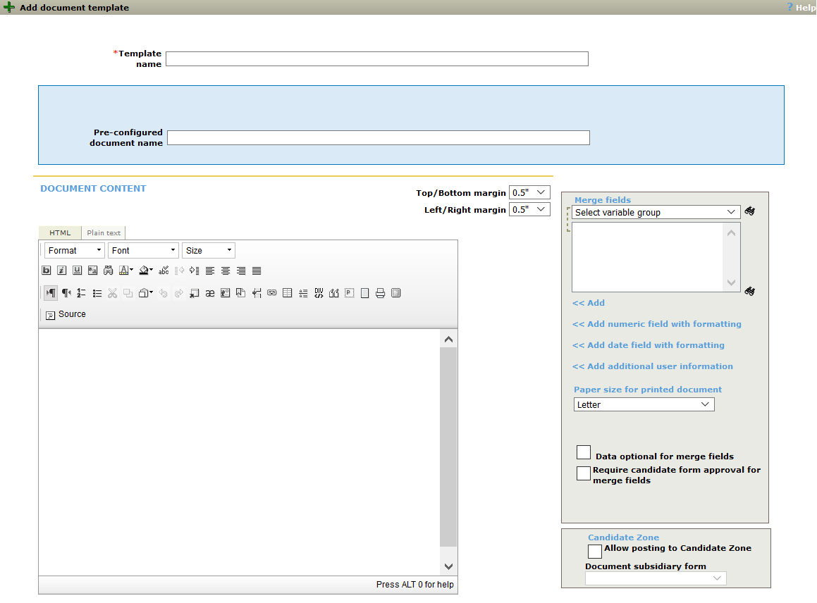
Figure 5- 8: Add Document Template

To add a document template by using a Word or other word processor:

- From the Hiring Navigation icon , click Admin Communications Add document template.
- Select Word or other word processor (must create .doc or .docx file types) and click Go.
- In the Template name field, enter an informative name (50 characters maximum) for this document template.
- Optionally enter a name in the Pre-configured document name field to populate the Document name field for BrassRing users creating documents from the template. This field can help standardize document names, and as save users a step. In this field, you can use up to 255 characters and manually enter the following merge tokens, along with any free-form text, in any order or combination:
- [#SystemInfo:CurrentTime#] – System information token represents the server time (Eastern Time) when the document is generated. It is presented in the format hh:mm:ss (24-hour clock). The token is not included in the merge field list.
- [#Document:TemplateName#] – represents the contents of the document template’s Template name field. The token is not included in the merge field list.
- [#Contact-info:FirstName#] – Candidate field token for candidate’s first name
- [#Contact-info:LastName#] – Candidate field token for candidate’s last name
- [#RequisitionStd:AutoReqId#] - Req ID standard field token
- [#SystemInfo:TodaysDate#] – System Information token for today’s date. The date is calculated based on the date picked up from the server (Eastern Time). (When the two tokens [#SystemInfo:TodaysDate#] and [#SystemInfo:CurrentTime#] are included in the “Pre-configured document name” field, the date or time stamp in the generated document name in the File column is the same as the date or time stamp in the Date added column of the grid on the Attachments tab of the Talent Record.)
Note: You can use special characters, but IBM recommends not to use characters such as angle brackets (< and >) that might be interpreted as html by the html parser. An example of a name you might enter follows:
[#Contact-info:LastName#][#Contact-info:FirstName#]_ [#RequisitionStd:AutoReqID#]_[#SystemInfo:TodaysDate#]_ [#SystemInfo:CurrentTime#]_[#Document:TemplateName#]
which might resolve to:
JonesGenevieve_10567BR_19-Jul-2015_13:47:42_ProfessionalServicesOfferLetter
- Click the Browse button to upload the template .doc/.docx file. Select the file and click Open. Click the Upload button.
- A hyperlink to the template appears which allows you to edit the file, save it to your local environment, and reupload it to this page.
- Select Merge fields from the list and click Copy to add them to your clipboard to be included in your doc. template. By using Ctrl V, the merge fields can be inserted when editing the doc. template.
- If applicable, select Copy numeric field with formatting to add to your clipboard to be included in your doc. template. By using Ctrl V, the numeric field with formatting can be inserted when editing the doc. template.
- If applicable, select a Blurb and click to add to your clipboard to be included in your doc. template.
- Select the Data optional for merge fields to determine whether the document can be generated with or without the merge field data.
- Select Require candidate form approval for merge fields for the system to check and validate if any candidate forms are in a pending state. If any candidate forms still require approval, an error message displays.
- Use Insert blurb to select and Add any of your choices.
- Select the Org groups authorized to create this document, and as the Org groups authorized to administer this template.
- Select the user types authorized to edit content during document creation.
- Select one of the attachment categories. Selecting a sensitive category guarantees that attachments that are generated from the template are handled as sensitive attachments and are subject to the “sensitive attachments” user type privileges.
- Check Allow posting to Candidate zone to Identify if this document to be posted on the Candidate Zone. Then, select the Document subsidiary form to use when posted.
- Ensure that Active document template is set to Yes (the default) if you want this template to be active.
- Click Save. A message confirms that the document template was saved successfully.

Deactivate a document template

To deactivate a document template:

- From the Hiring Navigation icon , select Admin Communications Document templates.
- Locate the document template that you want to deactivate in the Document templates grid.
- Click the Deactivate icon in its row.
- Click Deactivate.

Delete a document template

To delete a document template:

- From the Hiring Navigation icon , select Admin Communications Document templates.
- Locate the document template that you want to delete in the Document templates grid.
- Click the Delete icon.
- Click Delete. A message confirms that the document template was deleted successfully.

Administering Blurbs
Created and maintained within BrassRing, blurbs are frequently used, standard texts that can appear in the body of email communications or documents that are sent by BrassRing users. Examples of typical blurbs are: a privacy policy, your company overview, Equal Opportunity Employer statement, etc.

Adding a Blurb
When adding a blurb, you can select to either use the HTML editor or to use a Word or other word processor that must create .doc or .docx file types.

To add a Blurb by using HTML editor:

- From the Hiring Navigation icon , click Admin Communications Add Blurb.
- Select HTML editor and click Go.

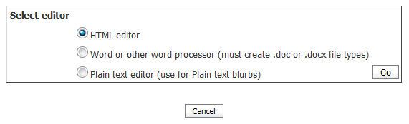
Figure 5- 9: Select HTML Editor to Add Blurb

- Enter the Blurb name and the Blurb text (see Figure 5-10). Use spell check to correct any possible errors in the text. From Merge fields, click List to select the fields you want included in the Blurb.
- Add numeric field with formatting must be configured first before you can select a format. It provides multi-level list capability (similar to that provided in word) for paragraphs. Multi-level list examples: 1, 1.1, 1.1.1, and 1.1.1.1; 1, 1.a, 1.a.i, and 1.a.i.1
- From Allow blurb to be selected during document or email creation indicate whether you would like to have the blurb that is listed as an option when creating documents or emails. If yes is selected, you must select a blurb category from the select category blurb field.
- From Make blurb conditional indicate whether the blurb should be conditional. If yes is selected, you have the option to specify the condition of the blurb from Display blurb when. You also have the option to make a selection from values.

Conditional Blurbs:
When you select Yes, the blurb name is appended with “(c)” in the blurb select list on the document and email template add or edit windows to indicate that this is a conditional field. (For example: “Executive benefits (c)”)
When a blurb is conditional, it is still selected as part of the email or document template, but during document or email generation the blurb text appears only if configured “conditions” are satisfied.
Display blurb when. This selection specifies what field needs to be present as a condition of displaying the blurb in the generated document.
Select a field from the list of fields associated with all Req standard, Req custom, and single per candidate per req form fields that contain option lists (multi-select, single-select, radio, or checkbox). Auto-fill fields (populated from a single-select or radio source form field or database field present in a single-per-candidate-per-req form) are also allowed.
You must set Make blurb conditional? to Yes to make this setting active. If the Make blurb conditional? field is set to Yes, you must make a selection in this field or an error message is displayed when you click Save.
Value = Select the specific field values that will be used to determine whether a blurb will or will not appear in a generated document or email.
If the Make blurb conditional? field is set to Yes, you must make a selection in this field or an error message is displayed when you click Save.
For multi-condition blurbs: If your company has activated this function.
Start group / End group. Use these to group two or more conditions by using parentheses (like algebraic expressions). Select Start group at the beginning of the conditions you want to join, and End group at the end to close the grouping.
N/A , AND , OR. Select AND or OR to logically join conditions. N/A is selected by default after each condition. When you select either AND or OR following the condition, the List>> button for the next condition is enabled.
A Not equal to (<>) or Not blurb condition is available. The Equal to condition is selected by default.
Multi-condition example:
If the Req Standard field ‘Manager’ = Paola McDougal AND ( Req Standard field ‘Recruiter’ = Lesley Smith OR Req Standard field ‘Recruiter’ = Nate Beltchev) then display this blurb.
You set three conditions for this example:
Condition [ReqS]Manager Value= Paola McDougal AND
Start group ( Condition [ReqS]Recruiter Value= Lesley Smith OR
Condition [ReqS]Recruiter Value= Nate Beltchev End group )
- If applicable, assign Org groups that will be allowed to add the blurb to their email communications being sent to candidates.
- If applicable, assign User Types that will be allowed to modify the blurb text during the document or email creation.
- From Active Blurb indicate whether the blurb will be active or inactive.
- Click Save.

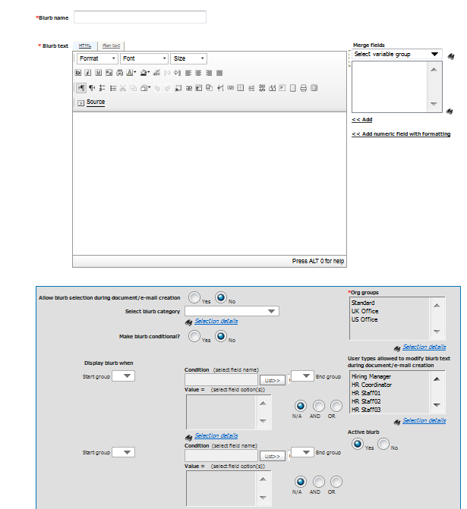
Figure 5- 10: Adding a Blurb by using HTML Editor

To add a Blurb by using Word or other word processor:

- From the Hiring Navigation icon , click Admin Communications Add Blurb.
- Select Word or other word processor (must create .doc or .docx file type) and click Go.
- Enter the Blurb name and the Blurb text.
- Click the Browse button to upload the template .doc / .docx file. Select the file and click Open. Click the Upload button.
- Select Merge fields from the list and click Copy to add them to your clipboard to be included in your .doc / .docx template. By using Ctrl V, the merge fields can be inserted when editing the .doc / .docx template.
- If applicable, select Copy numeric field with formatting to add to your clipboard to be included in your doc. template. By using Ctrl V, the numeric field with formatting can be inserted when editing the doc. template.
- If applicable, select a Blurb and click to add to your clipboard to be included in your doc. template.
- From Allow blurb to be selected during document or email creation indicate whether you would like to have the blurb that is listed as an option when creating documents or emails. If yes is selected, you must select a blurb category from the select category blurb field.
- From Make blurb conditional indicate whether the blurb should be conditional. If yes is selected, you have the option to specify the condition of the blurb from Display blurb when. You also have the option to make a selection from values.

Conditional Blurbs:
When you select Yes, the blurb name is appended with “(c)” in the blurb select list on the document and email template add or edit windows to indicate that this is a conditional field. (For example: “Executive benefits (c)”)
When a blurb is conditional, it is still selected as part of the email or document template, but during document or email generation the blurb text appears only if configured “conditions” are satisfied.
Display blurb when. This selection specifies what field needs to be present as a condition of displaying the blurb in the generated document.
Select a field from the list of fields associated with all Req standard, Req custom, and single per candidate per req form fields that contain option lists (multi-select, single-select, radio, or checkbox). Auto-fill fields (populated from a single-select or radio source form field or database field present in a single-per-candidate-per-req form) are also allowed.

You must set Make blurb conditional? to Yes to make this setting active. If the Make blurb conditional? field is set to Yes, you must make a selection in this field or an error message is displayed when you click Save.
Value = Select the specific field values that will be used to determine whether a blurb will or will not appear in a generated document or email.
If the Make blurb conditional? field is set to Yes, you must make a selection in this field or an error message is displayed when you click Save.
For multi-condition blurbs: If your company has activated this function.
Start group / End group. Use these to group two or more conditions by using parentheses (like algebraic expressions). Select Start group at the beginning of the conditions you want to join, and End group at the end to close the grouping.
N/A , AND , OR. Select AND or OR to logically join conditions. N/A is selected by default after each condition. When you select either AND or OR following the condition, the List>> button for the next condition is enabled.
Multi-condition example:
If the Req Standard field ‘Manager’ = Paola McDougal AND ( Req Standard field ‘Recruiter’ = Lesley Smith OR Req Standard field ‘Recruiter’ = Nate Beltchev) then display this blurb.
You set three conditions for this example:
Condition [ReqS]Manager Value= Paola McDougal AND
Start group ( Condition [ReqS]Recruiter Value= Lesley Smith OR
Condition [ReqS]Recruiter Value= Nate Beltchev End group )
- If applicable, assign Org groups that will be allowed to add the blurb to their email communications being sent to candidates.
- If applicable, assign User Types that will be allowed to modify the blurb text during the document or email creation.
- From Active Blurb indicate whether the blurb will be active or inactive.
- Click Save.

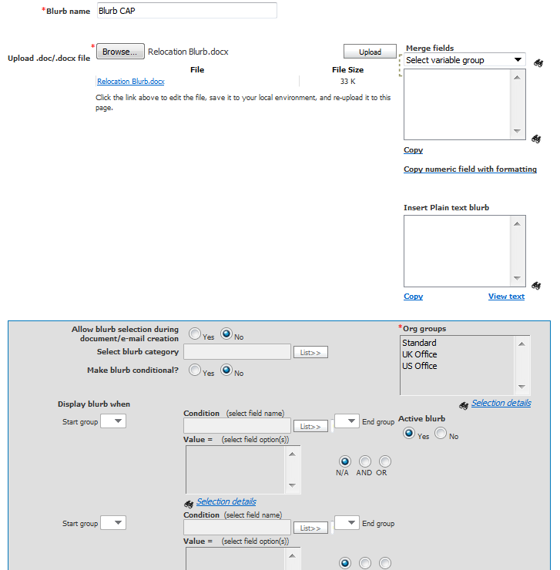
Figure 5- 11: Adding a Blurb by using Word or Word Processor

Document Packet Templates
BrassRing allows users to post packets of documents to the Candidate Zone. These packets are called Document Packet Templates. They might include Offer Letter, Benefits Information, Company Information, etc. If your company has activated this function, System Administrators have the privilege to manage document packet templates.

Adding Document Template Packets

To add a Document Packet Template:

- From the Hiring Navigation icon , select Admin Communications Add document packet templates.
- Optionally complete the Pre-configured document name field by selecting a merge field from the Add link.
- Enter the instructional text (no merge fields in this text) and the number of days the packet is to remain posted. Use spell check to correct any possible errors in the instructional text.
- Browse to the files you want to include in the packet and upload them. Those already included are listed the Browse and Upload buttons. Click their links to display them; click the delete icon to remove them from the packet.
- Select the Org groups authorized to use or administer the template.
- From the Activate Template field, indicate whether the Document packet template will be active or inactive.
- When finished adding the template, click Save.

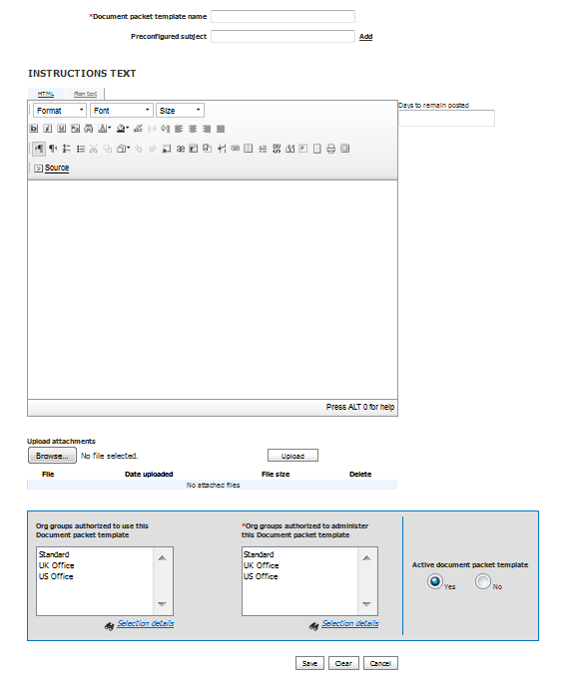
Figure 5- 12: Adding a Document Packet Template

System Email Templates
System email templates can be associated with user locale/eLink type combinations so that you can provide default message text for eLinks. This default text is appended to any message text created by the BrassRing user when sending an eLink. Default text prevents eLinks from being sent with no message text, thereby making the eLink far less likely to be filtered out as spam.

Default text can be set up for the following eLink types:

- Candidate – eLink Talent Record (Clicking “eLink” action menu in any candidate listing page/panel or Talent Record).
- Candidate – eLink Blank Form (Clicking “eLink Blank Form” in Talent Record > Forms tab).
- Candidate – eLink Form (Clicking “eLink” icon in Talent Record > Forms > eLink icon in the list of available forms).
- Req Approval - The eLink the approver receives. This only affects the standard approval function and does not affect elinks sent from the Custom Approval Workflow.

If you have "System email templates" administer or view privileges, you can access the menu items to administer any configured system email templates.

Adding System Email templates

To add a system email Template:

- From the Hiring Navigation icon , select Admin Communications Add system email templates.
- Enter a Template name and default text in the Message Body. These two fields are required. Use spell check to correct any possible errors in the instructional text.
- Click Save.
Note: Make sure that after creating the system email templates, they are mapped in Workbench by your Workbench Administrator.

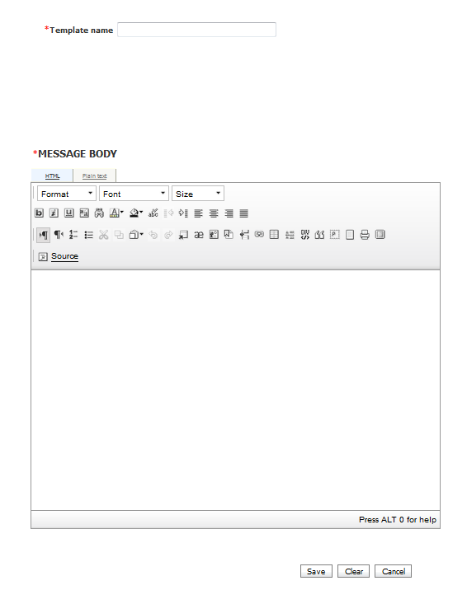
Figure 5- 13: Adding a System email Template

Chapter Summary

- Email and Letter templates are used to standardize communications send to your candidates.
- Batch letters enable you to send the same letter to many recipients at once by merging data that is entered and stored in BrassRing with the mail merge functions of MS Word.
- A blurb is a commonly used, standard text appearing in email or document template.

Check Your Skills

Answer these True or False questions:

- Email and Letter templates should be used sparingly as you can store a maximum of 200 total templates.
- The batch letters feature allows all users to create the same letter for multiple recipients at the same time.
- The batch letters process automatically marks letters as sent.
- Mail merge is similar to what is referred to in BrassRing as batch letters.

Answer the following short answer question:

- Describe the difference between Mass emails and email templates.

Check Your Skills Answers

Chapter 1
- F
- T
- F
- E
- C

Chapter 2
- F
- T
- F
- Job Code, Req Code, Source Code

Chapter 3
- F
- F
- F

Chapter 4
- F
- T
- F
- Added by, Candidate name, date or time added, note text, note type

Chapter 5
- F
- T
- F
- T
- Mass emails go to all BrassRing users while Email templates are sent to candidates.

Notices
This information was developed for products and services offered in the U.S.A and other countries. Consult your local IBM representative for information on the products and services currently available in your area. Any reference to an IBM product, program, or service is not intended to state or imply that only that IBM product, program, or service might be used. Any functionally equivalent product, program, or service that does not infringe any IBM intellectual property right might be used instead. However, it is the user's responsibility to evaluate and verify the operation of any non-IBM product, program, or service.

IBM might patents or pending patent applications covering subject matter described in this document. The furnishing of this document does not grant you any license to these patents. You can send license inquiries, in writing, to:

IBM Director of Licensing
IBM Corporation
North Castle Drive
Armonk, NY 10504-1785
U.S.A.

For license inquiries regarding double-byte (DBCS) information, contact the IBM Intellectual Property Department in your country or send inquiries, in writing, to:

Intellectual Property Licensing
Legal and Intellectual Property Law
IBM Japan Ltd.
1623-14, Shimotsuruma, Yamato-shi
Kanagawa 242-8502 Japan

The following paragraph does not apply to the United Kingdom or any other country where such provisions are inconsistent with local law:

INTERNATIONAL BUSINESS MACHINES CORPORATION PROVIDES THIS PUBLICATION “AS IS” WITHOUT WARRANTY OF ANY KIND, EITHER EXPRESS OR IMPLIED, INCLUDING, BUT NOT LIMITED TO, THE IMPLIED WARRANTIES OF NON-INFRINGEMENT, MERCHANTABILITY OR FITNESS FOR A PARTICULAR PURPOSE.

Some states do not allow disclaimer of express or implied warranties in certain transactions, therefore, this statement might not apply to you.

This information might include technical inaccuracies or typographical errors. Changes are periodically made to the information herein; these changes will be incorporated in new editions of the publication. IBM might make improvements and changes in the product(s) and the program(s) described in this publication at any time without notice.

Any references in this information to non-IBM web sites are provided for convenience only and do not in any manner serve as an endorsement of those web sites. The materials at those web sites are not part of the materials for this IBM product and use of those web sites is at your own risk. IBM might use or distribute any of the information you supply in any way it believes appropriate without incurring any obligation to you.
Licensees of this program who want to have information about it for the purpose of enabling: (i) the exchange of information between independently created programs and other programs (including this one) and (ii) the mutual use of the information which has been exchanged, should contact:

IBM Corporation
5 Technology Park Drive
Westford Technology Park
Westford, MA 01886

Such information might be available, subject to appropriate terms and conditions, including in some cases, payment of a fee.

The licensed program described in this information and all licensed material available for it are provided by IBM under terms of the IBM Customer Agreement, IBM International Program License Agreement, or any equivalent agreement between us.

Any performance data contained herein was determined in a controlled environment. Therefore, the results obtained in other operating environments might vary significantly. Some measurements might have been made on development-level systems and there is no guarantee that these measurements will be the same on generally available systems. Furthermore, some measurements might have been estimated through extrapolation. Actual results might vary. Users of this document should verify the applicable data for their specific environment.

Information concerning non-IBM products was obtained from the suppliers of those products, their published announcements or other publicly available sources. IBM has not tested those products and cannot confirm the accuracy of performance, compatibility or any other claims related to non-IBM products. Questions on the capabilities of non-IBM products should be addressed to the suppliers of those products.

All statements regarding IBM's future direction or intent are subject to change or withdrawal without notice, and represent goals and objectives only. All IBM prices shown are IBM's suggested retail prices, are current and are subject to change without notice. Dealer prices might vary.

This information is for planning purposes only. The information herein is subject to change before the products described become available.

This information contains examples of data and reports used in daily business operations. To illustrate them as completely as possible, the examples include the names of individuals, companies, brands, and products. All of these names are fictitious and any similarity to the names and addresses used by an actual business enterprise is entirely coincidental.

Trademarks
These terms are trademarks of International Business Machines Corporation in the United States, other countries, or both:
- IBM
- AIX
- Sametime
- WebSphere
Java and all Java-based trademarks and logos are trademarks or registered trademarks of Oracle and its affiliates.
Microsoft and Windows are registered trademarks of Microsoft Corporation in the United States, other countries, or both.
Linux is a trademark of Linus Torvalds in the United States, other countries, or both.
Other company, product, or service names might be trademarks or service marks of others.

