IBM BrassRing on Cloud
Hiring Manager Quick Reference Guide
This Quick Reference Guide is provided without branding and can be edited by your organization as needed.

eLinks
- eLinks allow the recruitment team to send resumes or CVs and other information about candidates, or reqs for approval by using email.
- An eLink is a hyperlink included in an email that takes you to a candidate’s resume, CV, req, or a form.
- eLinks can be responded to with comments during the screening process of candidates.
- eLink activity is tracked. Recruiters can see whether someone has viewed or responded to an eLink.
- Internet access is required to open an eLink.
- Select Help (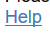) in the eLink window to assist with any additional questions.

Opening eLinks
- Open the email containing the eLink and read the message included by the Sender.
- Select the candidate’s name to open the eLink and review the candidate’s resume.
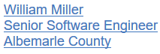

Reviewing eLinks
Select the menu items to review the information in the eLink. Not all menu items might be included with the eLink.
- Opens the candidate’s resume and cover letter if the candidate included one.
- Opens a summary of the candidate’s contact information, education, and employment information.
- Opens a PDF image of the resume, if the candidate uploaded their resume when applying.
- If included, can be used to check the candidate’s HR Statuses.
- If included, can be used to view or complete any forms, for example Job Response forms. Forms are divided into Forms to view and Forms to complete as needed.
- Select Respond to provide feedback. Feedback is sent to the sender’s email Inbox.

Approving Reqs by using eLinks
- To approve a req by using an eLink, select View requisition details in the email:
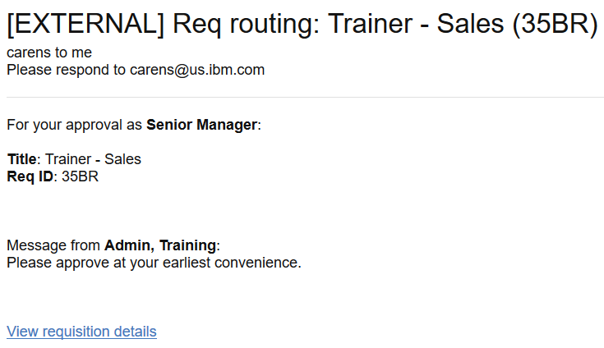
- The Req opens in a browser window.
  - Enter a message into the Message text field to send a message to the next approver.
  - The Req notes field should be used to indicate what needs to be edited on the req before it is posted.
- Select either Approve or Decline as needed.
- Select OK.

