IBM BrassRing on Cloud
BrassRing Admin Quick Reference Guide
This Quick Reference Guide is provided without branding and can be edited by your organization as needed.

Manage Email Templates
- Select Menu > Admin > Communications > Add communications template.
- Insert an email template name and body.
  - Insert merge fields by selecting the variable group by using the pull-down menu, selecting the merge field, and selecting Add.
  - Insert a link to a Talent Gateway by selecting a Talent Gateway Type, selecting the Talent Gateway, and selecting Add.
  - Insert a form to complete or view by selecting a Form and selecting Add in the appropriate section.
  - Insert a link to a form to complete or view by selecting a Form and selecting Add URL in the appropriate section.
  - To add eLinks to the Talent Record, check Add Talent Record eLinks, and select the sections as needed. When sending communication with the [#elink:Talent Record#] token, the template attributes Send to: Other recipients is selected by default and the Send to: Candidates option is disabled.
  - Insert a blurb by selecting a Blurb and selecting Add. Preview the blurb text by selecting the blurb and selecting View text.
  - To add attachments, select Choose Files, select the files on your computer, and select Upload.
- Select the authorized users, active status, and manual/auto options.
- Select Yes for Save Copy of Correspondence.
- Select Save.

Manage Document Templates
- Select Menu > Admin > Communications > Add document template.
- Insert a template name.
- Insert a pre-configured document name (optional).
- Insert the document content.
  - Insert merge fields by selecting the variable group by using the pull-down menu, selecting the merge field, and selecting Add.
  - Select the paper size, and margins.
  - Insert a blurb by selecting a Blurb and selecting Add. Preview the blurb text by selecting the blurb and selecting View text.
  - To add attachments, select Choose Files, select the files on your computer, and select Upload.
- Select the authorized users, and active status.
- Select Save.

Manage Document Packet Templates
- Select Menu > Admin > Communications > Add document packet template.
- Insert a template name.
- Insert the instruction text of the document packet template.
- Select the days to remain posted. The document packet template automatically unposts on the last day.
- If needed Upload attachments from your desktop to be included in the document packet template.
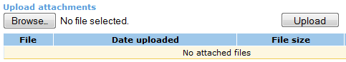
- Select Org Groups authorized to use and administer the Document packet template
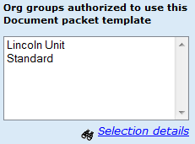
- Select Yes to activate the document packet template.
- Select Save.

Manage Letter Templates
- Select Menu > Admin > Communications > Add letter template.
- Insert a letter template name.
- Select List>> next to Merge Fields.
- Select the Merge fields to include in the Letter template by selecting List and selecting the Merge fields.
- Select the data is required or optional for merge fields for this letter to be created.
- Select Launch MS Word to open a Word doc. Then click Preview Merge Format. A new window opens with merge tokens selected.
- Create the letter in MS Word. Add the merge tokens by copying the characters in the Document Reference column and pasting them into the Word doc.
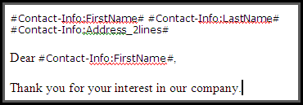
- Save the document to your computer.
- In BrassRing, select Browse and upload the Word doc as a letter template
- Select Org Groups authorized to send and the Users authorized to administer this letter.
- Select Yes to activate the Letter
- Select Yes or No to require Letter creation from within a req folder.
- Select Yes or No to determine whether a copy of the correspondence is saved.
- Select Save.

Administer Codes
- Select Menu > Admin > Admin+ > Codes.
- Select the administer codes list icon () for the code to edit.
- To add a new code, select + Add new code, enter the code information, and select Save. Required fields are marked with a red asterisk.
- To edit information for an existing code, select the edit pencil icon () for that code, edit the information and select Save.
- To deactivate a code, select the code and select the Deactivate icon ().

Administer Lists
- Select Menu >Admin >Admin+ > Lists.
- Select the administer this list icon () for the list to edit.
- To add a new option, select + Add new option, enter the option code and description, and select Save.
- To edit an option, select the edit pencil icon () for that option, edit the information, and select Save.
- To deactivate an option, select the option and select the Deactivate icon ().
- Select Export code list to MS Excel to export the list to Microsoft Excel.

Stack Duplicate Resumes or CVs
There might be an occasion where duplicate resumes are not automatically stacked by the system duplicate check. BrassRing Administrators can manually stack two duplicate profiles. This process cannot be undone.
Stacking a candidate creates a previous version of the resume with all action history. The previous versions can be viewed on the resume tab of the candidate’s talent record.
- Select the candidate with the possible duplicate resume and select Actions > Stack Duplicate.
- The candidate overview appears for the first record. Toggle between the two records by using the links.
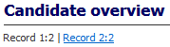
- If you determine that both records belong to the same candidate, decide which record to show as current and which is the duplicate.
- Select Keep this candidate for the record to keep and select OK.
- Select the candidate’s name to open the Talent Record and select View Submission History.
- The duplicate resume or CV can be viewed by selecting the link in the duplicates section of the submission history.

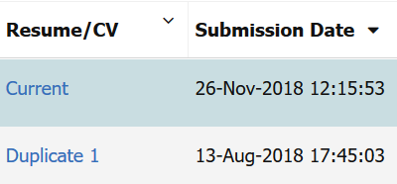

Send Mass Email
Sending a Mass email is used to communicate with all active system users. The email is not specific to user types or groups.
- Select Menu > Admin > Admin+ > Mass e-mail to users.
- Insert a message subject and body.
- Select Send.

Audits
Notes Audit is used to review public and personal notes (My Notes) that have been added to candidates.
Attachments Audit: is used to monitor the attachments that your users have added to BrassRing or your candidates have uploaded on Talent Gateways.
Login Failure Audit: is used to identify all failed login attempts to BrassRing by user name. It checks whether the name was valid and provides the date, time, and IP address of the attempt.
- To run an audit, select Menu > Admin > Admin +.
- Select the type of audit to run; Attachments audit, Notes audit, or Login failure audit.
- Enter the report parameters and the sort options for the report.
- Select Run.

Running Standard Reports
Standard reports are categorized into five categories:
  - Billing reconciliation reports
  - System reports
  - Hire/Req reports
  - Dashboard reports
  - Talent Gateway Reports
- To run standard reports, select Menu > Reports > Standard reports.
- Select the run icon () for the report to be run.
- The filter page opens. Insert any additional criteria for the report. Additional criteria can help narrow activities based on a specific date range, specific divisions or locations, or by specific members of the hiring team.
- Insert the report criteria in the filter fields.
- Insert a report schedule if needed. The report is emailed to any recipients based on the schedule.
- Select an output format.
- Select Generate report now.
- Select any Sorting/Grouping options to organize the report as needed.
