IBM® Kenexa® BrassRing on Cloud

Requisition Import Technical Specifications API Guide

Version 1.1
Release Date: June 3, 2014

Edition Notice
Note: Before using this information and the product it supports, read the information in the Notices section at the end of this document.
This edition applies to IBM® Kenexa® BrassRing on Cloud and to all subsequent releases and modifications until otherwise indication in new editions.

Licensed Materials - Property of IBM

© Copyright IBM® Corporation, 2014.
US Government Users Restricted Rights – Use, duplication or disclosure restricted by GSA ADP Schedule Contract with IBM Corp.

Table of Contents
Edition Notice I
Chapter 1: Introduction 1
1.1 What are BrassRing’s XML Integration APIs 1
1.2 Purpose 1
1.3 Audience 1
Chapter 2: BrassRing’s Requisition Integration APIs 2
2.1 Overview 2
2.2 Communication Methodology 2
2.3 Rules for the Requisition Import Integration 2
2.4 Requisition Snapshot in BrassRing 3
2.5 Requisition Tag Definitions (Summary) 4
2.6 Requisition Tag Definitions – Detailed Descriptions 6
2.6.1 Required Fields (Mandatory) 6
2.6.2 Optional Fields 9
2.6.3 Special Attributes 15
Chapter 3: XML Schemas 16
3.1 Sample XML Request 16
3.2 Sample XML Response (Success) 17
3.3 Sample XML Response (Failure) 18
3.4 Handling special characters in XML requests 19
Chapter 4: Envelope Processing 20
4.1 Sender 20
4.2 Recipient 20
4.3 TransactInfo 20
4.4 Packet 20
4.5 Payload 21
Chapter 5: Security 22
5.1 Standard Implementation Security 22
5.1.1 Message Integrity 22
5.1.2 Transport Layer Security (TLS) 22
5.1.3 IP restrictions 22
5.2 Optional Security Features 22
5.2.1 Message Layer Encryption/Security (MLS) 22
5.2.2 2-Way SSL / Certificate Based Authentication 23
Chapter 6: Integration API URLs 24
6.1 Message Router Addresses 24
Chapter 7: API Error Messages 25
Notices 26
Trademarks 27

- Introduction
  - What are BrassRing’s XML Integration APIs
BrassRing XML integrations feature flexible, secure, real-time integrations by sending XML over the Internet using web services or HTTP Posts. XML formats used in BrassRing XML integrations are based on HR-XML Consortium guidelines.

The BrassRing XML integration offerings allow BrassRing to work with customers to configure multi-level, robust integration relationships between BrassRing and any systems that can send and receive XML. Examples of these systems include HRIS systems such as SAP/Oracle/PeopleSoft, etc., and systems that perform HR-related services like background checks, assessments or compensation analysis.

The customer can choose to send data through either a web service or HTTP post. BrassRing handles the exchange of XML requests and responses using its own messaging software. The customer builds their own messaging system to exchange XML web service messages or HTTP post with BrassRing.
  - Purpose
The purpose of this document is as follows:
To present high-level architecture and design of BrassRing APIs and how BrassRing implements Requisition Import integrations to meet its customers’ needs for automated Requisition data management.
To describe suggested high-level workflow processes that can be supported between BrassRing and any external, third-party system that can send and receive XML requests and responses.
To describe the steps required to implement Requisition integration.
  - Audience
Client Decision Makers, HRIS Implementation Teams, Internal IT Teams, Systems Integrators and Support Teams.
BrassRing Engineering Services Team, Support Team, and Technical Services Group.

- BrassRing’s Requisition Integration APIs
  - Overview
Requisition data can be imported into BrassRing from an external system. Requisition data is any information that is in a Job Requisition such as the Job description, Job number, Department and so on.

A client can originate a Requisition in their HRIS system and build the integration in such a way as to automatically create a Requisition in BrassRing. The Requisition fields to be transferred are chosen by the client at integration set-up time and recorded in the XML_Integrations_Data_Mapping_Document.doc.
  - Communication Methodology
Connection to the BrassRing system is accomplished via two mechanisms using XML as a data transfer vehicle.
HTTP Post
Web services

Both the above mechanisms are synchronous, meaning all transactions are real-time with a request-response messaging and no message queuing.

The XML format is depicted in Section 3.

Client can choose to batch transactions or send data to BrassRing in real-time.

BrassRing will always process transactions in real-time regardless of whether they were batched or not by the client.
  - Rules for the Requisition Import Integration
Below are a few rules to consider when looking into the use of the Requisition Import Integration:
The XML schema cannot be customized (see sample XML below). The Req fields to be sent in the integration can however be added depending on a Client’s Req Template. Field requirements are outlined in the Data Mapping sections.
Requisition Import XML files are processed real-time via HTTPS Post or Web Services.
The Requisition API processes only one Requisition XML data per transaction. Bundle/group Requisition import is not allowed in the same XML.
Requisition Import API works on the Requisition template level. For example if a given client has 3 Requisition templates “Confidential Requisition”, “Contractor” and “Employee Requisition Form” and Requisition import should create a Requisition for all 3 templates, then the client must send the Requisition import to be repeated 3 times to create the Requisitions in 3 different templates.
Customer’s HRIS or external system should wait for a success/failure response before sending the next transaction in a sequential manner.
Field requirements (outlined in the Data Mapping sections).
Select fields (such as single-select, multi-select, check-box, radio button fields) mapped to the integration by default accept the defined description for that field in BrassRing. This setting can however be adjusted on a field by field level to accept the code instead. If a given client is using more than one language, the recommendation is to adjust the settings to accept code. Code will remain the same for all translated values, whereas descriptions could vary from language to language.
Special characters in the XML must be escaped. See Section 3.4
Send delta loads only. Full/destructive loads are not recommended.
  - Requisition Snapshot in BrassRing
Below is a screen print of the Requisition Grid and Profile screens for your reference.
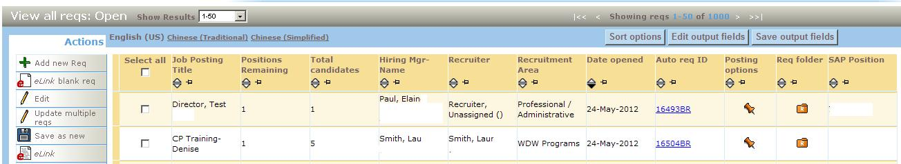

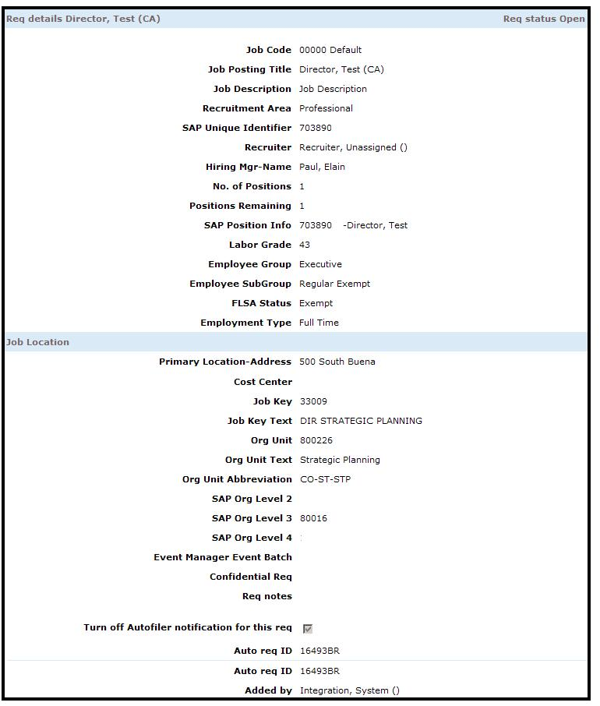
  - Requisition Tag Definitions (Summary)
Line # | Field Name | Field Type | Format | Length | XML Tag | BrassRing Notes
Mandatory Fields
1 | Requisition Number (Client) | Standard | Varchar | 30 | REQUISITIONNUMBER | Unique Job number for the Req
2 | Job Status | Standard | int | 4 | JOB_REQ_STATUS | Determines the Job Req Status
3 | Manager Name | Standard | Varchar | 255 | MANAGER | Hiring Manager on the Req
4 | Recruiter Name | Standard | Varchar | 255 | RECRUITER | Recruiter on the Req
5 | Job Title | Standard | Varchar | 70 | JOBTITLE | Represents the Job Title
6 | Job Description | Standard | Varchar | 8000 | JOBDESCRIPTION | Represents the Job Description
Optional Fields
7 | No of Positions | Standard | int | 4 | NO_OF_POSITIONS
8 | Department | Standard | Varchar | 75 | DEPARTMENT | Required tag - value can be blank
9 | Location / Division | Standard | Varchar | 50 | LOCATION
10 | Req Type | Standard | Varchar | 30 | REQTYPE
11 | Requisition Notes | Standard | Varchar | 4000 | REQNOTES
12 | Advertising Costs | Standard | numeric | 20 | ADCOSTS
13 | Travel Costs | Standard | numeric | 20 | TRAVELCOSTS
14 | Relocation Costs | Standard | numeric | 20 | RELOCCOSTS
15 | HR Department Recruiter Costs | Standard | numeric | 20 | HRDEPTRECCOSTS
16 | External/Agency Costs | Standard | numeric | 20 | EXTERNALCOSTS
17 | Referral Bonus | Standard | numeric | 20 | REFERRALBONUS
18 | Add Type | Standard | Varchar | 9 | ADDTYPE
20 | Start Date | Standard | date | 12 | STARTDATE
21 | Req Team | Standard | Varchar | 30 | TEAM -> EMPLOYEEID

Line # | Field Name | Field Type | Format | Length | XML Tag | BrassRing Notes
Custom Fields (examples fields below)
22 | Job Family | Custom | Varchar |  |  | The XML tags names will be
23 | Maximum Salary | Custom | Varchar |  |  | provided later after the client
24 | Minimum Salary | Custom | Varchar |  |  | identifies the fields from the Req
25 | Personnel Area | Custom | Varchar |  |  | forms
26 | Personnel Sub Area | Custom | Varchar
27 | Cost Center | Custom | Varchar

  - Requisition Tag Definitions – Detailed Descriptions
XML tags for Requisition Imports can be categorized as below.
Mandatory tags for insert: REQUISITIONNUMBER, JOB_REQ_STATUS, MANAGER, RECRUITER, JOBTITLE, and JOBDESCRIPTION
Minimum mandatory tags for update: REQUISITIONNUMBER, JOB_REQ_STATUS are the only 2 required tags for a delta.
Additional optional Standard tags: The following tags are BrassRing standard tags. They are not mandatory and should a Client need to use them, as long as they exist on Req templates, they can be mapped to the integration and can be used. These tags should be finalized in data mapping document for a given client.
LOCATION, REQTYPE, REQNOTES, ADCOSTS, TRAVELCOSTS, RELOCCOSTS, EXTERNALCOSTS, REFERRALBONUS, ADDTYPE, STARTDATE, JOBOO, TEAM (EMPLOYEEID or EMPLOYEENAME) this is the same as Req Team.
Additional optional custom tags: client’s specific custom field/tags. Good examples for common client custom tags are: COSTCENTER, MINIMUM_SALARY, MAX_SALARY
    - Required Fields (Mandatory)
      - REQUISITIONNUMBER (1)
This is the all-important tag that identifies the Unique Job number on the client’s system
XML Tag | Tag Required? | Value Required? | Format | Length
REQUISITIONNUMBER | Yes | Yes, required for both insert and update | Varchar | 30
_Rules:
This tag is the unique identifier for determining the inserting or updating of an existing Requisition record. This tag and its value must be present for all submissions. If the value of REQUISITIONNUMBER is present in BrassRing system, an update will be applied to the existing record. If the value REQUISITIONNUMBER is not present in BrassRing system, a brand new Requisition will be created.
REQUISITIONNUMBER is often referred to as BrassRing optional Requisition number.
REQUISITIONNUMBER value contains Client’s unique identifier for a Requisition.
If sending multiple languages for the same job, then the REQUISITIONNUMBER value should remain the same for all the languages and the language attribute will specify the language. See section 2.6.3 below.
Please note, recycling and reusing the same REQUISITIONNUMER is not permitted in BrassRing. When a Requisition is closed and fully recruited, it cannot be repurposed and reopened.
REQUISITIONNUMBER - is not the same as BrassRing’s unique Req number (often ending with BR, for example
123BR).
REQUISITIONNUMBER value can be also added to Req additional search category window and it is a reportable value as well. Contact BrassRing Support Team for creation and display of this field on the UI.

      - JOB_REQ_STATUS (2)
This tag identifies the Job Req Status.
XML Tag | Tag Required? | Value Required? | Format | Length
JOB_REQ_STATUS | Yes | Yes, required for both insert and update | Int | 4
Special instruction:
<JOB_REQ_STATUS KEEPSTATUS="Y"/> will keep the existing Req Status in the BrassRing system unchanged.
Rules:
Values:
0 (Open)
1 (Pending)
2 (Approved)
3 (Closed)
4 (Deleted)
5 (On Hold)
7 (Cancelled)
9 (Declined)
Tag and value are both required. If the tag is not present, the system will automatically import the Req with an Open status.
A Requisition can be created only in “Open”, “Approved” or “Pending” status.
Status navigation is allowed in specific orders and in many cases navigating backwards is not permitted.
From “Open”, a Requisition can go to “On Hold”, “Closed”, “Deleted”, and “Cancelled”.
From “Pending”, a Requisition can be taken to “Deleted”, “On Hold”, “Cancelled” or “Declined”.
From “Approved”, a Requisition can be taken to “Open”, “Deleted”, “On Hold” or “Cancelled”
From “Closed”, a Requisition can be taken to “Open” or “Deleted”.
From “Deleted”, a Requisition can be taken to “Open”, “Pending” or “Approved”.
From “On Hold”, a Requisition can be taken to “Open”, “Pending”, “Closed”, “Deleted” or “Cancelled”.
From “Cancelled”, a Requisition can be taken to “Cancelled”, “Approved” or “Pending”.
From “Declined”, a Requisition can be taken to “Pending”.

Important to note:
If the Requisition Attribute in Workbench is set to “Enforce final status of all candidates”, you will not be able to update an “Open” Requisition which contains at least one candidate who has not reached a final status to “Closed”, “Deleted”, “On hold” or “Cancelled” without receiving an error.

If you don’t want to enforce final status for “Deleted”, “On hold” or “Cancelled” you can update the Client Setting in Workbench to “Req final status selection for enforcing final status”. This setting will change the behavior of both the UI and the integration (i.e. will not enforce final status for users in BrassRing or through the integration).

The status of “Closed” will always enforce all candidates be in a final status.

      - MANAGER (3) and RECRUITER (4)
These tags determine the Hiring Manager and the Recruiter on the Requisition.
XML Tag | Tag Required? | Value Required? | Format | Length
MANAGER  RECRUITER | Yes | Yes, required for both insert and update | Varchar | 255
Rules:
Manager and Recruiter tag and value are required for an Insert.
Acceptable formats are:
Employee ID stored in BrassRing user table
First Name <space> Last Name (for example John Smith)
Please note, some Clients might have a user differentiator on.
In such case the format should be First Name <space> Last Name (differentiator).
For example John Smith (123456).
If client’s HRIS system does not have a corresponding Manager tag and value to send, since this tag and its value are mandatory, it is recommended to create a dummy hard coded manager in the BrassRing system and ask client to send a hard coded value.
For example
<MANAGER >Integration Manager</MANAGER>
<RECRUITER >Integration Recruiter</RECRUITER >

      - JOBTITLE (5)
This tag represents the Job Title for the Requisition
XML Tag | Tag Required? | Value Required? | Format | Length
JOBTITLE | Yes | Yes | Varchar | 70
Rules:
JOBTITLE tag and value are required for an insert.
JOBTITLE is a free text and can hold up to 70 chars maximum

      - JOBDESCRIPTION (6)
This tag represents the Job Description for the Requisition
XML Tag | Tag Required? | Value Required? | Format | Length
JOBDESCRIPTION | Yes | Insert Only | Varchar | 7500
Rules:
JOBDESCRIPTION tag and value are required for an insert.
JOBDESCRIPTION is a free text and can hold up to 7500 chars maximum.

    - Optional Fields
      - TEAM / REQ TEAM (7)
This tag represents the Req Team for the Requisition
XML Tag | Tag Required? | Value Required? | Format | Length
TEAM | No | No | Varchar | 7500
Rules:
Req team can be passed and populated via Req import integration.
A given Req can be assigned to more than one Req team person.
Req team can be passed in format of employee ID. Using employee ID is highly recommended for Clients who do use EmployeeId in the User setup (since employee ID is optional). Example below illustrates how multiple Req team members can be included using employee ID.
<TEAM action=”replace”>
<EMPLOYEEID>3057559</EMPLOYEEID>
<EMPLOYEEID>3057560</EMPLOYEEID>
<EMPLOYEEID>3057561</EMPLOYEEID>
<EMPLOYEEID>3057562</EMPLOYEEID>
</TEAM>
Req team can be passed in format of Employee name. Using Employee Name is recommended for clients who do not use EmployeeId . Example below illustrates how multiple Req team members can be included using Employee name.
<TEAM action=”replace”>
<EMPNAME>John Smith</EMPNAME>
<EMPNAME>Mandy Cooper</EMPNAME>
<EMPNAME>Liz Johnson</EMPNAME>
</TEAM>
Please note, if User differentiator setting is on and a Client decides to send EMPLOYEENAME, then the User differentiator chosen should be passed as well. In this example, the EmployeeID was the user differentiator selected. See example below:
<TEAM action=”replace”>
<EMPNAME>John Smith (3057559)</EMPNAME>
<EMPNAME>Mandy Cooper (3057560)</EMPNAME>
<EMPNAME>Liz Johnson (3057561)</EMPNAME>
<EMPNAME>Niki Anderson (3057562)</EMPNAME>
</TEAM>
Below are the other actions tags that can be used.
This tag should be used to delete the current Req Team and replace it with the values sent. Use if the client always sends the entire Req Team.
<TEAM action="replace">
<EMPNAME>employeeName</EMPNAME>
<EMPLOYEEID>3057559</EMPLOYEEID>
</TEAM>
This tag should be used to remove certain members from the Req Team. NOTE: You will get an error if you try to remove all members without replacing them.
<TEAM>
<remove>
<EMPNAME>employeeName</EMPNAME>
<EMPLOYEEID>3057559</EMPLOYEEID>
</remove>
</TEAM>

This tag should be used to add members to the current Req Team.
<TEAM>
<add>
<EMPNAME>employeeName</EMPNAME>
<EMPLOYEEID>3057559</EMPLOYEEID>
</add>
</TEAM>
This tag can be used to add and remove members from the Req Team. This could be used to remove all and add new instead of the replace tag above but all values would have to be sent.
<TEAM>
<remove>
<EMPNAME>employeeName</EMPNAME>
<EMPLOYEEID>3057559</EMPLOYEEID>
</remove>
<add>
<EMPNAME>employeeName</EMPNAME>
<EMPLOYEEID>3057559</EMPLOYEEID>
</add>
</TEAM>

      - PROXIMITY fields (8)
This tag and it’s attributes are used to provide the proximity information for the Requisition
XML Tag | Tag Required? | Value Required? | Format | Length
Proximity | No | No | Multi nodes
Rules:
Proximity fields can be handled via Req import integration.
Proximity contains 4 tags as listed in example below:
<Proximity>
<CountryId>223</CountryId>
<StateId>3153</StateId>
<CityId/>
<Zip>78204</Zip>
</Proximity>
Proximity can work with these combinations.
CountryId, StateId and CityId
CountryId, StateId and Zip
CountryId, StateId, CityId and Zip.
Please note that actual values that can be passed for these 4 tags, should be existing defined standard values in the BrassRing system. Please coordinate with your Engineer to provide the list of standard values that can be sent.
Below is a sample of the proximity values.
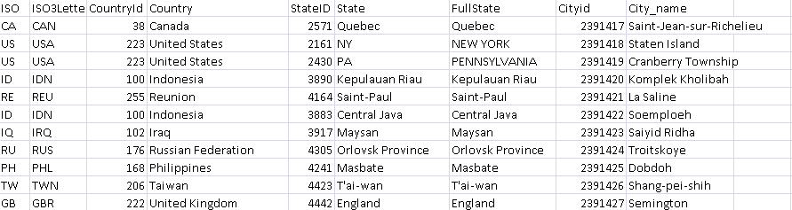

      - JOBOO fields (9)
This tag and its attributes are used to populate posting information of a Req on the Talent Gateways. Please note that not all posting options/selections are available through integration.
XML Tag | Tag Required? | Value Required? | Format | Length
JOBOO | No | No | Multi nodes
Rules:
A given Req can be posted to one or many Talent gateways. Below is an example of posting a Req to multiple gateways.
<JOBOO>
<SITE ID="123" NAME="CLIENT Careers" DAYSTILLPOSTING="0" POSTINGDAYS="365" QUESTIONSIDS="12345,98765" GQNAME="External Application" ASSESSMENTBATCH="Batch1" MINSCORE="5" MINASSESSMENTSCORE="10" MINREQUIREDSCORE="15" PASSHRSTATUS="Applied" FAILHRSTATUS="Company Not Interested" STATUS="A"/>
<SITE ID="456" NAME="CLIENT Internal Opportunities" DAYSTILLPOSTING="0" POSTINGDAYS="365" QUESTIONSIDS="12345,98765" GQNAME="Internal Application" ASSESSMENTBATCH="Batch3" MINSCORE="5" MINASSESSMENTSCORE="10" MINREQUIREDSCORE="15" PASSHRSTATUS="Applied" FAILHRSTATUS="Company Not Interested" STATUS="A" />
<!-- ... etc ... -->
</JOBOO>
Additionally question scoring can be added using the tags below in place of the ones above.
<JOBOO>
<SITE ID="123" NAME=" CLIENT Careers " DAYSTILLPOSTING="0" POSTINGDAYS="365" GQNAME="External Application" ASSESSMENTBATCH="Batch1" STATUS="A" MINSCORE="5" MINASSESSMENTSCORE="10" MINREQUIREDSCORE="15" PASSHRSTATUS="Applied" FAILHRSTATUS="Company Not Interested">
<QUESTIONS>
<Question ID="12345" requiredscore="10"/>
<Question ID="98765" requiredscore="10"/>
<!-- ... etc ... -->
</QUESTIONS>
</SITE>
<!-- ... etc ... -->
</JOBOO>

Below is a screen print of the BrassRing Posting Options page along with a description of each tag that is associated to this page.
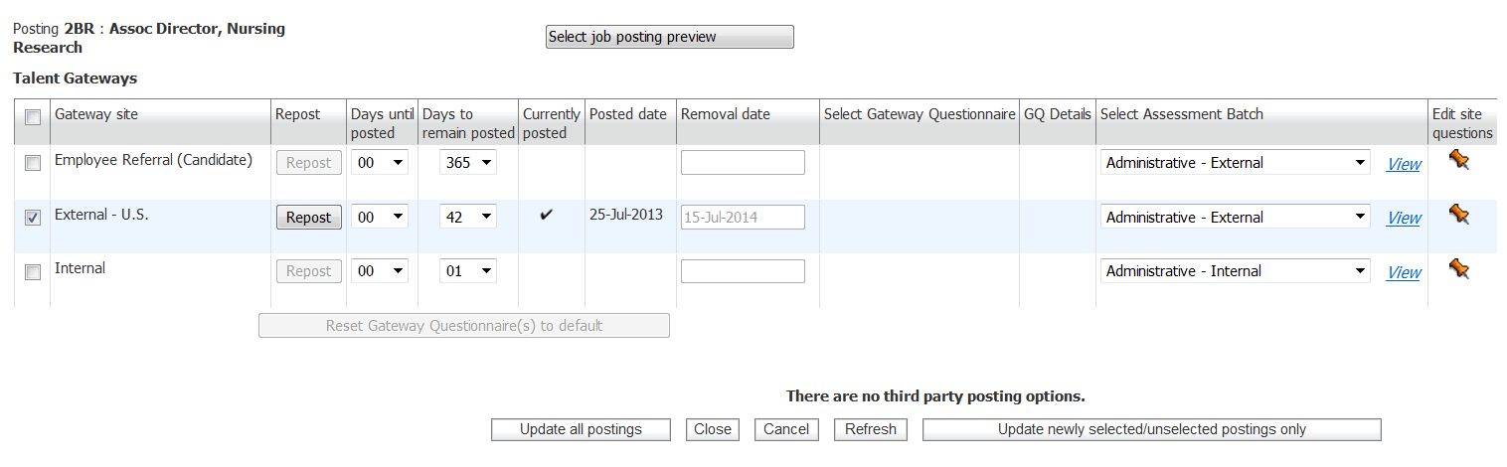
2
6
1
3
4
5

XML Tag | Description
1 - SITEID | SITE ID is mandatory and is the unique identifier for a given Talent Gateway. This number will vary between staging and production. If a new Gateway is created, a new Site ID will have to be added. Site IDs can be found in Workbench under Tools > Talent Gateways.
1 - NAME | NAME is mandatory and is the display name of a given Talent Gateway. This value is generally the same between staging and production. If a new Gateway is created, a new name will have to be added. Name can be found in Workbench under Tools > Talent Gateways.
2 - GQNAME | Gateway Questionnaire name. This value is generally the same between staging and production. If a GQ is revised or created, the name will have to be added in the XML. GQ Name can be found in Workbench under Tools > Gateway Questionnaires.
3 - ASSESSMENTBATCH | Name of the Assessment Batch associated to the posting. This is a query-select field in BrassRing that requires you to send Description (i.e. the name as you see it in Workbench/BrassRing).
4 - DAYSTILLPOSTING | This value indicates the date in which the Req should be posted on the gateway. A value of 0 indicates that it should be posted right away.
5 - POSTINGDAYS | This value sets the number of days a given Req should remain active on a given gateway. NOTE: Setting the value to 0 will un-post a Req if it is currently posted.
6 - STATUS | Status can be either “A” (Active/Posted/Checked) or “I” (Inactive/Not Posted/Unchecked).
_

Below is a screen print of the Edit Site Questions page along with a description of each tag that is associated to this page.
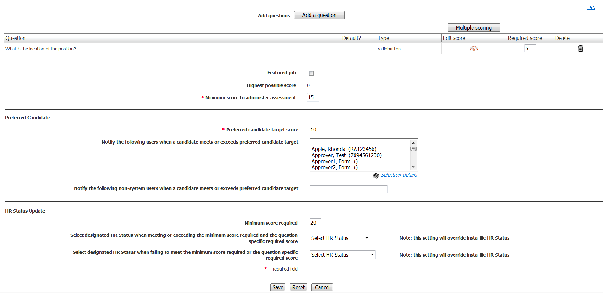
7
6
5
4
3
2
1

XML Tag | Description
1 - QUESTIONIDS | Adds questions to the posting. Please note that if values are provided, they wipe out the default questions associated to the specific gateway so please make sure to include the IDs for all the questions you want the candidate to answer.
2 - requiredscore | Required scores can be entered for any QUESTIONIDS that contain options for the candidate to choose from. This feature aid in screening candidates.
3 - MINSCORE | The target score is the threshold to define candidates who will be automatically routed to the designated users. A target score of "0" will assure that every candidate who applies for the position will be sent to the designated individuals. (An account setting may default this to the highest score possible).
4 – MINASSESSMENTSCORE | For use with scoring assessments. Accounts using the "Always launch assessments" setting will ignore this value.
5 - MINREQUIREDSCORE | For use when updating a candidate’s HR Status based on score.
6 - PASSHRSTATUS | For use when updating a candidate’s HR Status based on score. Must be a Start Status.
7 - FAILHRSTATUS | For use when updating a candidate’s HR Status based on score. Must be a Final Status.

      - Text Area Field Types
This rule applies to Text Area fields
XML Tag | Tag Required? | Value Required? | Format | Length
CUSTOM_TEXTAREA | No | No | Varchar
Rules:
Maximum allowed length for a Text Area type is 4000 characters.

      - “Option” Field Types (i.e. single-select, multi-select, check-box, radio button)
This rule applies to Option type custom and standard questions
XML Tag | Tag Required? | Value Required? | Format | Length
CUSTOM_SELECT/  STANDARD_SELECT | No | No | Varchar
Rules:
Value passed for an option question is the description defined for that field by default.
On field-by-field level, this setting can be adjusted to accept the code. This is highly recommended for multi-language integration Clients. Descriptions should be translated for each option for all languages that Reqs will be imported.
For example, if a Swedish requisition is being imported with a department code, the Swedish translation must exist for that code for the department field. See below the translated options for a given field in multiple languages.
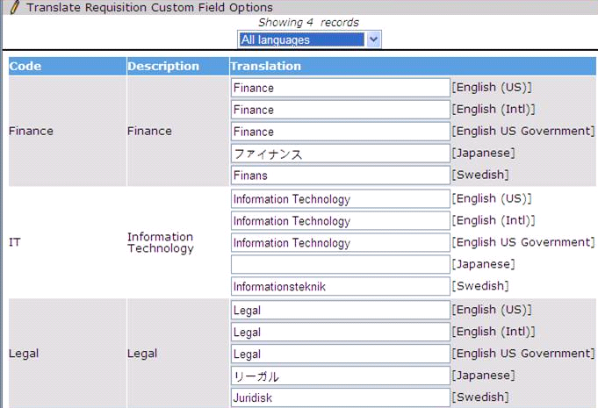
If Option question is a type of multi-select and multiple options should be passed and defaulted, that tag should repeated with appropriate defined values. For example:
<BUSINESSLOCATION>Boston</BUSINESSLOCATION>
<BUSINESSLOCATION>Miami</BUSINESSLOCATION>

    - Special Attributes
Requisition import has one mandatory attribute: “formtypeid.”. Each requisition template in the BrassRing system is represented by an auto-generated unique identifier. Including this numeric value in the “formtypeid” attribute is mandatory to be able to create a requisition in a given template.
Please note, since staging and production are independent environments, the formtypeid(s) are different in staging and production. Production formtypeid values will be provided, after production publish is complete and when UAT is signed off. Please refer to sample file section to view an example.
<REQUISITION formtypeid="134" name="Hourly">
Requisition import can also support multiple languages. Language is handled via an attribute. If a requisition must be created in multiple languages, that requisition must be submitted multiple times to BrassRing. Language attributes accepts 2 letter ISO format. BrassRing has a standard, static list of languages and their corresponding ISO formats. Client and PSE engineering should understand all the languages which will be used for a client to ensure all possible attribute values are exchanged.
If sending multiple languages for the same job, then the REQUISITIONNUMBER value should remain the same for all the languages and the language attribute will specify the language, example, EN, FR, ES, etc.
<REQUISITION formtypeid="1234" AutoFilerNotification="No" language="EN">
To keep the existing Req Status in the BrassRing system unchanged, pass an additional attribute in the following tag. This is especially useful during sending updates.
<JOB_REQ_STATUS KEEPSTATUS="Y"/>
Requisition import can also support selecting and deselecting auto filer notification. Auto filer notification, can be handled via AutoFilerNotification attribute. AutoFilerNotification attribute can only accept the following values:
Yes (Passing Yes means, uncheck/unselect auto filer notification check box)
No(Passing no means, check/select auto filer notification check box)

Please note values below are just sample data. Client-specific values will be provided during the sample file creation phase.
<REQUISITION formtypeid="1234" AutoFilerNotification="No" language="EN">
<REQUISITION formtypeid="1234" AutoFilerNotification="Yes" language="ES">

- XML Schemas
  - Sample XML Request
Below is a sample Requisition XML file. The items highlighted in yellow are required to be sent within the Payload. You can only send 1 Requisition data in a single XML.
<?xml version="1.0"?>
<Envelope version="01.00">
<Sender>
<Id>INTEGRATIONID</Id>
<Credential>CLIENTID</Credential>
</Sender>
<Recipient>
<Id/>
</Recipient>
<TransactInfo transactType="data">
<TransactId>15747</TransactId>
<TimeStamp>2006-02-28 09:22:10AM</TimeStamp>
</TransactInfo>
<Packet>
<PacketInfo packetType="data">
<PacketId>1</PacketId>
<Action>SET</Action>
<Manifest>CLIENT_REQUISITION</Manifest>
</PacketInfo>
<!-- Please note formtypeid attribute/attributes will change in production -->
<!-- Confidential Requisition Form= 123, Contractor= 124,Employee Requisition Form=125 -->
<Payload><![CDATA[<?xml version="1.0"?>
<REQUISITION formtypeid='123' name = “Confidential Requisition Form”>
<JOB_REQ_STATUS>1</JOB_REQ_STATUS>
<REQUSITIONNUMBER>Job Number</REQUSITIONNUMBER>
<JOBDESCRIPTION>Corporate. Under moderate supervision, designs, develops, tests, debugs and implements moderately complex operating systems components, software tools, and utilities required for the operation, maintenance, and control of computer systems. Makes moderately complex modifications to existing software to fit specialized needs and configurations. &lt;font face="Arial"&gt; &lt;strong&gt;This Summary Overview generally describes key job duties for Taco Bell Corporate employees.&#160; It is not all-inclusive, and a similar job at other Brands, Franchise or License locations may be different.&lt;/strong&gt;&lt;/font&gt;
</JOBDESCRIPTION>
<JOBTITLE>Systems Engineer</JOBTITLE>
<MANAGER>ManagerFirstName Lastname</MANAGER>
<RECRUITER>RecruiterFirstname Lastname</RECRUITER>
<DEPARTMENT>Corporate IT</DEPARTMENT>
<JOBCODE>A00268</JOBCODE>
<NUMBEROFPOSITIONS>1</NUMBEROFPOSITIONS>
<JOBFUNCTION>Information Technology</JOBFUNCTION>
<JOBFAMILY>Applications</JOBFAMILY>
<SALARYGRADE>Supervisor/Intermediate Prof</SALARYGRADE>
<FULLTIMEPARTTIME>Full time</FULLTIMEPARTTIME>
<REGULARTEMPORARY>Regular</REGULARTEMPORARY>
<SHIFT>All Shifts</SHIFT>
<COMPANY>Cool Beans, Inc.</COMPANY>
<BUSINESSUNIT>Corporate</BUSINESSUNIT>
<EEO1JOBCATEGORY>2-Professionals</EEO1JOBCATEGORY>
<FLSA>Exempt</FLSA>
<TEAM action=”replace”>
<EMPLOYEEID>3057559</EMPLOYEEID>
<EMPNAME>John Smith</EMPNAME>
</TEAM>
<Proximity>
<CountryId>223</CountryId><StateId>1924</StateId><CityId>56315</CityId><Zip>02452</Zip>
</Proximity>
<JOBOO>
<SITE ID="123" NAME="Acme Inc Careers" DAYSTILLPOSTING="0" POSTINGDAYS="365" QUESTIONSIDS="" STATUS="A"/>
<SITE ID="456" NAME="Internal Opportunities" DAYSTILLPOSTING="0" POSTINGDAYS="365" QUESTIONSIDS="" STATUS="A"/>
</JOBOO>
</REQUISITION>]]></Payload> </Packet></Envelope>
  - Sample XML Response (Success)
Below is a sample success response XML file.
<?xml version="1.0" encoding="utf-8"?>
<Envelope version="01.00">
<Sender>
<Id>INTEGRATIONID</Id>
<Credential>CLIENTID</Credential>
</Sender>
<Recipient>
<Id/>
</Recipient>
<TransactInfo transactType="response">
<TransactId>ABC12345</TransactId>
<TimeStamp>2012-05-30 09:22:29</TimeStamp>
<Status>
<Code>200</Code>
<ShortDescription>Success</ShortDescription>
<LongDescription>REQUISITION Data transfer was a success</LongDescription>
</Status>
</TransactInfo>
<Packet>
<PacketInfo packetType="response">
<PacketId>1</PacketId>
<Action>SET</Action>
<Manifest>REQUISITION_IMPORT</Manifest>
<Status>
<Code>200</Code>
<ShortDescription>Success</ShortDescription>
<LongDescription>REQUISITION Data transfer was a success</LongDescription>
</Status>
</PacketInfo>
<Payload/>
</Packet>
</Envelope

  - Sample XML Response (Failure)
Below is a sample failure response XML file.
<?xml version="1.0" encoding="utf-8"?>
<Envelope version="01.00">
<Sender>
<Id>INTEGRATIONID</Id>
<Credential>CLIENTID</Credential>
</Sender>
<Recipient>
<Id/>
</Recipient>
<TransactInfo transactType="response">
<TransactId>ABC12345</TransactId>
<TimeStamp>2012-05-30 09:21:36</TimeStamp>
<Status>
<Code>405</Code>
<ShortDescription>Failure</ShortDescription>
<LongDescription>REQUISITION Data transfer was not successful</LongDescription>
</Status>
</TransactInfo>
<Packet>
<PacketInfo packetType="response">
<PacketId>1</PacketId>
<Action>SET</Action>
<Manifest>REQUISITION_IMPORT</Manifest>
<Status>
<Code>405</Code>
<ShortDescription>Invalid option specified</ShortDescription>
<LongDescription>Validate Custom Question 4600/RECRUITMENGROUP has an invalid option</LongDescription>
</Status>
</PacketInfo>
<Payload/>
</Packet>
</Envelope>

  - Handling special characters in XML requests
There are several special characters that are either not allowed or not recommended for use within XML transmissions within text nodes, even within the CDATA section. These characters are: < (less than), > (greater than), & (ampersand), '(apostrophe) and "(quotation mark). In cases where these options appear within a text node within the XML, these characters must be escaped in order for the import to work without error.

The following table describes how special characters should be escaped in XML. Apostrophes, quotation marks and greater than signs are legal, but BrassRing recommends replacing them with the corresponding escape sequences, as well.

Special Characters | Escaped Character
< (less than) | &lt;
> (greater than) | &gt;
& (ampersand) | &amp;
' (apostrophe) | &apos;
" (quotation mark) | &quot;

Below are additional special characters that are not allowed in the Code values.

Other Special Characters | Denotation
; | semi colon
" | double quotes/single quotes
! | exclamation
~ | tilda
@ | apple
# | hash
= | equal to
+ | add
? | question mark
, | comma
> < | greater than / less than
% | percent
| | pipe
[ ] | square brackets
{} | curly braces

The above special characters are not allowed to be used in the Code values. Special characters such as above conflict with non-XML integrations and can be mistaken or conflict with delimiters in some integrations.
- Envelope Processing
The top level Envelope contains two attributes, version and encoding.
Version attribute identifies the version of the envelope. The only valid value at this time is “01.00”.
Encoding attribute identifies XML encoding and is optional. It can be set to “UTF-8” or “UTF-16”. The recommended setting is “UTF-16”.
The Envelope also has four top-level mandatory elements (Sender, Recipient, TransactInfo and Packet). These elements are described in detail below.
  - Sender
The values below will be provided at the time of implementation.
Employee Id: Sent in the Id tag for envelopes coming into BrassRing. This acts as the identification of the user who sends the XML data.
Client Id : Sent in the Credential tag.
  - Recipient
The URL of the recipient is passed in the Id tag. This helps to identify whether the data has been sent to the correct recipient destination.
  - TransactInfo
An identifier for the transaction should be included in the TransactId. This identifies the envelope transaction and not any of the constituent data, since there could be multiple documents within one envelope. The combination of the client Id, TransactId and PacketId creates a globally unique identifier for each packet.

A timestamp can be added in the optional TimeStamp. This date format should conform to ISO standard 8601 (i.e. “2000-10-09T14:14:11Z”)

transactType should be set to “data”. This attribute helps provide the envelope parser with a heads up on what to expect in the payloads.
  - Packet
The Packet contains the payload and metadata about the payload. The Payload element contains the actual XML and the PacketInfo element contains the metadata about the packet.

PacketInfo contains the following elements:
packetType This attribute describes the content of the packet. A packetType of data is the default.
PacketId: This element uniquely identifies the contents of the payload. PacketId is 1 unless suggested otherwise
Action: This optional element contains the transaction code – SET
Manifest: This is a mandatory element that identifies the contents of the payload. This field must be set to the value provided during implementation and should not be changed.
  - Payload
The Payload element contains one HR-XML document inside a CDATA section. This approach allows the payload to be parsed separately from the envelope and avoids any interdependency between envelope and contents when validating envelope documents.

Note: the Payload XML should not have any additional CDATA section within it as in nested CDATA sections.

- Security
Several security protocols and measures have been implemented to ensure security on the data transmission, message integrity, and message confidentiality. These mechanisms can be used to accommodate a wide variety of security models and encryption technologies.
  - Standard Implementation Security
    - Message Integrity
Message integrity is ensured on the XML data. Unique credentials within the XML act as authentication information for a transaction to be consumed. These credentials in the Id, Credential and Manifest nodes act as unique value for a given implementation.
    - Transport Layer Security (TLS)
Transport Layer Security (TLS) and its predecessor, Secure Sockets Layer (SSL), are cryptographic protocols that provide communication security over the Internet. TLS and SSL encrypt the segments of network connections above the Transport Layer, using asymmetric cryptography for key exchange, symmetric encryption for privacy, and message authentication codes for message integrity.

BrassRing integration API URLs (web service and HTTP Post URLs) are HTTPS-enabled and utilize 128 bit encryption over SSL when exchanging and transmitting information over the Internet. This is a mandatory encryption of the data that is enforced.
    - IP restrictions
To add another layer to security and protection, IP restrictions can also be enforced. At the time of implementation, IP addresses from Staging and Production environments can be provided that can be white-listed on an external firewall on the customer’s network. These IP addresses are provided on request.
  - Optional Security Features
    - Message Layer Encryption/Security (MLS)
In additional to the above security protocols, message layer encryption is also available on the payload data.

Message layer encryption is facilitated using RSA encryption on the XML. Both Java and Microsoft .NET development environments support APIs for RSA encryption. BrassRing uses 1024-bit RSA encryption key pairs along with a public key generated by the client to implement functions to encrypt, sign, decrypt and authenticate data.

Adding MLS adds to the cost and timeline of the project and as this is not part of standard implementations.

    - 2-Way SSL / Certificate Based Authentication
Additionally, client certificate authentications or 2-way SSL or mutual SSL authentication is also available to enforce additional security around the integrations. The method of data exchange is accomplished with the use of certificates that confirm the source of the data before processing the information. SSL Session negotiated by Handshake Protocol via a X.509 public key Certificate of Peer.

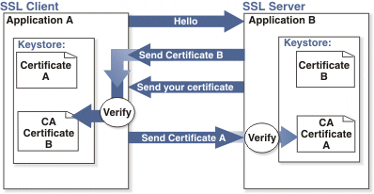

Adding 2-way SSL adds to the cost and timeline to the project as this is not part of Standard implementations.

Note: 2-way SSL is currently not available to clients on the China data-center.

- Integration API URLs
  - Message Router Addresses
Web service URLs you need to invoke to send transactional data to BrassRing. These URLs below apply to the US data-center only. Europe and China end point URLs are provided during time of implementation on such integrations.

Staging Environment
Web Service
URL - https://staging.brassring.com/HRISprocessor9/DispatchMessage.asmx
WSDL - https://staging.brassring.com/HRISprocessor9/DispatchMessage.asmx?wsdl

HTTP Post
URL - https://staging.brassring.com/jetstream/500/presentation/template/asp/HRISIntegration/msgdispatch.asp

Production Environment
Web Service
URL - https://trm.brassring.com/HRISprocessor9/DispatchMessage.asmx
WSDL - https://trm.brassring.com/HRISprocessor9/DispatchMessage.asmx?wsdl

HTTP Post
URL - https://trm.brassring.com/jetstream/500/presentation/template/asp/HRISIntegration/msgdispatch.asp

- API Error Messages
Below is a list of error messages that you may encounter when using the Requisition Import integration. We have also included an explanation in order to assist you with troubleshooting.

Code | Error Description | Reasoning
401 | ValidateAccess: - Access not setup for Sender – DSDSDS | Value in the Sender tag is incorrect
401 | Credential value is invalid | Value in the Credential tag in incorrect
405 | getProfileInfo: - Inactive subscription | Value in the Manifest tag is incorrect
405 | Data must be present in JobTitle to create a requisition | JobTitle is required
405 | Validate Custom Question : Question ID/FIELDNAME has an invalid option | Invalid Option Specified.
405 | spReqImport : Stored Procedure error Cannot change status of requisition from 3 to 7 | This error is encountered when an invalid sequence for the Job Req Status is sent. Refer to 2.6.1

NOTE: This list is not all inclusive but contains the errors that are most encountered.

Notices
This information was developed for products and services offered in the U.S.A and other countries. Consult your local IBM representative for information on the products and services currently available in your area. Any reference to an IBM product, program, or service is not intended to state or imply that only that IBM product, program, or service may be used. Any functionally equivalent product, program, or service that does not infringe any IBM intellectual property right may be used instead. However, it is the user's responsibility to evaluate and verify the operation of any non-IBM product, program, or service.
IBM may have patents or pending patent applications covering subject matter described in this document. The furnishing of this document does not grant you any license to these patents. You can send license inquiries, in writing, to:
IBM Director of Licensing
IBM Corporation
North Castle Drive
Armonk, NY 10504-1785
U.S.A.
For license inquiries regarding double-byte (DBCS) information, contact the IBM Intellectual Property Department in your country or send inquiries, in writing, to:
Intellectual Property Licensing
Legal and Intellectual Property Law
IBM Japan Ltd.
1623-14, Shimotsuruma, Yamato-shi
Kanagawa 242-8502 Japan
The following paragraph does not apply to the United Kingdom or any other country where such provisions are inconsistent with local law:
INTERNATIONAL BUSINESS MACHINES CORPORATION PROVIDES THIS PUBLICATION “AS IS” WITHOUT WARRANTY OF ANY KIND, EITHER EXPRESS OR IMPLIED, INCLUDING, BUT NOT LIMITED TO, THE IMPLIED WARRANTIES OF NON-INFRINGEMENT, MERCHANTABILITY OR FITNESS FOR A PARTICULAR PURPOSE.
Some states do not allow disclaimer of express or implied warranties in certain transactions, therefore, this statement may not apply to you.
This information could include technical inaccuracies or typographical errors. Changes are periodically made to the information herein; these changes will be incorporated in new editions of the publication. IBM may make improvements and/or changes in the product(s) and/or the program(s) described in this publication at any time without notice.
Any references in this information to non-IBM Web sites are provided for convenience only and do not in any manner serve as an endorsement of those Web sites. The materials at those Web sites are not part of the materials for this IBM product and use of those Web sites is at your own risk. IBM may use or distribute any of the information you supply in any way it believes appropriate without incurring any obligation to you.

Licensees of this program who wish to have information about it for the purpose of enabling: (i) the exchange of information between independently created programs and other programs (including this one) and (ii) the mutual use of the information which has been exchanged, should contact:
IBM Corporation
5 Technology Park Drive
Westford Technology Park
Westford, MA 01886

Such information may be available, subject to appropriate terms and conditions, including in some cases, payment of a fee.
The licensed program described in this information and all licensed material available for it are provided by IBM under terms of the IBM Customer Agreement, IBM International Program License Agreement, or any equivalent agreement between us.
Any performance data contained herein was determined in a controlled environment. Therefore, the results obtained in other operating environments may vary significantly. Some measurements may have been made on development-level systems and there is no guarantee that these measurements will be the same on generally available systems. Furthermore, some measurements may have been estimated through extrapolation. Actual results may vary. Users of this document should verify the applicable data for their specific environment.
Information concerning non-IBM products was obtained from the suppliers of those products, their published announcements or other publicly available sources. IBM has not tested those products and cannot confirm the accuracy of performance, compatibility or any other claims related to non-IBM products. Questions on the capabilities of non-IBM products should be addressed to the suppliers of those products.
All statements regarding IBM's future direction or intent are subject to change or withdrawal without notice, and represent goals and objectives only. All IBM prices shown are IBM's suggested retail prices, are current and are subject to change without notice. Dealer prices may vary.
This information is for planning purposes only. The information herein is subject to change before the products described become available.
This information contains examples of data and reports used in daily business operations. To illustrate them as completely as possible, the examples include the names of individuals, companies, brands, and products. All of these names are fictitious and any similarity to the names and addresses used by an actual business enterprise is entirely coincidental.

Trademarks
These terms are trademarks of International Business Machines Corporation in the United States, other countries, or both:
- IBM
- AIX
- Sametime
- WebSphere
Java and all Java-based trademarks and logos are trademarks or registered trademarks of Oracle and/or its affiliates.
Microsoft and Windows are registered trademarks of Microsoft Corporation in the United States, other countries, or both.
Linux is a trademark of Linus Torvalds in the United States, other countries, or both.
Other company, product, or service names may be trademarks or service marks of others.

