IBM® Kenexa® BrassRing on the Cloud

HR Status Update Technical Specifications API Guide

Version 1.1
Release Date: July 22, 2014

Edition Notice
Note: Before using this information and the product it supports, read the information in the Notices section at the end of this document.
This edition applies to IBM® Kenexa® BrassRing on the Cloud and to all subsequent releases and modifications until otherwise indication in new editions.

Licensed Materials - Property of IBM

© Copyright IBM® Corporation, 2014.
US Government Users Restricted Rights – Use, duplication or disclosure restricted by GSA ADP Schedule Contract with IBM Corp.

Table of Contents
Edition Notice I
Chapter 1: Introduction 4
1.1 What are BrassRing’s XML Integration APIs 4
1.2 Purpose 4
1.3 Audience 4
Chapter 2: BrassRing’s HR Status Update Integration APIs 5
2.1 Overview 5
2.2 Communication Methodology 5
2.3 Rules for the HR Status Update Integration 5
2.4 HR Status Snapshot (BrassRing) 6
2.4.1 Candidate Grid 6
2.4.2 Candidate Record 6
2.4.3 Current HR Status 7
2.4.4 HR Status History 7
2.4.5 HR Status Update 7
2.5 HR Status Update Tag Definitions 8
2.5.1 Candidate Identifier Attributes 8
2.5.2 reqid 8
2.5.3 Action Date 9
2.5.4 Language and HR Status 9
Chapter 3: XML Schemas 10
3.1 Sample XML Request 10
3.2 Sample XML Response (Success) 11
3.3 Sample XML Response (Failure) 12
3.4 Handling special characters in XML requests 13
Chapter 4: Envelope Processing 14
4.1 Sender 14
4.2 Recipient 14
4.3 TransactInfo 14
4.4 Packet 14
4.5 Payload 15
Chapter 5: Security 16
5.1 Standard Implementation Security 16
5.1.1 Message Integrity 16
5.1.2 Transport Layer Security (TLS) 16
5.1.3 IP restrictions 16
5.2 Optional Security Features 16
5.2.1 Message Layer Encryption/Security (MLS) 16
5.2.2 2-Way SSL / Certificate Based Authentication 17
Chapter 6: Integration API URLs 18
6.1 Message Router Addresses 18
Chapter 7: API Error Messages 19
Notices 20
Trademarks 21

- Introduction
  - What are BrassRing’s XML Integration APIs
BrassRing XML integrations feature flexible, secure, real-time integrations by sending XML over the Internet using web services or HTTP Posts. XML formats used in BrassRing integrations are based on HR-XML Consortium guidelines.

The BrassRing XML integrations offering allows BrassRing to work with the customers to configure multi-level, robust integration relationships between BrassRing and any systems that can send and receive XML. Examples of these systems include HRIS systems such as SAP/Oracle/PeopleSoft, etc., and systems that perform HR related services like background checks, assessments or compensation analysis.

The customer can choose to send data through either a web service or HTTP post. BrassRing handles the exchange of XML requests and responses using its own messaging software. The customer builds their own messaging system to exchange XML web service messages or HTTP post with BrassRing.
  - Purpose
The purpose of this document is as follows:
To present high-level architecture and design of BrassRing APIs and how BrassRing implements HR Status Update integrations to meet its customers’ needs for automated data management.
To describe suggested high-level workflow processes that can be supported between BrassRing and any external, third-party system that can send and receive XML requests and responses.
To describe the steps required to implement the HR Status Update integration.
  - Audience
Client Decision Makers, HRIS Implementation Teams, Internal IT Teams, Systems Integrators and Support Teams.
BrassRing Engineering Services Team, Support Team, and Technical Services Group.

- BrassRing’s HR Status Update Integration APIs
  - Overview
Candidate HR status information can be imported from an external system to BrassRing. In BrassRing, candidate status defines at which step a candidate is in the hiring process. This integration service is intended to update the HR Status of candidate(s). The integration can be used by client HRIS systems or 3rd party vendors that wish to integrate with BrassRing.

The integration service will follow tracking logic rules that are set up in BrassRing with respect to start, intermediate and final HR Statuses.

The service does not support “Undo” HR Status or final HR Status updates such as “Hired” that will either Auto-Close a requisition or Count Down positions on a requisition.
  - Communication Methodology
Connection to the BrassRing Internal Talent Gateway system is accomplished via Web Services as a data transfer vehicle.

The above mechanism is synchronous, meaning all transactions are real-time with a request-response messaging and no message queuing.

The XML format is depicted in Section 3.

Client can choose to batch transactions or send data to BrassRing in real-time.

BrassRing will always process transactions in real-time regardless of whether they were batched or not by the client.
  - Rules for the HR Status Update Integration
The HR Status Update integration automates sending of HR Status updates from an external system to a candidate record in BrassRing.

Below are a few rules to consider when looking into the use of the HR Status Update Integration:
The XML schema cannot be customized (see sample XML below).
HR Status Update XML files are processed real-time via Web Services.
Customer’s HRIS or external system should wait for a success/failure response before sending the next transaction in a sequential manner.
Field requirements are outlined in the Data Mapping sections.
The Updated By value cannot be set through the import and will always appear in BrassRing as Integration, System.
The HR Status Update XML cannot be used to file a candidate to a Req, only update an HR Status for a candidate in a Req in which they are already filed.
HR Statuses can only be updated on Open Requisitions.
Send delta loads only. Full/destructive loads are not recommended.
  - HR Status Snapshot (BrassRing)
Below are screen prints of the HR Status sections of the Candidate Record in BrassRing for your reference.
    - Candidate Grid
The Candidate Grid can display current HR Status information for all candidates in the folder. Please note that the grid is configurable by user so it may look slightly different than below. Please see your IBM Representative to learn how to update configuration of this page.
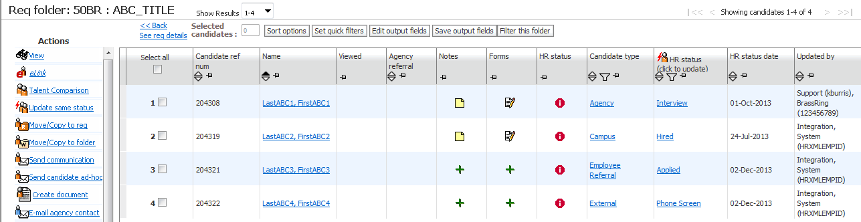
    - Candidate Record
The Candidate Record will display HR Status actions for the selected candidate in the Action Log. Also, if configured, you may see current HR Status details on the candidate ribbon.
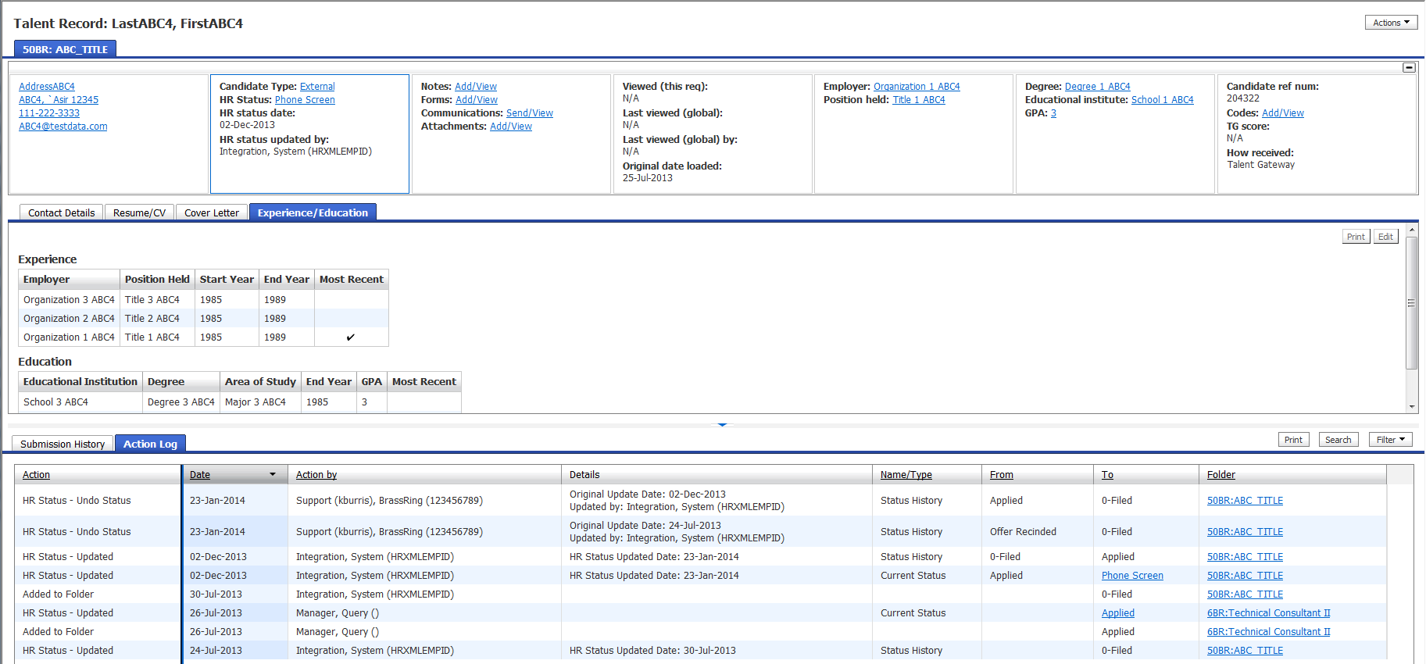

    - Current HR Status
The Current HR Status page will display the selected candidates current HR Status for all Reqs in which they are filed.
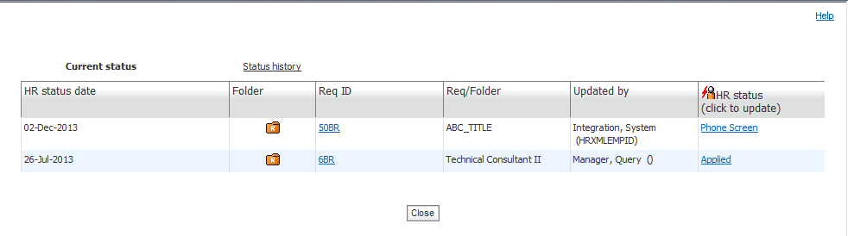
    - HR Status History
The Status History page will display the selected candidates HR Status History for all Reqs for which they are filed.
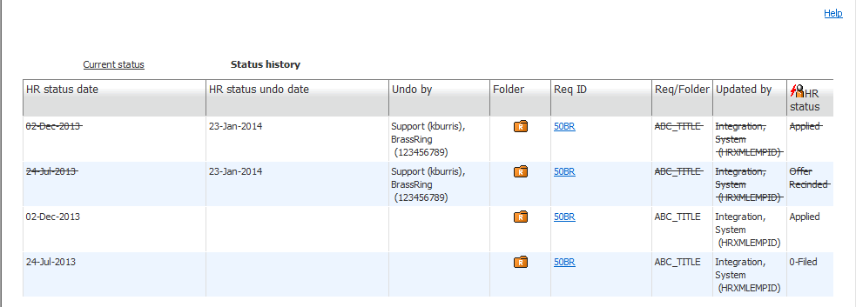
    - HR Status Update
The HR Status Update page is where users can update the candidate’s current HR Status.
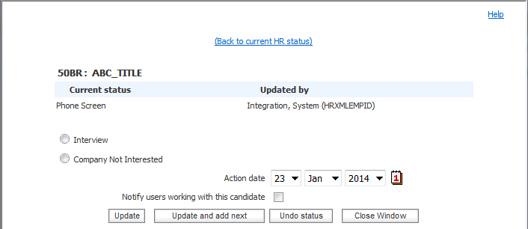

  - HR Status Update Tag Definitions
XML tags for the HR Status Update integration are categorized below.

    - Candidate Identifier Attributes
These attributes are used to determine the candidate the HR Status Update is associated to.
XML Tag | Tag Required? | Value Required? | Format | Length
resumekey | See rules below | See rules below. | Numeric | 15
firstname | See rules below | See rules below. | Varchar | 100
lastname | See rules below | See rules below. | Varchar | 100
email | See rules below | See rules below. | Varchar | 200
phone | See rules below | See rules below. | Varchar | 25
bruid | See rules below | See rules below. | Numeric | 15
Rules:
If resumeKey value is passed then no other candidate information is required (i.e. firstname, lastname, email and phone is not necessary.
If resumeKey value is not available, then firstname, lastname and (email or phone) value must be sent.
bruid is an internal representation of the Candidate ID in BrassRing. It is unlikely that an external system would be able to reference this value.

    - reqid
The Req Number in which the Candidate and HR Status are associated to.
XML Tag | Tag Required? | Value Required? | Format | Length
reqid | Yes | Yes | Varchar
Rules:
If Client Setting “Req Trigger” is set to Auto send the AutoReqID (i.e. 1234BR).
If Client Setting “Req Trigger” is set to Optional send the Optional Req ID.
HR Status will not update on a Req that is On Hold or Cancelled.

    - Action Date
The date in associated to the HR Status Update Action.
XML Tag | Tag Required? | Value Required? | Format | Length
actiondate | Yes | No | MM-DD-YYYY | 10
Rules:
If no value sent, the action date will default to the date the import was submitted.

    - Language and HR Status
This attribute is used to determine the “Action” to be performed
XML Tag | Tag Required? | Value Required? | Format | Length
language | No | No | Varchar | 2
HR Status | Yes | Yes | Varchar | 255
Rules:
Language is a 2 letter ISO code (i.e. EN, FR, etc.).
The integration will follow the tracking logic rules that are set up in BrassRing with respect to start, intermediate and final HR Status. Integration will error if tracking logic is not followed.
BrassRing integrations do not support “Undo” HR Status or final HR Status updates such as “Hired” that will either Auto-Close a requisition or Count Down positions on a requisition.

- XML Schemas
  - Sample XML Request
Below is a sample HR Status Update XML file for your reference.

<?xml version="1.0" encoding="UTF-8"?>
<Envelope version="01.00" xmlns:xsi="http://www.w3.org/2001/XMLSchema-instance">
<Sender>
<Id>BrassRing to provide</Id>
<Credential>BrassRing to provide</Credential>
</Sender>
<Recipient>
<Id/>
</Recipient>
<TransactInfo transactType=”data”>
<TransactId>3368</TransactId>
<TimeStamp>2014-01-24 12:07 PM</TimeStamp>
</TransactInfo>
<Packet>
<PacketInfo packetType=”data”>
<PacketId>1</PacketId>
<Action>INSERT</Action>
<Manifest>Kenexa to provide</Manifest>
</PacketInfo>
<Payload><![CDATA[<?xml version=”1.0” encoding=”UTF-8”?>
<UpdateStatus>
<Candidate firstname=”” lastname=”” email=”” phone=”” resumekey=”204308” bruid=””>
<status reqid=”50BR” actiondate=”01-24-2014” language=”en”>Offer Extended</status>
</Candidate>
</UpdateStatus>]]></Payload>
</Packet>
</Envelope>

  - Sample XML Response (Success)
Below is a sample success response XML file.
<?xml version=”1.0” encoding=”utf-8”?>
<Envelope version=”01.00” xmlns:xsi=”http://www.w3.org/2001/XMLSchema-instance”>
<Sender>
<Id>BrassRing to provide</Id>
<Credential>BrassRing to provide</Credential>
<remoteIP>216.52.51.250</remoteIP>
</Sender>
<Recipient>
<Id/>
</Recipient>
<TransactInfo transactType=”response”>
<TransactId>3368</TransactId>
<TimeStamp>2013-02-25 17:53 PM</TimeStamp>
<Status>
<Code>200</Code>
<ShortDescription>Success</ShortDescription>
<LongDescription>STATUSUPDATE Data transfer was a success</LongDescription>
</Status>
</TransactInfo>
<Packet>
<PacketInfo packetType=”response”>
<PacketId>1</PacketId>
<Action>INSERT</Action>
<Manifest>BrassRing to provide</Manifest>
<Status>
<Code>200</Code>
<ShortDescription>Success</ShortDescription>
<LongDescription>Candidate HRStatus was successfully updated</LongDescription>
</Status>
</PacketInfo>
<Payload><![CDATA[<UpdateStatus>
<Candidate resumekey=”204308”>
<status language=”EN” reqid=”50BR” actiondate=”12-02-2013”>Offer Extended</status>
</Candidate>
<Status>
<Code>200</Code>
<ShortDescription>Success</ShortDescription>
<LongDescription>Candidate HRStatus was successfully updated</LongDescription>
</Status>
</UpdateStatus>
]]></Payload>
</Packet>
</Envelope>

  - Sample XML Response (Failure)
Below is a sample failure response XML file.
<?xml version=”1.0” encoding=”utf-8”?>
<Envelope version=”01.00” xmlns:xsi=”http://www.w3.org/2001/XMLSchema-instance”>
<Sender>
<Id> BrassRing to provide </Id>
<Credential> BrassRing to provide </Credential>
<remoteIP>216.52.51.250</remoteIP>
</Sender>
<Recipient>
<Id/>
</Recipient>
<TransactInfo transactType=”response”>
<TransactId>3368</TransactId>
<TimeStamp>2013-02-25 17:53 PM</TimeStamp>
<Status>
<Code>405</Code>
<ShortDescription>Failure</ShortDescription>
<LongDescription>STATUSUPDATE Data transfer was not successful</LongDescription>
</Status>
</TransactInfo>
<Packet>
<PacketInfo packetType=”response”>
<PacketId>1</PacketId>
<Action>INSERT</Action>
<Manifest> BrassRing to provide</Manifest>
<Status>
<Code>405</Code>
<ShortDescription>HRStatus update failed</ShortDescription>
<LongDescription>Candidate HRStatus was not updated</LongDescription>
</Status>
</PacketInfo>
<Payload><![CDATA[<Root><Payload><![CDATA[<UpdateStatus>
<Candidate resumekey=”204308”>
<status language=”EN” reqid=”50BR” actiondate=”12-02-2013”>Offer Extended</status>
</Candidate>
<Status>
<Code>405</Code>
<ShortDescription>Process Status : Invalid HR status order specified. 69032 to 69032</ShortDescription>
<LongDescription>
<Candidate resumekey=”204308”>
<FailureReason>The candidate record was not created or updated. Invalid HR status order specified. Statuses must be imported in an order consistent with the configured tracking logic steps.</FailureReason>
</Candidate>
</LongDescription>
</Status>
</UpdateStatus>]]</Payload></Root>]]></Payload>
</Packet>
</Envelope>

  - Handling special characters in XML requests
There are several special characters that are either not allowed or not recommended for use within XML transmissions within text nodes, even within the CDATA section. These characters are: < (less than), > (greater than), & (ampersand), ‘(apostrophe) and “(quotation mark). In cases where these options appear within a text node within the XML, these characters must be escaped in order for the import to work without error.

The following table describes how special characters should be escaped in XML. Apostrophes, quotation marks and greater than signs are legal, but BrassRing recommends replacing them with the corresponding escape sequences, as well.

Special Characters | Escaped Character
< (less than) | &lt;
> (greater than) | &gt;
& (ampersand) | &amp;
‘ (apostrophe) | &apos;
“ (quotation mark) | &quot;

Below are additional special characters that are not allowed in the Code values.

Other Special Characters | Denotation
; | semi colon
“ | double quotes/single quotes
! | exclamation
~ | tilda
@ | apple
# | hash
= | equal to
+ | add
? | question mark
, | comma
> < | greater than / less than
% | percent
| | pipe
[ ] | square brackets
{} | curly braces

The above special characters are not allowed to be used in the Code values. Special characters such as above conflict with non-XML integrations and can be mistaken or conflict with delimiters in some integrations.
- Envelope Processing
The top level Envelope contains two attributes, version and encoding.
Version attribute identifies the version of the envelope. The only valid value at this time is “01.00”.
Encoding attribute identifies XML encoding and is optional. It can be set to “UTF-8” or “UTF-16”. The recommended setting is “UTF-16”.

The Envelope also has four top-level mandatory elements (Sender, Recipient, TransactInfo and Packet). These elements are described in detail below.
  - Sender
The values below will be provided at the time of implementation.
Employee Id: Sent in the Id tag for envelopes coming into BrassRing. This acts as the identification of the user who sends the XML data.
Client Id : Sent in the Credential tag.
  - Recipient
The URL of the recipient is passed in the Id tag. This helps to identify whether the data has been sent to the correct recipient destination.
  - TransactInfo
An identifier for the transaction should be included in the TransactId. This identifies the envelope transaction and not any of the constituent data, since there could be multiple documents within one envelope. The combination of the client Id, TransactId and PacketId creates a globally unique identifier for each packet.

A timestamp can be added in the optional TimeStamp. This date format should conform to ISO standard 8601 (i.e. “2000-10-09T14:14:11Z”)

transactType should be set to “data”. This attribute helps provide the envelope parser with a heads up on what to expect in the payloads.
  - Packet
The Packet contains the payload and metadata about the payload. The Payload element contains the actual XML and the PacketInfo element contains the metadata about the packet.

PacketInfo contains the following elements:
packetType This attribute describes the content of the packet. A packetType of data is the default.
PacketId: This element uniquely identifies the contents of the payload. PacketId is 1 unless suggested otherwise
Action: This optional element contains the transaction code – SET
Manifest: This is a mandatory element that identifies the contents of the payload. This field must be set to the value provided during implementation and should not be changed.
  - Payload
The Payload element contains one HR-XML document inside a CDATA section. This approach allows the payload to be parsed separately from the envelope and avoids any interdependency between envelope and contents when validating envelope documents.

Note: the Payload XML should not have any additional CDATA section within it as in nested CDATA sections.

- Security
Several security protocols and measures have been implemented to ensure security on the data transmission, message integrity, and message confidentiality. These mechanisms can be used to accommodate a wide variety of security models and encryption technologies.
  - Standard Implementation Security
    - Message Integrity
Message integrity is ensured on the XML data. Unique credentials within the XML act as authentication information for a transaction to be consumed. These credentials in the Id, Credential and Manifest nodes act as unique value for a given implementation.
    - Transport Layer Security (TLS)
Transport Layer Security (TLS) and its predecessor, Secure Sockets Layer (SSL), are cryptographic protocols that provide communication security over the Internet. TLS and SSL encrypt the segments of network connections above the Transport Layer, using asymmetric cryptography for key exchange, symmetric encryption for privacy, and message authentication codes for message integrity.

BrassRing integration API URLs (web service and HTTP Post URLs) are HTTPS-enabled and utilize 128 bit encryption over SSL when exchanging and transmitting information over the Internet. This is a mandatory encryption of the data that is enforced.
    - IP restrictions
To add another layer to security and protection, IP restrictions can also be enforced. At the time of implementation, IP addresses from Staging and Production environments can be provided that can be white-listed on an external firewall on the customer’s network. These IP addresses are provided on request.
  - Optional Security Features
    - Message Layer Encryption/Security (MLS)
In additional to the above security protocols, message layer encryption is also available on the payload data.

Message layer encryption is facilitated using RSA encryption on the XML. Both Java and Microsoft .NET development environments support APIs for RSA encryption. BrassRing uses 1024-bit RSA encryption key pairs along with a public key generated by the client to implement functions to encrypt, sign, decrypt and authenticate data.

Adding MLS adds to the cost and timeline of the project and as this is not part of standard implementations.

    - 2-Way SSL / Certificate Based Authentication
Additionally, client certificate authentications or 2-way SSL or mutual SSL authentication is also available to enforce additional security around the integrations. The method of data exchange is accomplished with the use of certificates that confirm the source of the data before processing the information. SSL Session negotiated by Handshake Protocol via a X.509 public key Certificate of Peer.

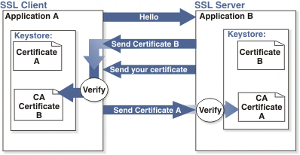

Adding 2-way SSL adds to the cost and timeline to the project as this is not part of Standard implementations.

Note: 2-way SSL is currently not available to clients on the China data-center.

- Integration API URLs
  - Message Router Addresses
Web service URLs you need to invoke to send transactional data to BrassRing. These URLs below apply to the US data-center only. Europe and China end-point URLs are provided during time of implementation on such integrations.

Staging Environment
Web Service
URL - https://staging.brassring.com/HRISStatus/HRISStatus.asmx
WSDL – https://staging.brassring.com/HRISStatus/HRISStatus.asmx?WSDL

Production Environment
Web Service
URL - https://trm.brassring.com/HRISprocessor9/DispatchMessage.asmx
WSDL – https://trm.brassring.com/HRISprocessor9/DispatchMessage.asmx?wsdl

- API Error Messages
Below is a list of error messages that you may encounter when using the HR Status Update integration. Please refer to the explanation below in order to assist you with troubleshooting.

Code | Error Description | Reasoning
401 | ValidateAccess: - Access not setup for Sender – DSDSDS | Value in the Sender tag is incorrect
401 | Credential value is invalid | Value in the Credential tag in incorrect
405 | getProfileInfo: - Inactive subscription | Value in the Manifest tag is incorrect
405 | Process Status : Invalid HR status order specified. 69032 to 69030 | Statuses must be imported in an order consistent with the configured tracking logic steps.
405 | Error Processing Profile fields | Missing candidate identifier (i.e. Name, resumekey,etc.)
405 | ValidateResumekey : Invalid Resumekey | Candidate could not be found based on resumekey provided.
405 | Reqid is blank, folderid is 0 and folderdescription is blank or invalid | No ReqID Provided
405 | Process Status : Input ReqId, FolderId or FolderDescription yielded an Invalid folderID | Req could not be found based on the ReqID provided.
405 | Process Status : Invalid Actiondate | Incorrect Date format (MM_DD_YYYY).
405 | Candidate not Filed to Requisition | Candidate must already be filed to a req in order to be updated.
405 | The candidate record was not created or updated. A req folder with a valid req status is required. | Req is not in an Open status.
405 | Timeout expired. The timeout period elapsed prior to completion of the operation or the server is not responding. | Service down. Retry message

NOTE: This list is not all inclusive but contains the errors that are most encountered.

Notices
This information was developed for products and services offered in the U.S.A and other countries. Consult your local IBM representative for information on the products and services currently available in your area. Any reference to an IBM product, program, or service is not intended to state or imply that only that IBM product, program, or service may be used. Any functionally equivalent product, program, or service that does not infringe any IBM intellectual property right may be used instead. However, it is the user's responsibility to evaluate and verify the operation of any non-IBM product, program, or service.
IBM may have patents or pending patent applications covering subject matter described in this document. The furnishing of this document does not grant you any license to these patents. You can send license inquiries, in writing, to:
IBM Director of Licensing
IBM Corporation
North Castle Drive
Armonk, NY 10504-1785
U.S.A.
For license inquiries regarding double-byte (DBCS) information, contact the IBM Intellectual Property Department in your country or send inquiries, in writing, to:
Intellectual Property Licensing
Legal and Intellectual Property Law
IBM Japan Ltd.
1623-14, Shimotsuruma, Yamato-shi
Kanagawa 242-8502 Japan
The following paragraph does not apply to the United Kingdom or any other country where such provisions are inconsistent with local law:
INTERNATIONAL BUSINESS MACHINES CORPORATION PROVIDES THIS PUBLICATION “AS IS” WITHOUT WARRANTY OF ANY KIND, EITHER EXPRESS OR IMPLIED, INCLUDING, BUT NOT LIMITED TO, THE IMPLIED WARRANTIES OF NON-INFRINGEMENT, MERCHANTABILITY OR FITNESS FOR A PARTICULAR PURPOSE.
Some states do not allow disclaimer of express or implied warranties in certain transactions, therefore, this statement may not apply to you.
This information could include technical inaccuracies or typographical errors. Changes are periodically made to the information herein; these changes will be incorporated in new editions of the publication. IBM may make improvements and/or changes in the product(s) and/or the program(s) described in this publication at any time without notice.
Any references in this information to non-IBM Web sites are provided for convenience only and do not in any manner serve as an endorsement of those Web sites. The materials at those Web sites are not part of the materials for this IBM product and use of those Web sites is at your own risk. IBM may use or distribute any of the information you supply in any way it believes appropriate without incurring any obligation to you.

Licensees of this program who wish to have information about it for the purpose of enabling: (i) the exchange of information between independently created programs and other programs (including this one) and (ii) the mutual use of the information which has been exchanged, should contact:
IBM Corporation
5 Technology Park Drive
Westford Technology Park
Westford, MA 01886

Such information may be available, subject to appropriate terms and conditions, including in some cases, payment of a fee.
The licensed program described in this information and all licensed material available for it are provided by IBM under terms of the IBM Customer Agreement, IBM International Program License Agreement, or any equivalent agreement between us.
Any performance data contained herein was determined in a controlled environment. Therefore, the results obtained in other operating environments may vary significantly. Some measurements may have been made on development-level systems and there is no guarantee that these measurements will be the same on generally available systems. Furthermore, some measurements may have been estimated through extrapolation. Actual results may vary. Users of this document should verify the applicable data for their specific environment.
Information concerning non-IBM products was obtained from the suppliers of those products, their published announcements or other publicly available sources. IBM has not tested those products and cannot confirm the accuracy of performance, compatibility or any other claims related to non-IBM products. Questions on the capabilities of non-IBM products should be addressed to the suppliers of those products.
All statements regarding IBM's future direction or intent are subject to change or withdrawal without notice, and represent goals and objectives only. All IBM prices shown are IBM's suggested retail prices, are current and are subject to change without notice. Dealer prices may vary.
This information is for planning purposes only. The information herein is subject to change before the products described become available.
This information contains examples of data and reports used in daily business operations. To illustrate them as completely as possible, the examples include the names of individuals, companies, brands, and products. All of these names are fictitious and any similarity to the names and addresses used by an actual business enterprise is entirely coincidental.

Trademarks
These terms are trademarks of International Business Machines Corporation in the United States, other countries, or both:
- IBM
- AIX
- Sametime
- WebSphere
Java and all Java-based trademarks and logos are trademarks or registered trademarks of Oracle and/or its affiliates.
Microsoft and Windows are registered trademarks of Microsoft Corporation in the United States, other countries, or both.
Linux is a trademark of Linus Torvalds in the United States, other countries, or both.
Other company, product, or service names may be trademarks or service marks of others.

