IBM® Kenexa® BrassRing on the Cloud

Foundation Import Technical Specifications API Guide

Version 1.3
Release Date: September 10, 2014

Edition Notice
Note: Before using this information and the product it supports, read the information in the Notices section at the end of this document.
This edition applies to IBM® Kenexa® BrassRing on the Cloud and to all subsequent releases and modifications until otherwise indication in new editions.

Licensed Materials - Property of IBM

© Copyright IBM® Corporation, 2014.
US Government Users Restricted Rights – Use, duplication or disclosure restricted by GSA ADP Schedule Contract with IBM Corp.

Table of Contents
Edition Notice 2
Chapter 1: Introduction 6
1.1 What are BrassRing’s XML Integration APIs 6
1.2 Purpose 6
1.3 Audience 6
Chapter 2: BrassRing’s Foundation Integration APIs 7
2.1 Overview 7
2.2 Communication Methodology 7
2.3 Rules for the Foundation Import Integration 8
2.4 Guidelines when creating Foundation Options 8
2.5 Foundation Data Snapshot (BrassRing) 9
2.6 Foundation Tag Definitions 10
2.6.1 Code 10
2.6.2 Description 10
2.6.3 Status 10
2.6.4 Special Attributes (Optional) 11
Chapter 3: XML Schemas 12
3.1 Sample XML Request 12
3.3 Sample XML Response (Success) 14
3.4 Sample XML Response (Failure) 15
3.5 Handling special characters in XML requests 16
Chapter 4: List Filtering (Optional) 17
4.1 Workbench Configuration 17
4.2 Important Notes 18
4.3 Tags for List Filtering 18
4.3.1 XML Option 1 18
4.3.2 XML Option 2 19
4.4 Sample XML with List Filtering 19
Chapter 5: Job Code Code Access Groups (Optional) 20
5.1 How to create a Code Access group 20
5.2 Features of Job Code XML 20
5.3 Sample Foundation with CAG XML 21
5.4 Managing Code Access Groups via XML 22
5.4.1 Change CAG Name/Label 22
5.4.2 Delete CAG 22
5.4.3 Remove Job Code from all CAG 22
5.4.4 Change a Job Code’s CAG 22
5.5 Asynchronous Processing 23
5.5.1 Real-Time Sync Response 23
5.5.2 Import Response/Results 24
Chapter 6: Envelope Processing 25
6.1 Sender 25
6.2 Recipient 25
6.3 TransactInfo 25
6.4 Packet 25
6.5 Payload 26
Chapter 7: Security 27
7.1 Standard Implementation Security 27
7.1.1 Message Integrity 27
7.1.2 Transport Layer Security (TLS) 27
7.1.3 IP restrictions 27
7.2 Optional Security Features 27
7.2.1 Message Layer Encryption/Security (MLS) 27
7.2.2 2-Way SSL / Certificate Based Authentication 28
Chapter 8: Integration API URLs 29
8.1 Message Router Addresses 29
Chapter 9: API Error Messages 30
Notices 31
Trademarks 32

- Introduction
  - What are BrassRing’s XML Integration APIs
BrassRing XML integrations feature flexible, secure, real-time integrations by sending XML over the Internet using web services or HTTP Posts. XML formats used in BrassRing XML integrations are based on HR-XML Consortium guidelines.

The BrassRing XML integrations offering allows BrassRing to work with the customers to configure multi-level, robust integration relationships between BrassRing and any systems that can send and receive XML. Examples of these systems include HRIS systems such as SAP/Oracle/PeopleSoft, etc., and systems that perform HR related services like background checks, assessments or compensation analysis.

The customer can choose to send data through either a web service or HTTP post. BrassRing handles the exchange of XML requests and responses using its own messaging software. The customer builds their own messaging system to exchange XML web service messages or HTTP post with BrassRing.
  - Purpose
The purpose of this document is as follows:
To present high-level architecture and design of BrassRing APIs and how BrassRing implements Foundation Import integrations to meet its customers’ needs for automated Foundation data management.
To describe suggested high-level workflow processes that can be supported between BrassRing and any external, third-party system that can send and receive XML requests and responses.
To describe the steps required to implement Foundation integration.
  - Audience
Client Decision Makers, HRIS Implementation Teams, Internal IT Teams, Systems Integrators and Support Teams.
BrassRing Engineering Services Team, Support Team, and Technical Services Group.

- BrassRing’s Foundation Integration APIs
  - Overview
Foundation data is data that is present on the BrassRing system on a Requisition form or a Candidate form as a custom drop-down list. Foundation data is sometimes referred to as form fields, and often appears in the form of tables in a Client’s HRIS system. These form fields can be uploaded into the system in one of two ways:
Manually using Workbench by Certified Workbench administrators
Automatically via Foundation Import Integrations using BrassRing APIs

The rest of the document is focused on Option 2, Foundation Import Integrations using BrassRing APIs.

These tables are usually uploaded in BrassRing during your initial system implementation and kept in synch real-time through the integrations thereafter.

Certain Form field types, such as “Single-select,” “Multi-select,” “Radio Button,” and “Check Box,” contain an options list that would house Foundation data elements. Examples of such fields could be Department, Locations, Cost Centers, Business Units, etc.
  - Communication Methodology
Connection to the BrassRing system is accomplished via two mechanisms using XML as a data transfer vehicle.
HTTP Post
Web services

Both the above mechanisms are synchronous, meaning all transactions are real-time with a request-response messaging and no message queuing. The XML format is depicted in Section 3. Client can choose to batch transactions or send data to BrassRing in real-time. BrassRing will always process transactions in real-time regardless of whether they were batched or not by the client.

  - Rules for the Foundation Import Integration
The Foundation import integration automates the management of Foundation data and eliminates the manual process of keeping the lists in synch. Foundation data can be added, updated, activated, and inactivated using the integrations.

Below are a few rules to consider when looking into the use of the Foundation Import Integration:
The XML schema cannot be customized (see sample XML below).
The Foundation Import integration should be used to maintain the options lists that are too large or change too often for a System Admin to keep up with. For those clients who have multiple Req Forms, the Foundation integration also has the ability to filter what options users see based on Req Template.
Foundation Import XML files are processed real-time via HTTP Post or Web Services.
XML should be limited to a maximum of 300 Foundation options per transaction. Customer’s HRIS or external system should wait for a success/failure response before sending the next transaction in a sequential manner.
Field requirements are outlined in the Data Mapping sections.
Send delta loads only. Full/destructive loads are not recommended.
  - Guidelines when creating Foundation Options
When creating field options, please keep in mind the following:
To limit user confusion, be as descriptive as possible.
There is a 255 character limit on the Description, but options for Single-select and Multi-select should be kept to 40 or fewer so they will easily appear in the space allowed in the drop-down list. If options are cut off, the user can click on Selection Details to view entire text.
Options can be translated into other purchased languages (translations for each language must be provided by your organization).
It is recommended to limit the use of special characters (i.e. &, ( ) *, etc.) to increase data integrity and make searching easier.
For each foundation data item, there are three required tags:
<Code> sets the foundation option code and serves as a record key to identify whether it is an update to an existing record or an insert of a new record.
<Description> sets the description of an option, which is what will be displayed to the end user in the UI.
<Status> flags each item as being active (A) or inactive (I).
Note: An ‘I’ status is used to remove the record from the user interface. Records are not actually deleted from BrassRing for historical and reporting purposes but instead are marked inactive.

  - Foundation Data Snapshot (BrassRing)
Foundation Data can be manually set up in 2x BrassRing by System Administrators or by using Workbench. Below is a screen print of the Foundation management screen in BrassRing for your reference.

Req & Candidate Form Options Lists (Admin > Admin + > Lists)
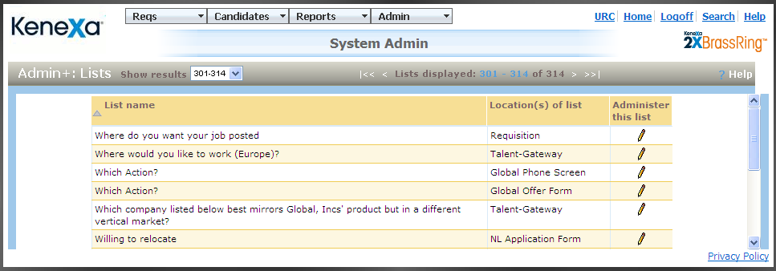

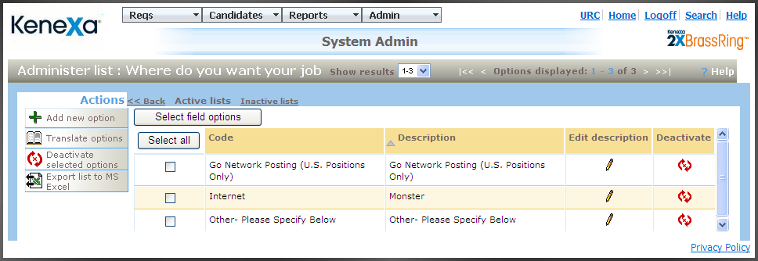

  - Foundation Tag Definitions
XML tags for Foundation Imports can be categorized as below.

    - Code
This is the tag which identifies the Code for the Foundation data. This is the value that is used to determine whether to update or insert the option in BrassRing.
XML Tag | Tag Required? | Value Required? | Format | Length
Code | Yes | Yes, required for both insert and update | Varchar | 70
Rules:
This tag plays the unique identifier for determining to insert or update an existing Option record for a Foundation field.
Avoid use of all special characters, such as & ( ) * | $ % , etc., and limit to only numeric and alphanumeric values

    - Description
This is the Description value
XML Tag | Tag Required? | Value Required? | Format | Length
Description | Yes | Yes, required for both insert and update | Varchar | 255
Rules:
Although the field allows 255 characters, we recommend you use fewer than 40 characters for better viewing experience on the drop down list.

    - Status
This tag determines whether to activate or inactivate an option.
XML Tag | Tag Required? | Value Required? | Format | Length
Code | Yes | Yes, required for both insert and update | Varchar | 5
Rules:
Valid values are A (Active) or I (Inactive).

    - Multiple Languages
Foundation data can also be sent in multiple languages if the client needs to send data in those languages. In these cases the Code always remains the same but the Description can be processed in multiple languages. This can be accomplished by using the language attribute on the Description, as in the following example where the language will be English.

<Description language="EN">Cool Beans, Inc</Description>

- XML Schemas
  - Sample XML Request
Below is a sample Foundation XML file (without list filtering) for your reference.
<?xml version="1.0"?>
<Envelope version="01.00">
<Sender>
<Id>INTEGRATIONID</Id>
<Credential>CLIENTID</Credential>
</Sender>
<Recipient>
<Id/>
</Recipient>
<TransactInfo transactType="data">
<TransactId>TRANSACTIONID</TransactId>
<TimeStamp>2006-02-28 09:22:10AM</TimeStamp>
</TransactInfo>
<Packet>
<PacketInfo packetType="data">
<PacketId>1</PacketId>
<Action>SET</Action>
<Manifest>FOUNDATION_CLIENTNAME_FIELDNAME</Manifest>
</PacketInfo>
<Payload><![CDATA[<?xml version="1.0"?>
<Foundation_Data>
<Foundation_Item>
<Code>0001</Code>
<Description>Code 1</Description>
<Status>A</Status>
</Foundation_Item>
<Foundation_Item>
<Code>0002</Code>
<Description>Code 2</Description>
<Status>I</Status>
</Foundation_Item>
<Foundation_Item>
<Code>0003</Code>
<Description>Code 3</Description>
<Status>A</Status>
</Foundation_Item>
<Foundation_Item>
<Code>0004</Code>
<Description>Code 4</Description>
<Status>A</Status>
</Foundation_Item>
<Foundation_Item>
<Code>0005</Code>
<Description>Code 5</Description>
<Status>I</Status>
</Foundation_Item>
</Foundation_Data>
]]></Payload>
</Packet>
</Envelope>
  - Sample XML Response (Success)
Below is a sample success response XML file.
<?xml version="1.0" encoding="utf-8"?>
<Envelope version="01.00">
<Sender>
<Id> INTEGRATIONID</Id>
<Credential>CLIENTID</Credential>
<remoteIP></remoteIP>
</Sender>
<Recipient>
<Id/>
</Recipient>
<TransactInfo transactType="response">
<TransactId>TRANSACTIONID</TransactId>
<TimeStamp>2012-03-19</TimeStamp>
<Status>
<Code>200</Code>
<ShortDescription>Success</ShortDescription>
<LongDescription>FOUNDATION Data transfer was a success</LongDescription>
</Status>
</TransactInfo>
<Packet>
<PacketInfo packetType="response">
<PacketId>1</PacketId>
<Action>SET</Action>
<Manifest> FOUNDATION_CLIENTNAME_FIELDNAME </Manifest>
<Status>
<Code>200</Code>
<ShortDescription>Upload successful.</ShortDescription>
<LongDescription>Foundation Data was uploaded successfully.</LongDescription>
</Status>
</PacketInfo>
<Payload/>
</Packet>
</Envelope>

  - Sample XML Response (Failure)
Below is a sample failure response XML file.
<?xml version="1.0" encoding="utf-8"?>
<Envelope version="01.00">
<Sender>
<Id> INTEGRATIONID</Id>
<Credential>CLIENTID</Credential>
<remoteIP></remoteIP>
</Sender>
<Recipient>
<Id/>
</Recipient>
<TransactInfo transactType="response">
<transactId>15747</transactId>
<timeStamp>2011-12-06 01:09 PM</timeStamp>
<Status>
<Code>405</Code>
<ShortDescription>Failure</ShortDescription>
<LongDescription>FOUNDATION Data transfer was not successful</LongDescription>
</Status>
</TransactInfo>
<Packet>
<PacketInfo packetType="response">
<packetId>1</packetId>
<Action>SET</Action>
<Manifest> FOUNDATION_CLIENTNAME_FIELDNAME </Manifest>
<Status>
<Code>405</Code>
<ShortDescription>Upload failed.</ShortDescription>
<LongDescription>Upload was not successful. See errors in the XML below.</LongDescription>
</Status>
</PacketInfo>
<Payload><![CDATA[<?xml version="1.0"?><Foundation_Data><Foundation_Item><Code>Credit</Code><ErrDescription>Required tag "Status" does not have any data in the XML. Code “12345” could not be uploaded.</ErrDescription></Foundation_Item></Foundation_Data>]]></Payload>
</Packet>
</Envelope>

  - Handling special characters in XML requests
There are several special characters that are either not allowed or not recommended for use within XML transmissions within text nodes, even within the CDATA section. These characters are: < (less than), > (greater than), & (ampersand), '(apostrophe) and "(quotation mark). In cases where these options appear within a text node within the XML, these characters must be escaped in order for the import to work without error.

The following table describes how special characters should be escaped in XML. Apostrophes, quotation marks and greater than signs are legal, but BrassRing recommends replacing them with the corresponding escape sequences, as well.

Special Characters | Escaped Character
< (less than) | &lt;
> (greater than) | &gt;
& (ampersand) | &amp;
' (apostrophe) | &apos;
" (quotation mark) | &quot;

Below are additional special characters that are not allowed in the Code values.

Other Special Characters | Denotation
; | semi colon
" | double quotes/single quotes
! | Exclamation
~ | Tilde
@ | Apple
# | Hash
= | equal to
+ | Add
? | question mark
, | comma
> < | greater than / less than
% | percent
| | pipe
[ ] | square brackets
{} | curly braces

The above special characters are not allowed to be used in the Code values. Special characters such as above conflict with non-XML integrations and can be mistaken or conflict with delimiters in some integrations.
- List Filtering (Optional)
Shared Foundation fields (same fields used on multiple Requisition templates) can be filtered per template and language to display only the options that are relevant to that template and/or language. For example on Req Template A, Cost Center 1234 is located in California or Texas while on Template B, it is located in Minnesota or Wisconsin.

The Foundation API with list-filter XML import allows you to work with several templates for list filtering in a single XML, while Workbench only allows you to filter the list for the template you are currently viewing.

NOTE: List filtering a foundation field does not work in conjunction with Req Field Association (RFA). RFA should be used to list filter options across all Req Templates (i.e. regardless of Req, Cost Center 1234 is always located in Texas).
  - Workbench Configuration
The Foundation with list filtering XML will override current Workbench list filter configurations.
If current filter is already configured to “Selected options” in Workbench, visibility of the option will be changed according to the “action” attribute. If Action is “hide” and the option is already hidden or Action is “show” and option is already selected to be displayed, then no action is made and no error is generated.
If the current filter is “All options” then the filter type will be switched to “Selected options”. All options will be initially selected, and then List-filtering rules will be applied.
If the language selection is not “All Languages” and current filter is “Apply all languages selection” then filter type will be changed to “Selected options”. Current set of “All Languages” options will be initially selected – it may be either all options or selected options set. After that List-filtering rules will apply.

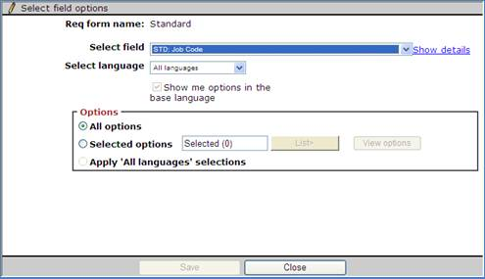
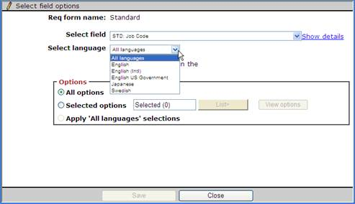
  - Important Notes
- The list filters provided for Job Code will be visible in Workbench for Job Code standard field. If the option is not specified in the XML no change will be made to its visibility.
- XML will not switch the Workbench setting from showing “selected list” of options to “all options”.
- XML will filter by language and cannot create filters for ALL LANGUAGES.
- Filters can only be created on the following Foundation fields:
  - Standard Req Fields Location and Department
  - Any configurable custom Req field from Req field index or any Req template.
  - Job Code
- Only one List Filter node per foundation item is allowed.
- Req field index form is not allowed in the filter by name or by form type id.
  - Tags for List Filtering
- Filter formname: Name of the Req form template. This is the Req Template Database Name in Workbench.
- Formtypeid: Instead of a formname, formtypeid can also be provided. Your BrassRing Representative can provide you with this value.
- action: Must be either “show” or “hide”. This is a required attribute.
    - XML Option 1
<Foundation_Item>
<Code>0002</Code>
<Description>Code 2</Description>
<Status>A</Status>
<ListFilters>
<Filter formname=" Requisition Form 1" action="show"/>
<Filter formtypeid="1234" action="hide"/>
<Filter formname="Requisition Form 2" action="hide"/>
</ListFilters>
</Foundation_Item>
    - XML Option 2
<ListFilters>
<Filter formname=" Requisition Form 1, Requisition Form 2, Requisition Form 3" action="show"/>
</ListFilters>
  - Sample XML with List Filtering
<?xml version="1.0"?>
<Envelope version="01.00">
<Sender>
<Id> INTEGRATIONID</Id>
<Credential>CLIENTID</Credential>
</Sender>
<Recipient>
<Id/>
</Recipient>
<TransactInfo transactType="data">
<TransactId>TRANSACTIONID</TransactId>
<TimeStamp>2006-02-28 09:22:10AM</TimeStamp>
</TransactInfo>
<Packet>
<PacketInfo packetType="data">
<PacketId>1</PacketId>
<Action>SET</Action>
<Manifest> FOUNDATION_CLIENTNAME_FIELDNAME </Manifest>
</PacketInfo>
<Payload><![CDATA[<?xml version="1.0"?>
<Foundation_Data>
<Foundation_Item>
<Code>0001</Code>
<Description>Code 1</Description>
<Status>A</Status>
<ListFilters>
<Filter formname="KNXA Corp, KNXA Requisition Form, KNXA Learning" action="show"/>
</ListFilters>
</Foundation_Item>
<Foundation_Item>
<Code>0002</Code>
<Description>Code 2</Description>
<Status>A</Status>
<ListFilters>
<Filter formname=" KNXA Corp " action="show"/>
<Filter formtypeid="1234" action="hide"/>
<Filter formname=" KNXA Learning" action="hide"/>
</ListFilters>
</Foundation_Item>
</Foundation_Data>
]]></Payload>
</Packet>
</Envelope>

- Job Code Code Access Groups (Optional)
Code access groups (CAG) are generally used when clients have a need to assign a set of specific Job Codes to specific set of Users. Once configured, users will only be able to view job codes tied to their assigned code access group(s). Users can be assigned to more than one group.

NOTE: This section pertains only to Job Code Foundation integrations. At this time CAG XML files can only be submitted and processed asynchronously which is different than the Foundation process described above (additional details about the differences are outlined below).

  - How to create a Code Access group
Code access groups can be created manually through Workbench or via the 2-step integration process below.
- Async Job Code Foundation Import XML: CAG is created and assigned to a Job Code
NOTE: The Client Setting “Import allow Code Access Group creation” must be set to “Yes” in order to create a CAG via import XML.
- Sync User Import XML: User is assigned to view Job Codes within a specific (existing) CAG.

This portion of the document will focus on step 1. Please see the User Import API for details on creating an integration for step 2.

  - Features of Job Code XML
Because this XML processes asynchronously the tags below will need to be added to your typical Foundation XML:
Email: This tag should contain the email(s) of parties who should be notified about the status of the Asynchronous transaction. If more than one email should be included, they have to be comma separated.
<Email>TEST@test.com</Email>
<Email>TEST@test.com,Test2@test.com</Email>
Header: This tag sets the integration to run asynchronously/
<Foundation_Data Asynchronous="Yes" xmlns:xsi="http://www.w3.org/2001/XMLSchema-instance">
Job Description: Job Codes in BrassRing can also be assigned a default Job Description. This tag is available to be populated but is not required.
<Job_Description>Where does this Job Description go?</Job_Description>
Code Access Groups: Assigns a job code to a Code Access group(s). If the CAG that is submitted alreay exists the Job Code will be added to the group. If the CAG that is submitted does not already exist, it will be created and the Job Code(s) assigned. To assign more than one CAG to a specific code, the groups should be semicolon separated.
<Code_Access_Groups>GroupA</Code_Access_Groups>
<Code_Access_Groups>GroupA;GroupB</Code_Access_Groups>

  - Sample Foundation with CAG XML
Below is a sample Job Code Foundation XML that contains Code Access Groups.
<?xml version="1.0" encoding="UTF-8"?>
<Envelope version="01.00">
<Sender>
<Id>IBM TO PROVIDE</Id>
<Credential>IBM TO PROVIDE</Credential>
<Email>Test@us.ibm.com</Email>
</Sender>
<Recipient>
<Id/>
</Recipient>
<TransactInfo transactType="data">
<TransactId>15747</TransactId>
<TimeStamp>2014-09-10 10:44 AM</TimeStamp>
</TransactInfo>
<Packet>
<PacketInfo packetType="data">
<PacketId>1</PacketId>
<Action>SET</Action>
<Manifest>TEST_JOBCODE_FOUNDATION</Manifest>
</PacketInfo>
<Payload><![CDATA[<?xml version="1.0"?>
<Foundation_Data Asynchronous="Yes" xmlns:xsi="http://www.w3.org/2001/XMLSchema-instance">
<Foundation_Item>
<Code>CAGTest1</Code>
<Description language="EN">CAG Test 1</Description>
<Status>A</Status>
<Job_Description>Test Job Code. Max 7500 Characters.</Job_Description>
<Code_Access_Groups>Group A;Group B</Code_Access_Groups>
</Foundation_Item>
<Foundation_Item>
<Code>CAGTest2</Code>
<Description language="EN">CAG Test 2</Description>
<Status>A</Status>
<Job_Description>Test Job Code. Max 7500 Characters.</Job_Description>
<Code_Access_Groups>Group B</Code_Access_Groups>
</Foundation_Item>
</Foundation_Data>
]]></Payload>
</Packet>
</Envelope>

  - Managing Code Access Groups via XML
    - Change CAG Name/Label
Code access group labels can only be changed via Workbench and not through integration.
    - Delete CAG
Code access group labels can only be deleted via Workbench and not through integration.
    - Remove Job Code from all CAG
In order to remove a job code from all code access groups, Code_Access_Groups tags should be included but no value should be sent. For example:
<Foundation_Item>
<Code>JobCode1</Code>
<Description>Test Job Code Description 1</Description>
<Status>active</Status>
<Code_Access_Groups></Code_Access_Groups>
</Foundation_Item>

If Code_Access_Groups tag is eliminated and not sent, all previous existing associations will remain unchanged. Eliminating the tag does not remove a job code from a Code Access Group.
    - Change a Job Code’s CAG
Assume JobCode 1 belongs to Code access Group A and it should be changed to Code Access Group B. Below is a sample XML how to un-assign from Group A and assign to Group B.
<Foundation_Item>
<Code>JobCode1</Code>
<Description>Test Job Code Description 1</Description>
<Status>active</Status>
<Code_Access_Groups>Group B</Code_Access_Groups>
</Foundation_Item>

Assume JobCode 1 belongs to Code access Group A and it should be changed to Include Code Access Group B as well. Below is a sample XML how to keep the job code assigned to code access Group A and also assign to Group B.
<Foundation_Item>
<Code>JobCode1</Code>
<Description>Test Job Code Description 1</Description>
<Status>active</Status>
<Code_Access_Groups>Group B; Group A</Code_Access_Groups>
</Foundation_Item>

A Job code can belong to multiple code access groups. Code access group values are semicolon separated.
<Foundation_Item>
<Code>JobCode1</Code>
<Description>Test Job Code Description 1</Description>
<Status>active</Status>
<Code_Access_Groups>Group B; Group C</Code_Access_Groups>
</Foundation_Item>
  - Asynchronous Processing
When an Asynchronous Job Code/Code Access Group is submitted, a real time response is sent. This response is like a receipt indicating BrassRing received your transaction and it is in queue to be processed. You will receive an email that contains the results of the actual import.

    - Real-Time Sync Response
Below is an example of the real-time response to let you know we received your file:
<?xml version="1.0" encoding="utf-8"?>
<Envelope version="01.00">
<Sender>
<Id>TEST</Id>
<Credential>TEST</Credential>
<Email>Test@us.ibm.com</Email>
<remoteIP>216.52.51.250</remoteIP>
</Sender>
<Recipient>
<Id/>
</Recipient>
<TransactInfo transactType="response">
<TransactId>15747</TransactId>
<TimeStamp>2014-09-10 10:44 AM</TimeStamp>
<Status>
<Code>200</Code>
<ShortDescription>Success</ShortDescription>
<LongDescription>FOUNDATION Data transfer was a success</LongDescription>
</Status>
</TransactInfo>
<Packet>
<PacketInfo packetType="response">
<PacketId>1</PacketId>
<Action>SET</Action>
<Manifest>TEST_JOBCODE_FOUNDATION</Manifest>
<Status>
<Code>200</Code>
<ShortDescription>Success</ShortDescription>
<LongDescription>Code Import XML transfer was a success</LongDescription>
</Status>
</PacketInfo>
<Payload/>
</Packet>
</Envelope>

    - Import Response/Results
Shortly after the XML is processed, an email will be sent indicating the status of the upload (Failed, Partially Successful or Completely Successful). For data security purposes, the actual reason for failure will not be included in the email. You can find the log in Workbench > Tools > Task Manager.

Below is a sample email notification and screen shot of a downloaded spread sheet. Please note this log spread sheet contains a number of tabs. You can review over all statistics, Inserted rows, Updated rows, Errors and duplicates.

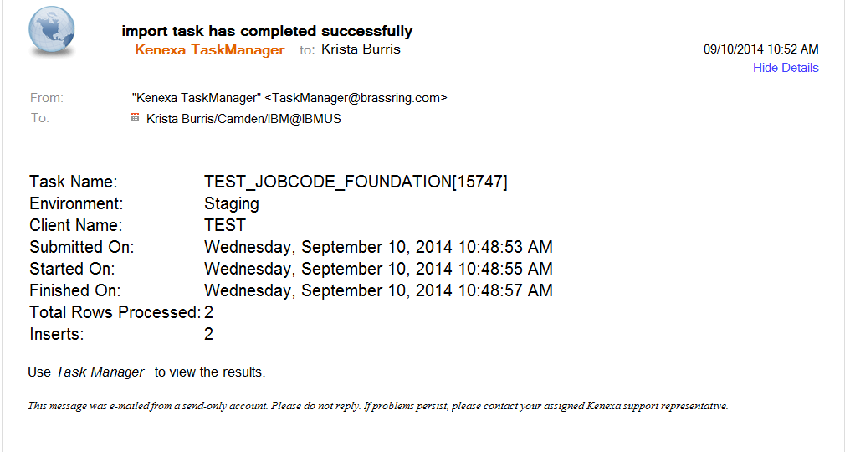

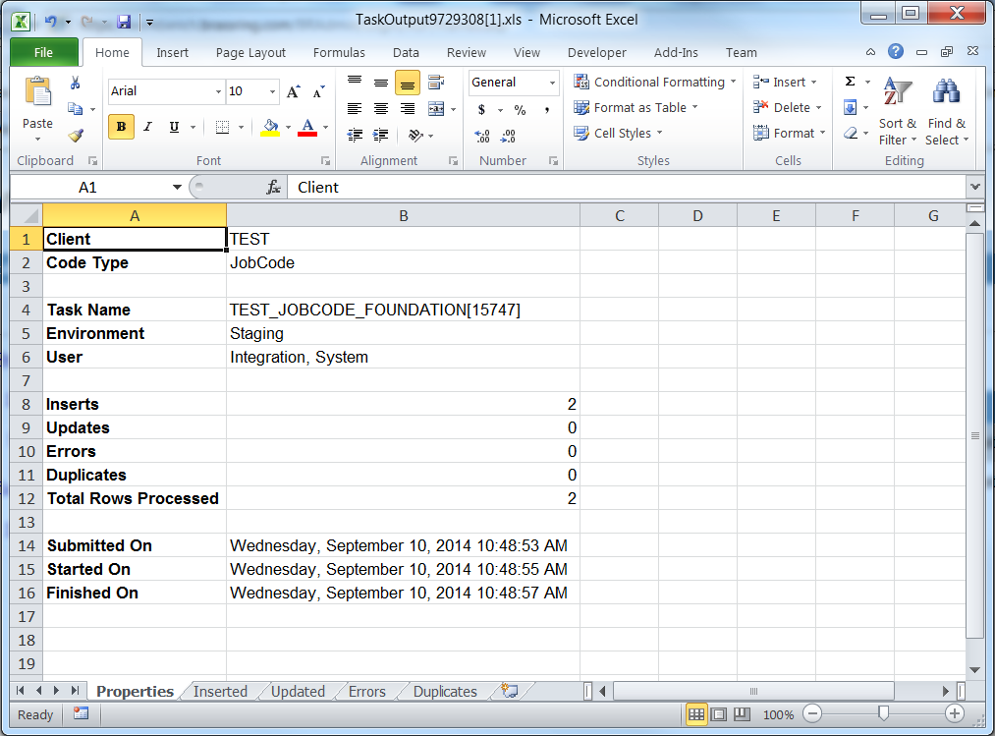
- Envelope Processing
The top level Envelope contains two attributes, version and encoding.
Version attribute identifies the version of the envelope. The only valid value at this time is “01.00”.
Encoding attribute identifies XML encoding and is optional. It can be set to “UTF-8” or “UTF-16”. The recommended setting is “UTF-16”.

The Envelope also has four top-level mandatory elements (Sender, Recipient, TransactInfo and Packet). These elements are described in detail below.
  - Sender
The values below will be provided at the time of implementation.
Employee Id: Sent in the Id tag for envelopes coming into BrassRing. This acts as the identification of the user who sends the XML data.
Client Id : Sent in the Credential tag.
  - Recipient
The URL of the recipient is passed in the Id tag. This helps to identify whether the data has been sent to the correct recipient destination.
  - TransactInfo
An identifier for the transaction should be included in the TransactId. This identifies the envelope transaction and not any of the constituent data, since there could be multiple documents within one envelope. The combination of the client Id, TransactId and PacketId creates a globally unique identifier for each packet.

A timestamp can be added in the optional TimeStamp. This date format should conform to ISO standard 8601 (i.e. “2000-10-09T14:14:11Z”)

transactType should be set to “data”. This attribute helps provide the envelope parser with a heads up on what to expect in the payloads.
  - Packet
The Packet contains the payload and metadata about the payload. The Payload element contains the actual XML and the PacketInfo element contains the metadata about the packet.

PacketInfo contains the following elements:
- packetType This attribute describes the content of the packet. A packetType of data is the default.
- PacketId: This element uniquely identifies the contents of the payload. PacketId is 1 unless suggested otherwise
- Action: This optional element contains the transaction code – SET
- Manifest: This is a mandatory element that identifies the contents of the payload. This field must be set to the value provided during implementation and should not be changed.
  - Payload
The Payload element contains one HR-XML document inside a CDATA section. This approach allows the payload to be parsed separately from the envelope and avoids any interdependency between envelope and contents when validating envelope documents.

Note: the Payload XML should not have any additional CDATA section within it as in nested CDATA sections.

- Security
Several security protocols and measures have been implemented to ensure security on the data transmission, message integrity, and message confidentiality. These mechanisms can be used to accommodate a wide variety of security models and encryption technologies.
  - Standard Implementation Security
    - Message Integrity
Message integrity is ensured on the XML data. Unique credentials within the XML act as authentication information for a transaction to be consumed. These credentials in the Id, Credential and Manifest nodes act as unique value for a given implementation.
    - Transport Layer Security (TLS)
Transport Layer Security (TLS) and its predecessor, Secure Sockets Layer (SSL), are cryptographic protocols that provide communication security over the Internet. TLS and SSL encrypt the segments of network connections above the Transport Layer, using asymmetric cryptography for key exchange, symmetric encryption for privacy, and message authentication codes for message integrity.

BrassRing integration API URLs (web service and HTTP Post URLs) are HTTPS-enabled and utilize 128 bit encryption over SSL when exchanging and transmitting information over the Internet. This is a mandatory encryption of the data that is enforced.
    - IP restrictions
To add another layer to security and protection, IP restrictions can also be enforced. At the time of implementation, IP addresses from Staging and Production environments can be provided that can be white-listed on an external firewall on the customer’s network. These IP addresses are provided on request.
  - Optional Security Features
    - Message Layer Encryption/Security (MLS)
In additional to the above security protocols, message layer encryption is also available on the payload data.

Message layer encryption is facilitated using RSA encryption on the XML. Both Java and Microsoft .NET development environments support APIs for RSA encryption. BrassRing uses 1024-bit RSA encryption key pairs along with a public key generated by the client to implement functions to encrypt, sign, decrypt and authenticate data.

Adding MLS adds to the cost and timeline of the project and as this is not part of standard implementations.

    - 2-Way SSL / Certificate Based Authentication
Additionally, client certificate authentications or 2-way SSL or mutual SSL authentication is also available to enforce additional security around the integrations. The method of data exchange is accomplished with the use of certificates that confirm the source of the data before processing the information. SSL Session negotiated by Handshake Protocol via a X.509 public key Certificate of Peer.

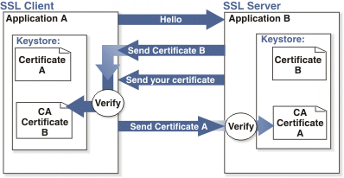

Adding 2-way SSL adds to the cost and timeline to the project as this is not part of Standard implementations.

Note: 2-way SSL is currently not available to clients on the China data-center.

- Integration API URLs
  - Message Router Addresses
Web service URLs you need to invoke to send transactional data to BrassRing. These URLs below apply to the US data-center only. Europe and China end-point URLs are provided during time of implementation on such integrations.

Staging Environment
Web Service
URL - https://staging.brassring.com/HRISprocessor9/DispatchMessage.asmx
WSDL - https://staging.brassring.com/HRISprocessor9/DispatchMessage.asmx?wsdl

HTTP Post
URL - https://staging.brassring.com/jetstream/500/presentation/template/asp/HRISIntegration/msgdispatch.asp

Production Environment
Web Service
URL - https://trm.brassring.com/HRISprocessor9/DispatchMessage.asmx
WSDL - https://trm.brassring.com/HRISprocessor9/DispatchMessage.asmx?wsdl

HTTP Post
URL - https://trm.brassring.com/jetstream/500/presentation/template/asp/HRISIntegration/msgdispatch.asp

- API Error Messages
Below is a list of error messages that you may encounter when using the Foundation Import integration. We have also included an explanation in order to assist you with troubleshooting.
Code | Error Description | Reasoning
401 | ValidateAccess: - Access not setup for Sender – DSDSDS | Value in the Sender tag is incorrect
401 | Credential value is invalid | Value in the Credential tag in incorrect
405 | getProfileInfo: - Inactive subscription | Value in the Manifest tag is incorrect
405 | Required tag Code does not have any data in the XML. Code could not be uploaded. | Code is missing. It is a required field
405 | Required tag Description does not have any data in the XML. Code “12345” could not be uploaded. | Missing Description value. Description is a required field
405 | Status X is not a valid status value. Acceptable values are 1 (active) or 0 (inactive). Code “12345” could not be uploaded. | Value is Status field is incorrect
405 | Action is invalid: Filter for IntegrationTest could not be uploaded. | Invalid action for list filter
405 | Filter for “Req Form Name” could not be uploaded. | Missing Filter formname or formtypeid
405 | ListFilters tag is present more than once in the XML. Filters for code “ABC” could not be uploaded. | List Filter Tag is listed more than once for the same Foundation Item
405 | Invalid formname or formtypeid: ( 53 ). Filter for “ABC” could not be uploaded. | Filter formname or formtypeid is invalid
405 | Timeout expired. The timeout period elapsed prior to completion of the operation or the server is not responding. | Service down. Retry message

NOTE: This list is not all inclusive but contains the errors that are most encountered.

Notices
This information was developed for products and services offered in the U.S.A and other countries. Consult your local IBM representative for information on the products and services currently available in your area. Any reference to an IBM product, program, or service is not intended to state or imply that only that IBM product, program, or service may be used. Any functionally equivalent product, program, or service that does not infringe any IBM intellectual property right may be used instead. However, it is the user's responsibility to evaluate and verify the operation of any non-IBM product, program, or service.
IBM may have patents or pending patent applications covering subject matter described in this document. The furnishing of this document does not grant you any license to these patents. You can send license inquiries, in writing, to:
IBM Director of Licensing
IBM Corporation
North Castle Drive
Armonk, NY 10504-1785
U.S.A.
For license inquiries regarding double-byte (DBCS) information, contact the IBM Intellectual Property Department in your country or send inquiries, in writing, to:
Intellectual Property Licensing
Legal and Intellectual Property Law
IBM Japan Ltd.
1623-14, Shimotsuruma, Yamato-shi
Kanagawa 242-8502 Japan
The following paragraph does not apply to the United Kingdom or any other country where such provisions are inconsistent with local law:
INTERNATIONAL BUSINESS MACHINES CORPORATION PROVIDES THIS PUBLICATION “AS IS” WITHOUT WARRANTY OF ANY KIND, EITHER EXPRESS OR IMPLIED, INCLUDING, BUT NOT LIMITED TO, THE IMPLIED WARRANTIES OF NON-INFRINGEMENT, MERCHANTABILITY OR FITNESS FOR A PARTICULAR PURPOSE.
Some states do not allow disclaimer of express or implied warranties in certain transactions, therefore, this statement may not apply to you.
This information could include technical inaccuracies or typographical errors. Changes are periodically made to the information herein; these changes will be incorporated in new editions of the publication. IBM may make improvements and/or changes in the product(s) and/or the program(s) described in this publication at any time without notice.
Any references in this information to non-IBM Web sites are provided for convenience only and do not in any manner serve as an endorsement of those Web sites. The materials at those Web sites are not part of the materials for this IBM product and use of those Web sites is at your own risk. IBM may use or distribute any of the information you supply in any way it believes appropriate without incurring any obligation to you.

Licensees of this program who wish to have information about it for the purpose of enabling: (i) the exchange of information between independently created programs and other programs (including this one) and (ii) the mutual use of the information which has been exchanged, should contact:
IBM Corporation
5 Technology Park Drive
Westford Technology Park
Westford, MA 01886

Such information may be available, subject to appropriate terms and conditions, including in some cases, payment of a fee.
The licensed program described in this information and all licensed material available for it are provided by IBM under terms of the IBM Customer Agreement, IBM International Program License Agreement, or any equivalent agreement between us.
Any performance data contained herein was determined in a controlled environment. Therefore, the results obtained in other operating environments may vary significantly. Some measurements may have been made on development-level systems and there is no guarantee that these measurements will be the same on generally available systems. Furthermore, some measurements may have been estimated through extrapolation. Actual results may vary. Users of this document should verify the applicable data for their specific environment.
Information concerning non-IBM products was obtained from the suppliers of those products, their published announcements or other publicly available sources. IBM has not tested those products and cannot confirm the accuracy of performance, compatibility or any other claims related to non-IBM products. Questions on the capabilities of non-IBM products should be addressed to the suppliers of those products.
All statements regarding IBM's future direction or intent are subject to change or withdrawal without notice, and represent goals and objectives only. All IBM prices shown are IBM's suggested retail prices, are current and are subject to change without notice. Dealer prices may vary.
This information is for planning purposes only. The information herein is subject to change before the products described become available.
This information contains examples of data and reports used in daily business operations. To illustrate them as completely as possible, the examples include the names of individuals, companies, brands, and products. All of these names are fictitious and any similarity to the names and addresses used by an actual business enterprise is entirely coincidental.

Trademarks
These terms are trademarks of International Business Machines Corporation in the United States, other countries, or both:
- IBM
- AIX
- Sametime
- WebSphere
Java and all Java-based trademarks and logos are trademarks or registered trademarks of Oracle and/or its affiliates.
Microsoft and Windows are registered trademarks of Microsoft Corporation in the United States, other countries, or both.
Linux is a trademark of Linus Torvalds in the United States, other countries, or both.
Other company, product, or service names may be trademarks or service marks of others.

